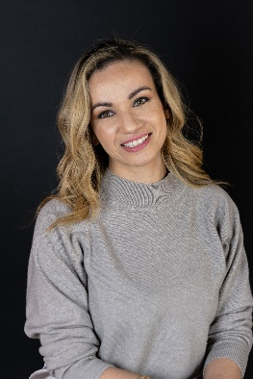
Fayza Abdallaoui
Fayza Abdallaoui is part of the Sustainable Livelihoods Canada team and works as an Evaluation Associate. As the founder of Next Level Impact Consulting in 2016, Fayza brings to the Building Employment Pathways project, her experience rooted in years of entrepreneurship, employability and financial education. She acts as a convener, supporting the Sustainable Livelihoods coaches in developing and growing their practice of this evidence-based approach designed to capture the many effects of social and economic exclusion on people’s lives and developing asset-building strategies that can move them towards resilient livelihoods. She is bilingual in French and English and graduated in Philosophy and Communications.

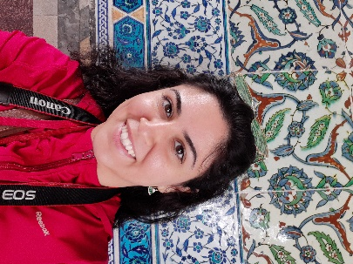
Noor Al-Azary
Noor Al-Azary brings five years of experience in the cognitive neurosciences field specializing in human decision-making. Prior to working at CCRW, she has cultivated 1 year of industry experience working with public health datasets and analyzing indirect impacts of COVID-19 on individual, local, and national scales. Within CCRW, Noor’s focus is in measuring the factors involved in the career journeys of persons with disabilities for the purpose of accessibility prioritization and dissemination of Canada’s underutilized talent.

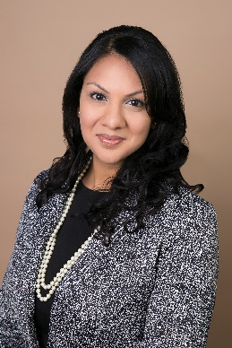
Dr. Imma Antony
Dr. Antony is a registered Clinical and Counselling Psychologist and completed her graduate education at the University of Toronto. She is a course instructor for Motivational Interviewing at the University of Toronto. She received her Motivational Interviewing Trainer certification through the Motivational Interviewing Network of Trainers (MINT), an international organization committed to promoting high-quality MI practice and training. Dr. Antony has developed several MI workshops and trainings across a variety of settings (e.g., hospitals, mental health community centres, poverty reduction programs, education/schools). Dr. Antony has worked with SL Canada for a decade to embed MI-informed coaching into Sustainable Livelihoods practice, and to design an MI-informed SL coaching practice training program. The training has been delivered to over 100 front-line staff and managers at more than 20 organizations across Canada.

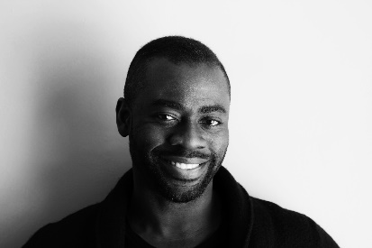
Dr. Charles Anyinam
Dr. Charles Anyinam is an accomplished registered nurse and educator with 20 years of experience in the post-secondary sector. He is an Associate Professor in the School of Nursing at Nipissing University. He brings a wealth of educational and leadership experience to this position. Before joining Nipissing University, Dr. Anyinam taught and held academic, administrative leadership and educational roles at York University, Trent University and George Brown College. Dr. Anyinam obtained his BSc. in Nursing and MSc. in Nursing from McMaster University and completed his PhD in Critical Disability Studies through the School of Health Policy and Management at York University. His research interests focus primarily on work and disability and disability in education and clinical practice. He is currently the research lead of the Building Employment Pathways for People with Disabilities project funded through Employment and Social Development Canada's Workplace Opportunities: Removing Barriers to Equity (WORBE) grants and contributions program.Dr. Anyinam's recognitions include the 2022 Nipissing University Chancellors Award for Excellence in Teaching (FASBU), the 2013 Registered Nurses Association of Ontario (RNAO) Leadership Award in Nursing, the 2009 Dean's Teaching Award (Early Career) at York University's Faculty of Health and several nominations for prestigious honours such as the 3M National Teaching Fellowship nomination and Toronto Star Nightingale award.

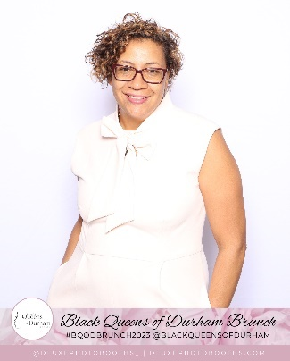
Liza Arnason
Li Liza Arnason BA, MA in Sociology and Equity Studies in Education at OISE, is the Owner and Principal of Arnason Consulting, Chair of the UCalgary Black Alumni Network, the founder and Chair of the Ase Community Foundation for Black Canadians with Disabilities, and above all a mom, grandma, and mentor. Liza's commitment to the principles of "nothing without us" and "for us, by us”, has always been the cornerstone of her work as an educator, administrator, and community advocate. Her depth of knowledge and expertise is informed by her lived experiences, research and policy initiatives, and work experience over 30 years. Liza draws on critical pedagogy including Black Feminism, disability justice, and critical race theories to inform community-based research and policy change initiatives. She unapologetically brings the lived experiences of those intersectional experiences of race, gender, and disability to the “table”, identifying nuances, gaps, and disparities within systems, structures, and research. Through collective leadership across Canada, Liz continues to design and advocate for new models and systems that will affect real change.

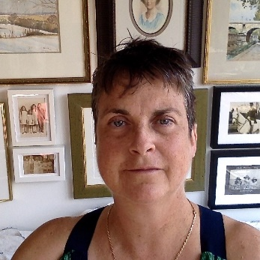
Chloë G. K. Atkins
Primary investigator of “The PROUD Project” on Under-employment & Disability at the University of Toronto. PROUD is funded by federal, tri-council grants and, private funders. Atkins has a PhD in Political Theory from the University of Toronto) and a postdoc in Law from Cornell University (Fulbright). She writes about disability, bioethics, anti-ableism, health equity, vulnerable identities, human rights and, phenomenological and narrative scholarship. Atkins authored My Imaginary Illness (Cornell 2010) receiving 3 prizes: the American Journal of Nursing (2011) Book of the Year. She has held Fulbright, Killam, Clarke and SSHRC fellowships. Her most recent publications are: "The epistemological and ethical weakness of using Clinical Frailty Scores in ICU triage." Chest (forthcoming). “Questionable Refuge.” in DISABLED Faculty and Staff in Higher Education: Intersecting Identities and Everyday Experience, ed. Mary Lee Vance and Beth Harrison. Beyond the ADA, Association of Higher Education and Disability, Huntersville, North Carolina, 2023.

Kim Atwood
My name is Kim Atwood. I am a retired occupational therapist. I worked as a self-employed occupational therapist in Ontario for several years; my practice niche was assistive / adaptive technology assessment and training. I also worked as an Adaptive Technologist at Queen’s University and St. Lawrence College for many years. Presently, I am a PhD Candidate at Queen’s University with the Department of Sociology. My PhD research project is ongoing. My qualitative research explores how reliance on accessible public transportation or paratransit services affects the educational, employment and occupation (i.e. self-care, productivity and leisure) opportunities of persons living with disabilities in Ontario. I hope to conclude this research and graduate in the Fall of 2024. I currently work as a Research Assistant on one of the Inclusive Design for Employment Access (IDEA) ‘School To Work Transition’ research projects supervised by Dr. Dan Samosh.

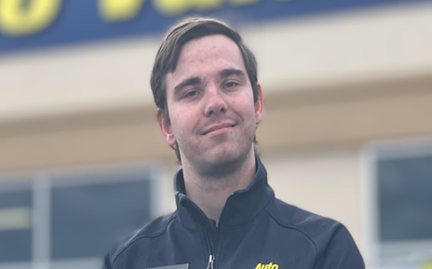
Drew Barclay
Drew is an and graduate of the EmploymentWorks program who has made remarkable strides in his journey. With dedication and perseverance, he secured employment in the retail industry after successfully completing the program. Now, he eagerly embarks on his next adventure, driven by a passion to work with and support the autistic community.
autistic self-advocate
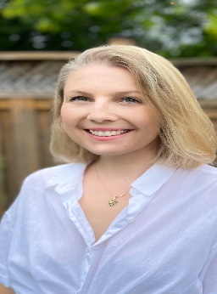
Kathleen Beitz
Having a background in early childhood education and early childhood resourcing, Kathleen has experience working alongside family and children with disabilities. Having lived perspective, Kathleen has a strong passion for supporting individuals goals holistically.
Currently working at CNIB research and IDEA team Kathleen works in knowledge translation to educate individuals in concepts of equity, inclusion diversity, and accessibility as well as leading research projects that focus on early digital literacy, skills and safe Internet use curriculums for children with disabilities.


Neil Belanger

Neil Belanger has over 30 years of experience working within in Canada’s Indigenous and non-Indigenous disability and health sectors. For the past ten years, Neil has been the Executive Director of the British Columbia Aboriginal Network on Disability Society or BCANDS, an Indigenous disability organization holding Special Consultative Status with the United Nations. BCANDS provides a variety of programs and services relating to Indigenous disability across Canada. BCANDS work has been highlighted through numerous provincial, national and international awards and recognition, the most recent being the Zero Project International Award presented to the Society in Vienna, Austria, in 2019. In addition to his work at BCANDS, Neil serves in a variety of disability related advisory roles.


Angela Black
Angela Black is a community practitioner and social change maker. After 15 years working as a professional artist and business owner in the Arts & Culture sector, Angela entered public service to contribute to the growth of her work in the areas of Inclusion, Diversity, Equity and Accessibility. Knowing rapid and tangible change could be made at this level of government for the equity deserving communities she works with and belongs to, Angela jumped at- and was given an employment opportunity that has allowed her to create access to meaningful employment on a larger scale. Angela is currently co-lead for the Equal Employment Opportunities program for the Government of New Brunswick and has been building this historically one person led program into a team of 7, alongside long-time colleague Amond McKenna. The Equal Employment Opportunities Program exists to remove barriers to employment and to provide supports to all levels of government in the areas of inclusion, Diversity, equity, and accessibility. You can reach her here: Angela.Black@gnb.ca

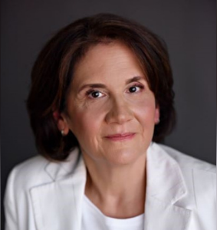
Dr. Adriana Berlingieri, Ph.D.
Dr. Berlingieri is an organizational consultant, facilitator, and researcher. Her professional and scholarly interests are centered on harassment and violence at work. Dr. Berlingieri has extensive professional experience in senior positions in the areas of learning and development within organizations in an array of sectors internationally. As an Associate at the Centre for Research & Education on Violence Against Women & Children, at Western University, she works with various multidisciplinary teams to conduct actionable research on workplace harassment and violence that shapes the development of prevention and intervention practices.

Olivia Boonstra
Olivia Boonstra is a Knowledge Mobilization Coordinator and Senior Research Officer at Eviance. Olivia completed their Masters (MA) in Criminology and Social Justice at Toronto Metropolitan University (TMU) and has worked in community for the past ten years. Olivia has a varied experience having previously worked on projects focused on harm reduction, anti-hate initiatives, prison abolition, and the issue of student debt for students with disabilities. Olivia is devoted to intersectional research and interested in connecting this experience as they continue to work in the area of disability justice.

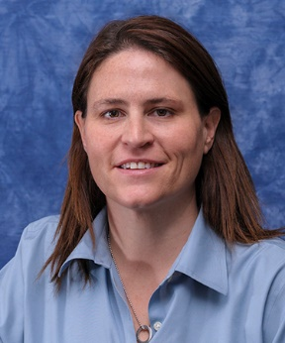
Angela Bradley
Angela Bradley is a dynamic professional with a deep commitment to advancing the rights and opportunities of people with disabilities. Her indigenous heritage, stemming from her grandfather who was a member of the Mohawks of the Bay of Quinte, Tyendinaga Mohawk Territory, has instilled in her a strong sense of identity and purpose. Currently serving as Senior Director, Social Enterprise and Philanthropy at Community Living Toronto, Angela's dedication to the non-profit sector has been both a personal passion and a lifelong professional journey. Her commitment to enhancing choice and opportunities for people with disabilities is evident through her involvement in a variety of impactful initiatives. Angela holds an Honours BA in Psychology & Sociology from Queen's University and has pursued post-graduate studies across North America including, York University, the Rotman School of Management, and the MBA program at North Park University. Angela’s expertise extends to fundraising, marketing, and revenue generation. With a track record spanning over three decades, she has led an array of events that have garnered recognition for their excellence - everything from intimate community gatherings to high-profile political and celebrity affairs. Always with a focus on inclusion, community, and empowerment. Beyond her professional roles, Angela is a passionate volunteer, sharing her knowledge with others seeking to improve various aspects of their organization. From event management and governance structures to fundraising and marketing strategies, government relations, and communication tactics, Angela’s contributions extend beyond her official roles. Her lifelong journey is a testament to her commitment to fostering more inclusive and supportive communities for all.
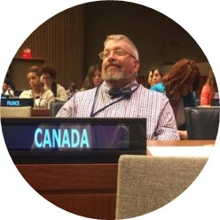
Max Brault
Max Brault is the Vice President of Accessibility Consulting Services and BDO’s National practice lead for Accessibility. Max has a vision to move Canada towards a barrier-free society by demonstrating to the world that Canadians with disabilities contribute to society and to successful business ventures. Max organized and facilitated the Persons with Disabilities Champions and Chairs Committee (PwDCCC) and was instrumental in guiding the federal government toward new and progressive accessibility legislation, Bill C-81, the Accessible Canada Act (2019). Max alongside with the BDO team work together to identify accessibility issues in Canada―for corporations, governments, and non-governmental agencies―and to provide strategic solutions to address them. Max is bilingual and is comfortable working in both French and English. He is security cleared to the Secret level. Max Brault is one of the key individuals who influenced the development of Accessibility Canada Act. He also has just under 20 years of working in the Employment Equity file. Finally, Max has spent last 5 years prior to leaving the public service directly supporting Deputy Ministers on the PwD & EE file between Infrastructure Canada and Treasury Board of Canada Secretariat. Recipient of the Diamond Jubilee Medal, The Correction Service Canada Award of Distinction, and the Michelle C. Comeau Human Resources Leadership Award, Max Brault has worked in employment equity for the past 20 years. He is also the author of the paper “Interdepartmental Forum of Persons with Disabilities: A Dialogue for Action.”.

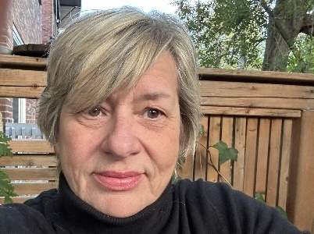
Bonnie Brayton
Bonnie is the Chief Executive Officer at DAWN Canada. She is a recognized thought leader in both the feminist and disability movements in Canada and internationally. She is also an active member of the Gender & Trade Advisory Group at Global Affairs Canada and has been actively involved in international feminist disability organizing for many years. From 2016 to 2021, Ms. Brayton served as a member of the Federal Minister’s Advisory Council on Gender-Based Violence (WAGE). From 2020 until now, Ms. Brayton continues to serve on Minister Kamal Khera’s (ESDC) Disability Advisory Group (MDAG). Ms. Brayton is also a founding member of the Ending Violence Association of Canada and served on the Steering Committee of La Maison Parent-Roback,from 2008 to 2015. Bonnie has also contributed to several anthologies including A BOLD VISION and LIVING THE EDGES, a DisAbled Women’s Reader from Inanna publications and STILL LIVING THE EDGES, the second release. Bonnie is proud to be the co-chair of the GFLWD (Global Forum for Women on the Leadership of Women with Disabilities. Ms. Brayton is also the Partner Liaison for the seven-year initiative funded by SSHRC “Engendering Disability-Inclusive Development” based at the University of Guelph.

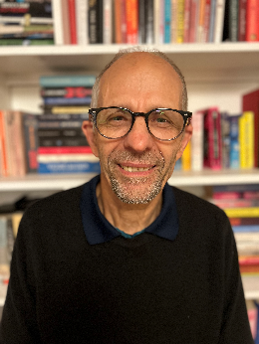
Orlando Buonastella
Orlando Buonastella works at the Injured Workers Community Legal Clinic. For over 40 years he has provided legal, advocacy and peer support to injured workers. He is one of the founders of the Injured Workers’ Speaker School, a project developed under the Research Action Alliance on the Consequences of Workplace Injury (RAACWI) process, a collaboration of injured workers, advocates and academic researchers.

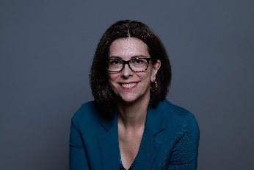
Stephanie Cadieux

In May 2022, Stephanie Cadieux was appointed to a four-year term as Canada’s first Chief Accessibility Officer (CAO). Before her appointment, Ms. Cadieux was a member of the Legislative Assembly of British Columbia from 2009 to 2022. Between 2010 and 2012, she held various positions, including Minister of Social Development, Minister of Labour, Citizens’ Services and Open Government, and Minister of Community, Sport and Cultural Development. As Minister of Social Development, she served as lead social policy maker and introduced a breakthrough approach to remove policy barriers for people living with severe disabilities. From 2012 to 2017, she served as Minister of Children and Family Development. In this role, she placed a special focus on increasing adoption levels and support for young people aging out of foster care. She also championed a single parent employment initiative that led to thousands of single parents being able to move into the labour market in jobs that would have previously been inaccessible due to lack of training and childcare support. Prior to her engagement in provincial politics, she was the director of marketing and public relations for the BC Paraplegic Association.
Ms. Cadieux is a member of the disability community and has used a wheelchair since the age of 18. Her lived experience gives her a deep understanding of the unnecessary barriers faced by people with disabilities and the cost of these barriers to our collective wellbeing. She has long been an enthusiastic change leader, and a strong advocate for diversity, accessibility, and disability and gender inclusion. She is passionate about creating environments where everyone is welcome and diverse talents are embraced. She is a firm believer that as a society, we can no longer afford to accommodate inaccessibility and must challenge outdated mindsets and unconscious bias at every opportunity. Throughout her career, she has been a tireless advocate for increased accessibility. Her volunteer activities have included serving as Director for Disability Alliance BC, as an Ambassador with the Rick Hansen Foundation, President of the Realwheels Theatre in Vancouver, and mentoring with the YWCA. She brings a forward-thinking outlook and extensive experience in strategic policy development to her role as CAO and is dedicated to driving results that create real, positive changes in the lives of people with disabilities and empower us, as a society, to make better decisions and identify innovative solutions that will benefit everyone.

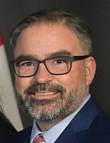
Daniel Carleton
Daniel Carleton is Chief of Staff for Michelle Kovacevic. He leads a team of nine, overseeing the Federal-Provincial Relations and Social Policy Branch operations.
Daniel has collaborated with LiveWorkPlay for close to a decade – starting as an advocate within the Public Service before becoming a hiring manager. He has helped to pave the way and identify several opportunities for persons with disabilities in the Public Service of Canada.

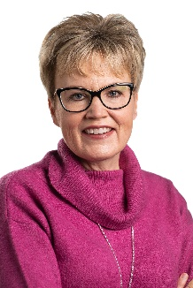
Krista Carr
Krista Carr is a long-time advocate in the inclusion movement. She is the Executive Vice President (CEO) of Inclusion Canada, one of Canada’s 10 largest charitable organizations. Inclusion Canada is a national federation of 300 local and 13 Provincial/Territorial Associations working on behalf of approximately 1 million Canadians with a developmental disability and their families. Krista has over 25 years of experience in the non-profit sector as a champion of inclusion. Before joining Inclusion Canada, she was the Executive Director of the New Brunswick Association for Community Living (NBACL), a leading provincial non-profit organization that works with people with an intellectual disability and their families to accomplish the mission of full inclusion across the lifespan. In her current role, Krista is responsible for leading the Inclusion Canada National organization, the Inclusion Canada Foundation and Inclusive Education Canada (IEC). In addition to her extensive work portfolio, Krista sits on a number of provincial and national disability-related boards and committees. She was a member of the COVID Disability Advisory Group and was Chair of the Ministerial Disability Advisory Group, established by the honourable Carla Qualtrough, Minister of Employment, Workforce Development and Disability Inclusion. Krista offers a unique perspective on disability-related supports and services, both nationally and internationally. Krista is a graduate of the University of New Brunswick (UNB) where she earned a Bachelor’s in Business Administration (BBA) and several diplomas in Human Resources and Management from UNB’s College of Extended Learning. She is fluently bilingual and works on behalf of CACL’s federation in both French and English. She currently resides in New Brunswick with her husband and two daughters.


Sinthea Chowdhury
Sinthea is the National Project Coordinator for the Ready, Willing & Able program. She has spent the last decade working in various disability spaces. With experience in program development, implementation, and advocacy, Sinthea specializes in collaborating with diverse communities across the country to understand their unique needs and foster culturally centered community initiatives. Drawing from her experience in the performing arts, she enjoys incorporating elements of storytelling into her work. Currently, Sinthea coordinates a number of trailblazing projects at Ready, Willing and Able, including several career advancement initiatives, and a BIPOC Youth employment project. She looks forward to continuing her work with diverse disability communities throughout Canada and to further develop her intersectional lens.

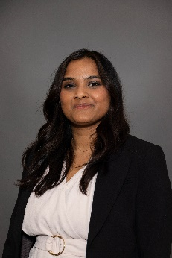
Rakhee Chowdhury
Rakhee Chowdhury is the Communications Manager at Autism Alliance of Canada and Ready, Willing & Able. Rakhee completed her graduate studies at l’Université de Montréal (Québec) in Psychology at the International Laboratory for Brain, Music and Sound Research, where her work focused on the intersection of language and music processing in children on the spectrum. Over the last 15 years, Rakhee has been involved in a variety of projects centering the needs of neurodiverse youth and their families. At the Centre for Innovation in Autism & Intellectual Disabilities in Montreal, Rakhee led EmploymentWorks, a pre-employment initiative for Autistic youth, adults, and persons with disabilities, and provided parent coaching supports to families of pre-school children on the spectrum. At McGill University, Rakhee led the operations of accommodated exams for students with disabilities at the Student Accessibility & Achievement and contributed to the unit’s leadership team during the shift to a remote academic environment. Rakhee strives to create accessible and inclusive spaces for all persons.

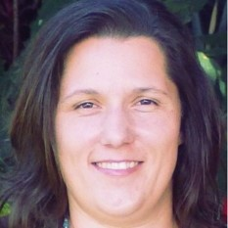
Angie Conrad
Angie Conrad has been in the disability sector for over 25 years in service delivery, administration, and policy development at municipal, provincial and federal levels. Most recently she is the Manager of Accessibility Policy at Canada Post which entails the integration of Accessibility across the corporation.

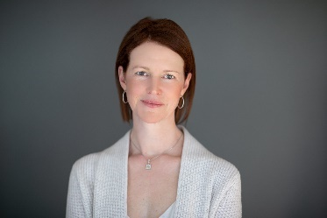
Jennifer Crowson
Jennifer holds a Bachelor and Master of Social Work from McMaster University and a Ph.D. from the University of Edinburgh. She is a registered Social Worker with over twenty-five years of work professional work experience in child welfare, policy, and research. She has had several key management positions with both non-government and government agencies in Canada and Scotland. Her work has mainly focused on children and young people. She is a part time faculty member with the School of Social Work at McMaster University, where she teaches as a sessional instructor. Jennifer is a strong analytical and critical thinker with a passion for policy development, robust research, program development and excellent teaching.

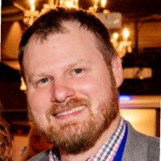
Mike Cyr
Mike has over 20 years of leadership experience in the Deaf community and not for profit sector. As an innovative leader, he is always exploring new ideas, strategies, and approaches to improving the quality of life of all members in the community. Inspired by the work CCRW does for persons with disabilities in our country, Mike is committed to influencing attitudes and perceptions of our candidates and employers in order to create an inclusive workplace where each individual is able to bring their true self to work each day.

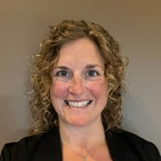
Kerri Deir

Kerri has dedicated her career to empowering others. She is an accessibility consultant with CCRW, specializing in working with Red Seal Trade apprentices. Kerri is passionate about troubleshooting barriers and finding solutions to ensure equity is attainable. She works with employers, educators, unions and community stakeholders to educate on the broad spectrum of disability, highlighting that many disabilities are invisible. Kerri is excited that CCRW is paving the way for apprentices to be heard and understood and a leader in influencing the industry on diversity and inclusion.

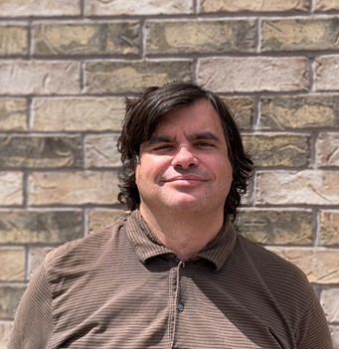
Andrew Depedro
Andrew Depedro was born, raised and lives in Ottawa, Ontario. He has an undergraduate degree in Humanities and Native Studies from The University of Saskatchewan, and is trilingual in English, French and Spanish. He currently works as an Office and Program Support Administrator at Innovation, Science and Economic Development Canada (ISED). In his spare time, Andrew is involved in music journalism and volunteering in the local music scene. He has conducted interviews with artists such as Sebastian Bach of Skid Row and Max Cavalera of the band Sepultura. Additionally, he has been a volunteer at Ottawa BluesFest for the last fifteen years, and also volunteers at CityFolk Festival.

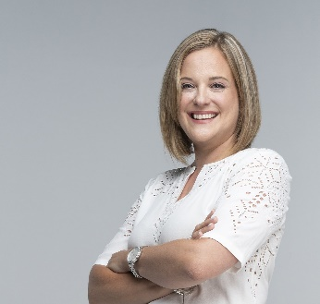
Jillian Dowding
With a strong background in project management, research, and data and evaluation, Jillian excels in streamlining complex projects, optimizing workflow processes, and employing data-driven strategies to inform program delivery and decision-making. With a background in public policy research and nonprofit leadership, Jillian is dedicated to evidence generation and using data to drive impactful outcomes.

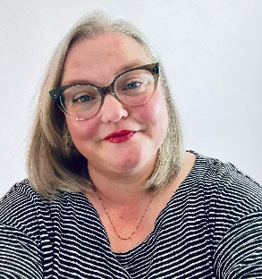
Melissa Egan
Melissa Egan is the National Lead, Episodic Disabilities at Realize. She has worked in the field of health education for over 20 years as a presenter and facilitator, developing and delivering trainings to diverse audiences across Canada. Melissa brings a commitment to inclusion, diversity, equity, and accessibility to her work and has worked extensively with the 2SLGBTQIA+ community, and Indigenous people. Melissa holds a Master of Education in workplace learning and social change from the University of Toronto.

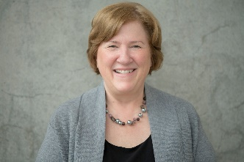
Doramy Ehling
Doramy Ehling is the Chief Executive Officer of the Rick Hansen Foundation (RHF). As CEO, Doramy leads the Foundation in its’ vision of an inclusive world where people with disabilities are living to their full potential. Over the past 11 years, Ehling has supported the development of several innovations at RHF including the Rick Hansen Institute (a global translational research network) and the Rick Hansen Foundation Accessibility Certification™ program. She has also been involved in national awareness and fundraising campaigns associated with the Foundation’s 20th, 25th and 30th Anniversaries. Prior to joining the Foundation, Doramy worked for 27 years in high performance sport working in Ottawa for several national multi-sport organizations and the Government of Canada/Sport Canada where she worked with the Federal Secretariat on the Vancouver 2010 Olympic and Paralympic Games. During this time she had an opportunity to work on several major policy initiatives including the National Sport Policy, Federal Hosting Policy, Policy on Sport for Athletes with Disabilities, and Policy on Aboriginal Peoples’ Participation in Sport. Doramy has been an active volunteer in the sport community over the past 30 years including serving on the Boards of Volleyball BC, Sport BC and the Sport Medicine Council of Canada and participating in Olympic, Pan American, Commonwealth and World University Games Mission Staffs. She is currently serving as Chair for the Host Committee of the National Women’s Volleyball Training Centre located at the Richmond Olympic Oval. Doramy is a member of the Advisory Board, Diversity Institute, Ryerson University and a member of the Greater Vancouver Board of Trade’s Advisory Committee of the Diversity and Inclusion Leadership Council. Originally from Vancouver and a graduate of the University of British Columbia, Doramy now resides in Richmond, BC with her two daughters.

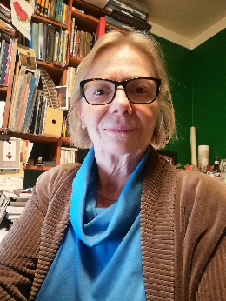
Marion Endicott
Marion Endicott worked for forty years, in Toronto, as an advocate for injured workers at Injured Workers Community Legal Clinic, funded by Legal Aid Ontario. Her work involved representation of workers in their appeals and dealings with the workers compensation system, policy and legislation analysis and campaigns, and work with injured workers groups and speakers school. She was a founding member of the Bancroft Institute for Studies in Workers Compensation which helped establish the Research Action Alliance on the Consequences of Work Injury (RAACWI). The successful experience of this SSHRC-funded research-action project is the subject of a book, “Who Killed Sir William?” written by Marion and co-author, Steve Mantis.
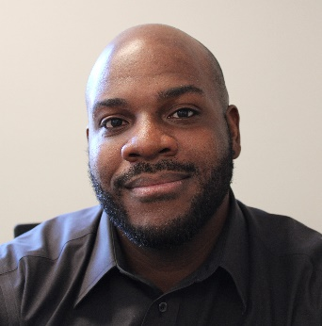
Justin Eweka
Justin Eweka has an incredible amount of experience and success working in this field in Halifax Nova Scotia. He has been coaching Special Olympics soccer for eighteen years, was a Senior Session Leader for twelve years at Club Inclusion, has provided various respite services throughout the community, and for the last three years has been an Employment Facilitator and Job Coach at Easter Seals Nova Scotia. Justins focus has been to build The Next Step Program supporting youth who identify as having disabilities prepare and find community employment, as well as orchestrating the Supported Employment Collective. The SEC, at its beginning stages, connects nine supported employment providers within Halifax Regional Municipality Nova Scotia with precise focus and goals for more range of access to employment services for the individuals we support.
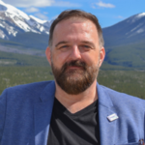
Frank Fagan
Frank Fagan is the Assistant National Director of the Ready, Willing & Able program and comes from an extensive background in non-profit management and the arts. Building from a Communications/Film degree from the University of Windsor in 1989, Frank’s career started in the marketing side of film and music. Eventually, Frank then segued into a sector-advocacy role for the arts, where he led provincial/regional cultural organizations in the development of major initiatives, including the development of the Cultural Policy framework Government of Newfoundland and Labrador. Frank has been with Ready, Willing and Able since its inception in 2014; occupying the role of National Manager of Operations for the first 8 years and becoming the Assistant National Director as of 2022.

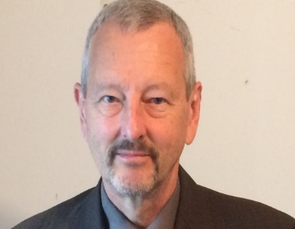
Alec Farquar
Alec Farquhar is a lawyer with a long career in workers’ compensation, disability and employment and occupational health and safety. He is currently Chair, Engagement, for the Centre for Research in Work Disability Policy and member of the steering committee for Disability and Work Canada. He is also a member of the Canadian Standards Association Strategic Steering Committee for Occupational Health and Safety, which includes the CSA Disability Management Standard. Previously, Alec was the Director of the Ontario Ministry of Labour’s Occupational Health and Safety Branch, Director of the Office of the Worker Adviser and Managing Director of the Occupational Health Clinics for Ontario Workers. Alec has worked extensively on employer/worker partnerships around the recruitment, inclusion and accommodation of persons with disabilities. Alec has a long history of working with vulnerable worker communities including immigrant, racialized and indigenous workers, women and young workers. He is fluent in Italian and French which has helped him connect directly with those communities. A graduate of Princeton University, Alec has an L.L.B. from the University of Toronto Faculty of Law. He is currently a member of the Ontario Bar Association Workers’ Compensation Section Executive.

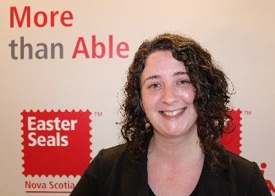
Kyla Gagné
Kyla Gagné has been working with individuals who identify as having a disability for twenty years. She has provided respite services, lead individual programming and case management, and is dedicated to advocating alongside the people she supports. The last nine years of her career Kyla has been working for Easter Seals Nova Scotia, first as a Skills Instructor, then as an Employment Facilitator and Job Coach. Kyla has successfully designed and implemented The New Leaf Reverse Job Fair in Halifax Nova Scotia, an innovative job fair that gives Job Seekers their own booths to highlight their skills and experience. Through The New Leaf Reverse Job Fair our mission is to make the process as accessible as possible for job seekers searching for inclusive employment as well as for local employers continually committed to building inclusive workplace culture.

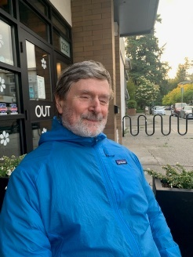
Peter Field
Peter Field is a diversity and inclusion consultant living in Hope British Columbia. For 28 years peter held positions of increasing responsibility with the Government of Canada in areas like employment equity, duty to accommodate, learning, leadership, human resources policy and labour relations. In 2019 Peter retired from his federal government career to pursue consulting and his passion as a marathon runner and podcaster.


Nadine Ghadie
Nadine Ghadie is an Administrative Assistant in the Federal-Provincial Relations and Social Policy Branch, at the Department of Finance. Nadine has a range of information management responsibilities, including scanning and printing documents for both the Branch and the Deputy Minister's office, and archiving notes and presentations on the Department’s e-file management system. Beyond her professional life, Nadine is a devoted wife and mother to a young daughter. She finds enjoyment in travel, shopping, and capturing precious moments through family photoshoots. Looking ahead, Nadine envisions expanding her family by having more children and dreams of eventually living in Abu Dhabi. Her educational background includes graduation from Woodroffe High School. Before joining the Department of Finance, she gained experience through a year-long contract at Health Canada.

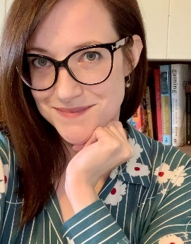
Dr. Haley Gienow-McConnell
Dr. Haley Gienow-McConnell is a Senior Accessibility Specialist at Left Turn Right Turn, an independent accessibility consulting firm based in Toronto, Ontario. Her doctorate is in History and Disability Studies, and she is well published in the field. Since transitioning away from academia, Haley has worked with a wide variety of non-profit organizations and with provincial ministries in the space of accessible employment. Here she honed her skills in training, knowledge translation, change management, and thought leadership, while continuing to pursue research. At Left Turn Right Turn, Haley has continued this type of work while broadening the sectors she serves and her areas of expertise. She continues to work with employment service organizations, as well as Crown corporations, public sector organizations, municipalities, and for-profit organizations, including large multi-national companies. Her current work covers all manner of accessibility planning, including accessibility assessments, as well as training, public engagement, legislative compliance, and change management. Haley has a mental health disability--bipolar disorder--and she lives with her deaf American Sign Language-using husband and their autistic daughter. The family uses English and ASL to communicate.
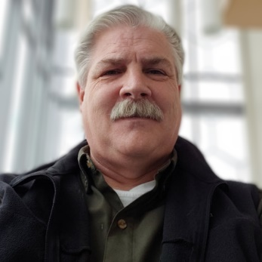
Monte Hardy

Monte has over 30 years of experience working in different Deaf service organizations in British Columbia and Ontario. He has served as Director for the Provincial Services for the Deaf and Hard of Hearing, an organization that provided residential services and family services, as well as managed many contracted services such as summer programs for Deaf children and youth, summer intervenor services for deafblind children, and early intervention for children who are Deaf, hard of hearing, deafblind, visually impaired, and blind. In Ontario, he was the Regional Director for Hamilton, Niagara, Halidmand, and Brantford at the Canadian Hearing Services (formerly Society). Services included mental health counselling, interpreting, audiology, hearing health care, and general support services. He has provided consulting services to Canadian Hard of Hearing Association and Western Institute for the Deaf and Hard of Hearing (now Wavefront). He was active in the BC Deaf community, advocating for Video Relay Services as part of the BCVRS committee. He also was a part of a BC committee advocating for an apology from the International Congress of Education for the Deaf in 2010 for the Milan 1881 decision where they banned sign language in Deaf schools around the world. He is currently working toward his PhD in Child and Youth Studies at Brock University.
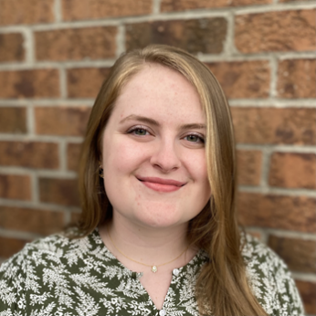
McKenna Goodwin

McKenna Goodwin is a Red Seal Endorsed General Carpenter based in Ottawa, Ontario. She completed her apprenticeship with Carpenter’s Union Local 93. McKenna actively seeks opportunities to educate on and improve equity, diversity, inclusion, and accessibility on the job site and in the skilled trades as a whole. She is a vocal advocate for tradeswomen and mental wellness.

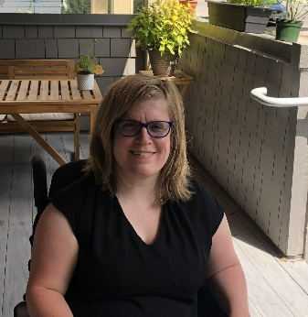
Melissa Graham
Melissa has lifelong experience with disability and over a decade in frontline work in the disability community, working for the Self-Managed Attendant Services Program and other organizations in the disability sector. Her background is in both social work and disability activism, and she is known particularly for bringing people together from different lived experiences. Melissa is a newcomer to the province of Manitoba. Prior to her move, she was the founder and lead organizer for the Toronto Disability Pride March, an annual event she organized for 11 years that continues today. She has a long history in disability policy and research focused on intersectionality, decolonization, social justice and accessibility.


Eakam Grewal
Eakam Grewal is a MSc student in Rehabilitation Sciences at McMaster University. Her research focuses on understanding the intersecting identities of race and disability in the context of employment and is a research associate with Inclusive Design for Employment Access Social Innovation Laboratory (IDEA SIL).


Janessa Griffith
Janessa Griffith is the Research Director at the Work Wellness Institute. She holds a PhD in Medical Science from the University of Toronto. Her research focuses on bridging the gap between research and implementation. Recently, Janessa conducted research on vaccine hesitancy in Canada which gained national and international media coverage. Janessa mobilized this research by creating an initiative to promote vaccine uptake in Canada which was recognized by the Prime Minister of Canada, Justin Trudeau, and Canada’s Chief Public Health Officer, Theresa Tam.

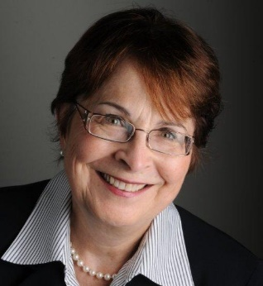
Mary Gusella
Mary Gusella is a retired as Chief Commissioner of the Canadian Human Rights Commissions following a 36-year Public Service career. Her public sector experience includes serving as a Deputy Minister, a Chairperson of both a Crown corporation and a private sector corporation under the Canada Not-for-profit Corporations Act (CNPCA), Head of Agency, CEO of a Crown Corporation, Chair of a bi-national (Canada/US) organization, and Commissioner of the Public Service Commission as well as 14 years serving on boards of directors. Mary is a volunteer with LiveWorkPlay since 2014 and Chair of the Federal Employment Strategy Group under the Inclusive Employment Initiative.
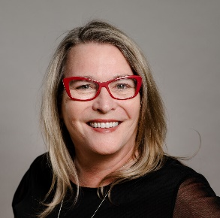

Maureen Haan
Maureen has been the President & CEO of CCRW since 2012. CCRW is the only national organization with the sole vision of equitable and meaningful employment for people with disabilities, in operation for over 40 years. Under Maureen’s leadership, CCRW has seen an increase in direct program service throughout Canada, as well as a more transparent, streamlining of understanding the business case of hiring a person with a disability. Maureen provides insight to employer engagement through CCRW best practices and proven results. Maureen has been very active in the cross-disability sector, currently focusing on employment issues. She has been involved with numerous committees and groups that increase awareness of and access for the disability sector and the Deaf community, including involvement with Civil Society on the UN Convention of Rights for Persons with Disabilities (CRPD) as the lead for employment for persons with disabilities – specifically Article 27; leadership with the Conference on Work and Disability in Canada; co-development and leadership of the pan-Canadian Strategy on Disability and Work; and as a Board member on the Accessibility Standards Canada. Maureen was appointed to the COVID-19 Disability Advisory Group (CDAG) during the COVID-19 pandemic and remains on the Minister Disability Advisory Group (MDAG). Maureen started her career in the Deaf community and is fluent in American Sign Language (ASL). Maureen lives in Thornhill with her two sons and her partner, Mike.

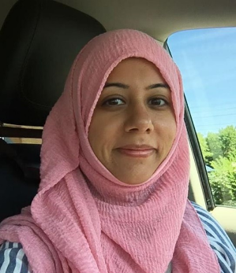
Raihanna Hirji-Khalfan
Raihanna Hirji-Khalfan has over 15 years of experience advancing disability rights, anti-racism, equity, and anti-oppressive practice in the non-profit and public sectors. Raihanna served as the Accessibility Officer at McMaster University where she managed the University’s accessibility program and compliance obligations with the Accessibility for Ontarians with Disabilities Act (AODA). Raihanna is a seasoned facilitator with expertise in design and delivery of training and education programs. She also has expertise in creating and managing programs for marginalized communities. Raihanna has a Masters degree in Business & IT, a Masters degree Critical Disability Studies, and an LLM in Canadian Common Law.

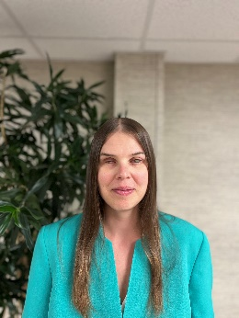
Christine Hochbaum
Dr. Christine V. Hochbaum was born and raised in Winnipeg. She graduated with a Bachelor of Arts (BA) Honours in Psychology and a BA 4-year in Conflict Resolution Studies in 2004 from the University of Winnipeg. In 2005, Christine moved to Vancouver to pursue graduate studies at the University of British Columbia (UBC). There she obtained a Master of Arts in Family Studies in 2008 and Doctor of Philosophy in Sociology in 2017. Christine began working as Lead, Strategic Research Analyst at the CNIB Inclusion, Diversity, Equity, and Accessibility (IDEA) team in March 2022. Christine was born legally blind and has experienced increased sight loss over the course of her lifetime.


Ian Humphreys
Ian Humphreys is a dedicated Employment Advisor at the Sinneave Famly Foundation. With the perspective of a neurodivergent self-advocate, Ian brings a unique outlook to his role. Currently overseeing EmploymentWorks program at The Ability Hub, Ian leads the delivery of in-person and online initiatives, ensuring successful participant outcomes. Ian's expertise extends to advising the EmploymentWorks National Project, where he provides insights, innovation, and guidance to drive program success nationwide. With a commitment to fostering community connections, and a passion for advocating for inclusive employment practices, Ian is driving positive change in the employment landscape.

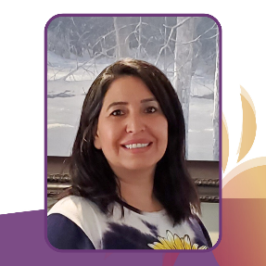
Evelyn Huntjens
Alongside her role at DAWN Canada, Evelyn is also the Program Coordinator for Indigenous Disability Canada (IDC/BCANDS), where she has worked since 2016.
Evelyn brings over seven years of leadership experience within the Indigenous disability sector, with a focus on coordinating and developing peer support navigation services for Indigenous persons living with disabilities. She brings passion and commitment to the work she has accomplished and she strives to advocate and break down barriers to support individuals and their families. Evelyn was one of the very first individuals to open RDSPs in British Columbia and she recognized the need for financial resource support in the disability community. Since then, she has taken the lead on developing and managing IDC/BCANDS’ award-winning Indigenous RDSP Navigator Program, which secures financial resources for Indigenous individuals living with disabilities and their families. The program's poverty-reduction focus ensures that individuals and their families receive the financial benefits they need and are entitled to. Currently, Evelyn is completing her Masters Certificate in Project Management at the Gustavson School of Business in Victoria, BC. Previously, she has worked as a personal financial planner within the financial services sector, focusing on financial education and mentoring.
Evelyn is First Nations and resides on Vancouver Island, BC. Since 2003, she has lived within the ancestral territory of the Quw’utsun First Nation. Evelyn Huntjens is a member of the Xeni Gwet’in – Tsilhqot’in People of the Nemiah Nation located in the heart of B.C., and she has ancestry from the Montreal Lake Cree First Nation in Saskatchewan.

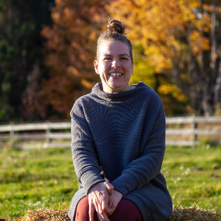
Chloée C. Godin-Jacques
Chloée Catherine (she/they | elle/eil) is a white settler disabled queer person. She is currently pursuing a Ph.D in Education at Western University. Chloée is an activist and strives to generate awareness about accessibility, disability, and intersectionality and dismantle preconceived notions by sharing her own diverse lived experiences through the means of blog posts and social media posts. She is also a Lead Consultant at Chloée Catherine Consulting, where she supports businesses and other organizations to further foster inclusive spaces for disabled persons. Chloée’s personal and professional interests lie within the realms of accessibility, activism, community-building, disability, higher education, intersectionality, and sexuality. You can follow Chloée’s journey via @chloeecatherine_ (on Instagram) and chloeecatherine.com

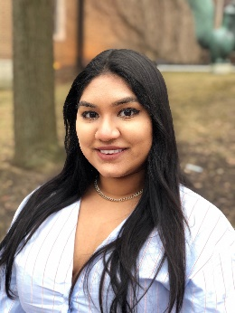
Selena Jodha
Selena Jodha works at CCRW, the only national charitable organization with the sole mission of employment for people with disabilities. At CCRW, she combines her expertise in academia with social services to appropriately serve the intersectional needs of the community. Based in Toronto, ON, Selena works with the CCRW team to navigate the relationship between job seekers who identify with disabilities and employers looking to increase their disability confidence and talent acquisition processes to hire diverse talent.
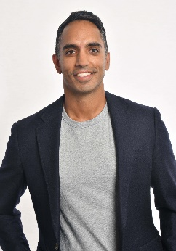
Arif Jetha
Dr. Arif Jetha is associate scientific director and scientist at the Institute for Work & Health. He is also an associate professor at the University of Toronto’s Dalla Lana School of Public Health. Dr. Jetha’s program of research aims at understanding how changes in the future of work affect the health and employment participation of vulnerable workers. He also leads research on the strategies to examine and support the employment inclusion of young workers with disabilities. He is currently the recipient of the Stars Career Development Salary Award from the Arthritis Society and holds grants from the Social Sciences and Humanities Research Council of Canada and New Frontiers in Research Fund.

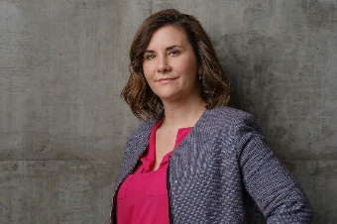
Colette Kaminsky
Colette Kaminsky is the Senior Assistant Deputy Minister of Skills and Employment Branch at Employment and Social Development Canada. Colette has an extensive background in public policy development, economic analysis, negotiations and program implementation, working both internationally and across Canada. Her key career accomplishments include: creating one of the government's largest investment funds for innovation and foreign direct investment, leading the negotiation of major FPT agreements and directing the economic analysis underpinning major international trade agreement negotiations. She has previously worked at Innovation, Science and Economic Development Canada, Agriculture and Agri-Food Canada, the Privy Council Office and Finance Canada. She holds a Masters in Economics from Queen's University and a Bachelors in Economics from the University of Saskatchewan.

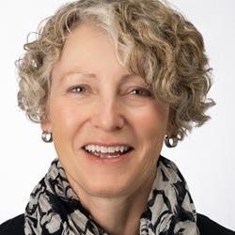
Karen Kelsey
Karen Kelsey is Lime Connect's Relationship Manager in Canada, where she is responsible for managing and building the corporate and post-secondary educational institution partnerships integral to the success of Lime Connect in the Canadian marketplace. Karen also focuses on attracting high-potential students and alumni to grow The Lime Network in Canada, and she acts as the lead and coordinator for the active Canadian volunteer base - Lime Connect Ambassadors. Ms. Kelsey brings many years of relationship management, human resources management and people management experience in the financial services sector to her role.

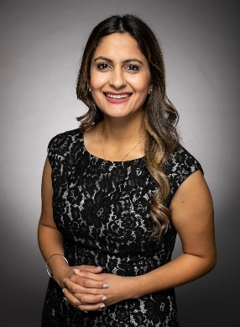
Hon. Kamal Khera
The Honourable Kamal Khera was first elected as the Member of Parliament for Brampton West in 2015. She has previously served as Minister of Seniors, as Parliamentary Secretary to the Minister of International Development, as Parliamentary Secretary to the Minister of National Revenue, and as Parliamentary Secretary to the Minister of Health.
Minister Khera is one of the youngest women ever elected to Parliament. A registered nurse, community volunteer, and political activist, she is passionate about improving the lives of those around her. Prior to entering politics, she worked as a registered nurse in the oncology unit at St. Joseph’s Health Centre in Toronto, where she gained a deeper understanding of the issues that impact people’s health and well-being every day. During the first wave of the COVID-19 pandemic, she went back to her roots as a registered nurse to volunteer at a hard-hit long-term care facility in her hometown of Brampton. Minister Khera continued to help on the front lines throughout the pandemic, including by administering vaccines in her community.
Truly believing that diversity is our strength, Minister Khera is motivated to create a better present and future for all Canadians.


Michelle Kovacevic
Michelle Kovacevic is the Senior Assistant Deputy Minister of Federal-Provincial Relations and Social Policy Branch at the Department of Finance. In this role she advises the Minister of Finance on a broad range of social policy issues including: health; labour; income security; Indigenous policy; diversity and inclusion; and culture. Michelle is a passionate advocate for Diversity and Inclusion who is keenly aware of diversity within disability. She has personally championed employment opportunities for two adults with intellectual disabilities within the Department of Finance and continues to challenge the Public Service to find work opportunities for those who face significant barriers to employment. In her spare time, Michelle is an avid athlete who uses sport as another way to give back to her community. She coaches competitive girls’ soccer teams and enjoys basketball, hiking and running. Once she takes her track shoes off, you’re most likely to find her enjoying a movie with some popcorn.
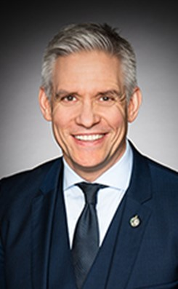
Hon. Mike Lake
Mike is the Member of Parliament for Edmonton-Wetaskiwin and was first elected in 2006. After his re-election in October 2008, he was appointed Parliamentary Secretary to the Minister of Industry, a position he held for seven years. On September 13, 2012, he was sworn into the Queen’s Privy Council, after being asked by Prime Minister Stephen Harper to serve on a Cabinet Committee tasked with efforts to balance the federal budget.
Mike has been elected six straight times and, in both 2019 and 2021, received the highest vote total out of all candidates, from all parties, across the country. In opposition, he has held three Shadow Minister positions: Youth, Sport and Accessibility; International Development; and Mental Health, Addictions and Suicide Prevention. Prior to entering federal politics, Mike worked for 10 years with the Edmonton Oilers Hockey Club where he served as National Accounts Manager, Director of Ticket Sales and Group Sales Manager. He holds a Bachelor of Commerce (with distinction) from the University of Alberta. Mike has two adult children, his son, Jaden, and daughter, Jenae. The Lakes have been active supporters of autism organizations, families and neurodiverse individuals across the country, and around the world, while sharing their story of life with Jaden, who has autism.


Brooke Leifso
Brooke Leifso is a Disabled/Crip applied researcher and social change facilitator. She brings many levels of lived experience to the NorQuest College Workplace Accessibility research chair position and uses an intersectional disability justice social model approach in her work. She has lived experience of disability and disability advocacy, facilitating support groups for parents with disabilities (Gateway Association), and adults with developmental disabilities to self-advocate and build community (Self Advocate Federation) and has worked for many years as a front-line Child and Youthcare Counsellor working with youth in government care with multiple diagnoses.

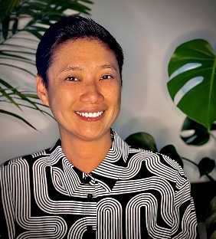
Winnie Luk
Winnie Luk is the inaugural Executive Director of the Disability Screen Office. The Disability Screen Office is a national, disability-led, not-for-profit organization that works with the Canadian screen industry to eliminate accessibility barriers and foster authentic and meaningful disability representation throughout the sector. Winnie is a disability advocate, 2SLGBTQI+ activist, and film industry leader with over 25 years of experience in the non-profit, film, entertainment, and public sectors. Among her numerous accomplishments, Winnie was the Director of Operations and Events at Inside Out, the presenter of the Toronto and Ottawa 2SLGBTQI+ Film Festivals. She was also the Managing Director of Rainbow Railroad, a charity which supports LGBTQI+ individuals seeking safe haven from around the globe. Additionally, Winnie is an Advisory Committee member for the Toronto Reel Asian International Film Festival and shareholder of the Glad Day Bookshop, the world’s oldest LGBTQI+ bookstore. Her lifelong encounters with mobility disabilities as well as her identities as a Chinese Queer Woman, fuel her passion for advocating for accessibility rights and fostering equity in communities.

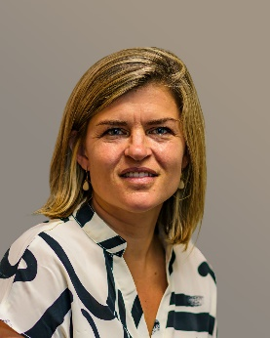
Sarah MacDonald
Sarah MacDonald is a professional dedicated to driving positive change in social enterprise and employment in the non-profit sector. As the Executive Project Manager at Community Living Toronto, she spearheads transformative initiatives focused on creating more opportunities for individuals with disabilities. With two decades of expertise in public policy, stakeholder relations, and campaign management, Sarah can skillfully maneuver through challenges to achieve concrete outcomes. Her parliamentary roles granted her insights into governance from both government and opposition perspectives. Sarah’s experience in the private sector, including roles at Hill & Knowlton, Agnico Eagle Mines, and Visa Canada, provided her with a comprehensive understanding of industry dynamics, corporate strategies, and effective stakeholder engagement. Sarah's earned a Bachelor of Arts from Houghton College. She resides in the Greater Toronto Area (GTA) with her husband and three children.


Rachel Maislin
Rachel Maislin is a Certified Vocational Rehabilitation Professional and Return to Work Disability Manager with the College of Vocational Rehabilitation professionals. She has a Master of Science in Rehabilitation Science from Queen’s University. She has diverse professional experience conducting vocational and return-to-work assessments, planning, and job coaching for various groups, including students, Veterans, and youth with disabilities. In her spare time, she enjoys live music, hiking travel, and volunteer work. Rachel is the lead coach of the Building Employment Pathways team of coaches.

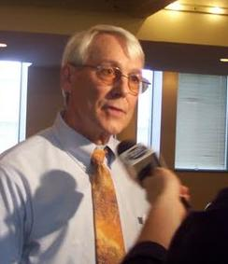
Steve Mantis
Steve was injured in an industrial accident in 1978 losing his left arm. He went through the W.C.B. system and saw first hand how it failed for many injured workers. In 1984, he helped found the Thunder Bay and District Injured Workers Support Group. He has been active ever since working to improve the lives of injured and disabled workers across Canada both through increasing the awareness of the barriers may disabled workers face and organizing self-help groups to address those barriers. He is presently the Chair of the Research Action Committee of the Ontario Network of Injured Workers Groups.

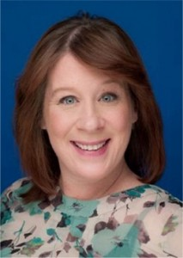
Sinead McCarthy
Sinead Mc Carthy is the VP of Development, Programs and HR at YES. Sinead joined YES in 1999. Sinead brings 35 years’ experience in the sector and a passion for helping youth. Sinead has developed many projects focused on labour market access for newcomers, youth and underrepresented people. Sinead is currently leading a Nation Employer focused project to advance the inclusion of persons who identify with a health issues into employment. As a newcomer to Canada (1999) Sinead understands the barriers they face trying to access good quality career related jobs.


Michelle McCaugherty
Michelle McCaugherty is a Project Coordinator with Independent Living Centre Kingston. Michelle has been working closely with women in the community for 10 years using a trauma informed approach. Using this approach, Michelle is an accomplished leader in the community providing support in diverse settings including transitional and supportive housing, correctional environments, in shelters, and through facilitating workshops and groups. It has been her passion that originated from her own lived experiences.
Michelle’s goal has always been to empower women. Supporting each woman through their own journey of healing, and personal growth at their own pace.
Michelle values the importance for women to support each other by working to lift each other up to be the best versions of themselves. She believes that when we provide knowledge in a compassionate way, it is then that healing can happen, and we become stronger together.

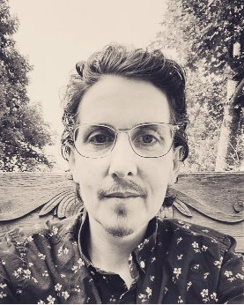
Amond McKenna
Amond McKenna is a tired Dad and a recluse cross-disability, anti-poverty, and mental health advocate who is flannel pant lounging at the intersection of multiply-disabled, autistic, trans, mad, and neuroqueer identities. Amond has been actively involved with community-based participatory action research and patient oriented research, suicide prevention, trauma relief art programs, and mutual aid efforts for over fifteen years. He is also an Employment Equity and Accessibility Strategist at the Finance and Treasury Board within the Government of New Brunswick, a role he occupies via virtual access, and on his own neurodivergent terms. Amond is committed to informing safer and more dignified processes, securing equitable structural changes, universally designing pathways to meaningful opportunities, building springboards for impacted leaders, as well as resourcing community-led initiatives that shift harmful disability narratives, promote a positive sense of Autistic and/or Disabled identity, and provide access to collective care. Amond believes in rest as resistance, but hasn't quite got the hang of that yet.

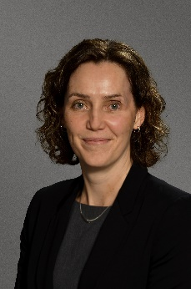
Tanya McLeod
Tanya McLeod is President of The Sinneave Family Foundation in Calgary, Alberta; an organization committed to coordinating and investing in a portfolio of purposeful initiatives and projects aimed at removing barriers and enhancing opportunities for autistic youth and adults to live, learn, work and thrive in their communities and realize their desired futures.

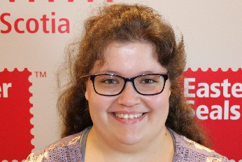
Heather McNamara
Heather McNamara was born and raised in Nova Scotia. She is a vibrant young woman active within Special Olympics for the last ten years competing in bowling, soccer, and golf. During her involvement at Club Inclusion, she has participated in many of their community involvement activities as well as their LIT program. Heather has successfully completed the Achieve Program through the Nova Scotia Community College and has accessed support through Easter Seals Nova Scotia and Autism Nova Scotia. She enjoys art, being social and involved in the community, music, and singing when no one is listening! Heather strives to be a positive role model within supported employment so others know that working can be fun, and maybe sometimes complicated, but that there is help when you need it and to not be afraid.

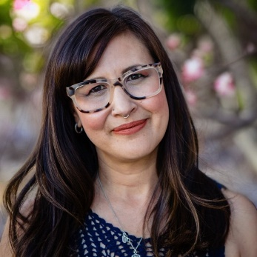
Jennifer Mei
Jennifer is a Registered Social Worker, Certified Career Practitioner and former post-secondary Faculty member with over a decade of experience academic and employment accessibility. She brings a wealth of personal and professional experience to her work and is passionate about creating safe, accessible and inclusive workplaces. As a bi-racial woman of colour, 1st generation Chinese Canadian on her dad’s side, diagnosed with adult ADHD, her approach is intersectional in nature and centres the lived experiences of the whole person. Jennifer holds a Master of Social Work degree from Wilfrid Laurier University and received an award for outstanding graduate work for her research on the mental health disclosure experiences of post-secondary students transitioning into a career environment.

Jamie Millar-Dixon
Jamie is the Principal of MacLeod Silver HR Business Partners based in Vancouver, BC and an Inclusive Workforce Consultant with BC Partners in Workforce Innovation. Now in it’s 8th year, BC WiN is a unique recruitment service that helps BC employers connect to the talent pool of people with disabilities/diverse abilities and it’s slated to scale from BC to ON next year. Jamie has an extensive Human Resources background of over 30 years, specializing in workforce diversity and inclusion, recruitment, training and HR start up. Her experience spans multiple industries. She has developed and delivered diversity training programs for both public and private sector employers. Recently, she co-authored Untapped Talent B2B Guide on Innovative Recruitment and Retention, a resource for employers on how to easily adapt each stage in the recruitment, onboarding and retention process to be able to hire more people with disabilities in their business. Jamie is also currently leading the development of recommendations to Accessibility Standards Canada on recruitment and retention standards to support the new Accessible Canada Act for federally regulated employers.

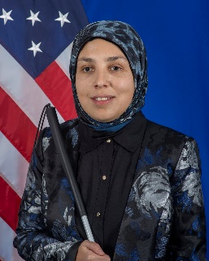
Sara Minkara
President Biden appointed Sara Minkara as the Special Advisor on International Disability Rights. In this role, Special Advisor Minkara leads the U.S. Department of State’s comprehensive strategy to promote and protect the rights of persons with disabilities internationally. Prior to joining the Department of State, she founded and served as CEO of Sara Minkara, LLC, which promotes authentic leadership and value-based inclusion. She also established Empowerment Through Integration (ETI), a nonprofit organization committed to developing a more inclusive global society and transforming social and cultural stigmas against disability. Special Advisor Minkara is a graduate of Wellesley College and Harvard University’s Kennedy School of Government. She has been recognized for her many contributions through appointments and awards, including honors from the Clinton Global Initiative, the Massachusetts Institute of Technology (MIT), Forbes 30 Under 30, Ashoka, Harvard, Halcyon, and the Vital Voices “100 Women Using Their Power to Empower” retrospective. Internationally, Special Advisor Minkara has promoted disability rights, diversity, access, and inclusion in a range of countries including Lebanon, Malaysia, Nicaragua, Rwanda, Thailand, and the United Kingdom. She speaks Arabic.
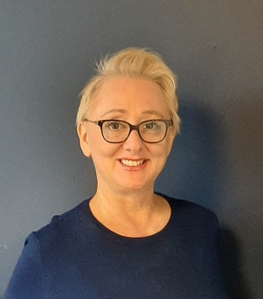
Dragana Mrdjenovic
Dragana is the project manager for Enabling Change program with Electricity Human Resources Canada; an organization that supports diversifying electricity industry across the country. Dragana holds a degree in Applied Linguistics, and she has over 15 years of experience in managing programs for integration of newcomers to Canada. She cares deeply about living and working in groups of people with different experiences and perspectives.


Sree Nallamothu
Sree is a passionate connector and storyteller, with extensive experience in relationship building, civic engagement and participatory filmmaking. She brings a long-standing commitment to social justice work, reflected in her collaborations with a broad range of organizations including Sakshi Human Rights Watch in India, the Arab Jewish Community Center in Jaffa, and the Community TV Network in Chicago. Her work at TNC focuses on supporting various advocacy campaigns, collaborations, and research in the areas of 2SLGBTQIA+ inclusion, Disability Justice, equity and belonging, and people-centred community development practices.

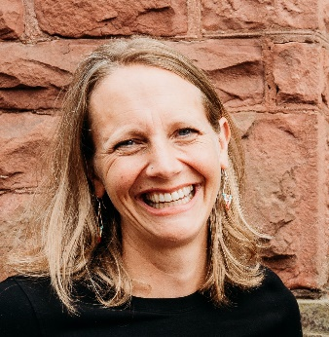
Anna Nelson
Anna Nelson is the Director of Employment Supports at LiveWorkPlay. Anna joined LiveWorkPlay in 2017 and, previously, worked in various leadership roles in the developmental services sector in Toronto, Ottawa, and Thunder Bay Ontario. She believes the most critical demonstration of inclusive employment progress is seeing more people with intellectual disabilities and autistic job seekers being hired for meaningful employment and seeing them develop within these jobs. Moving beyond awareness and into action drives her work every day. Mother of two active kids, Anna also loves to spend as much time in the woods as possible- x-country skiing, trail running, hiking, camping, canoeing, and exploring.

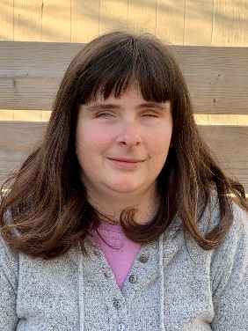
Katja Newman
Katja Newman (she/her/elle) is the National Educational Association of Disabled Students’ Financial Assistance Program Director and co-manager of the Building Employment Pathways project. A resident of Halifax Nova Scotia, she is a recent graduate of the online Masters in Grant Writing and Program Evaluation program at Concordia University Chicago. Prior to her Masters, Katja received a Bachelor's of Social Work from Carleton University and a Child & Youth Work Diploma from Georgian College. Outside of the classroom, she enjoys hiking, tandem bike riding, baking, cooking and educating audiences on the accessibility and inclusion related highs and lows that come with living life as a blind recent post-secondary student who navigates the world with the help of a guide dog
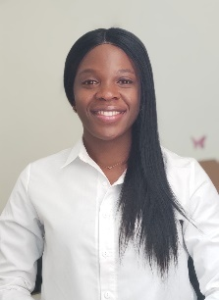
Tosin OmonyeOgedengbe
Tosin is passionate about improving the quality of life of individuals with disabilities, particularly those with vision loss. This drives her commitment to fostering sustainable accessibility and inclusivity practices across all societal levels. Currently serving as a Research Advisor at Wittich Vision Impairment Research Laboratory, Université de Montréal.
Her research work spans employment preparedness for people with vision loss, dual sensory impairment, and telerehabilitation. Her journey into disability stems from her international background as an Optometrist, which is a strong foundation for her work. She holds a Master degree in Vision Science from the Université de Montréal. Her academic journey has been marked with publications and significant recognition celebrating her commitment to research excellence, including the prestigious Mitacs Accelerate fellowship in collaboration with the Canadian National Institute for the Blind. Her research scholarship focused on inclusive design for employment access in Canada.

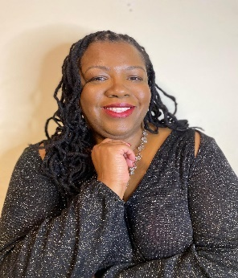
Ingrid Palmer
Ingrid Palmer is an award-winning speaker, bestselling author, and the IDEAL (Inclusion, Diversity, Equity, Accessibility, Leading to belonging) Chief Officer at Realize. As a visually impaired social justice advocate, Mrs. Palmer is committed to combating discrimination in all its forms, driving systemic change and debunking myths and stereotypes of stigmatized identities. Ingrid’s dedication is deeply rooted in her living experiences of foster care, disability, and gender-based violence.

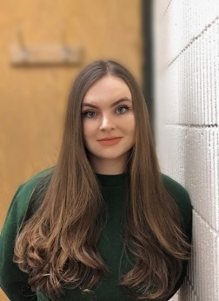
Sydney Penner
Sydney Penner is a Research Coordinator at the Work Wellness Institute. She holds a BA in Psychology from Simon Fraser University. Her research has focused on concurrent mental disorders and substance use, with an emphasis on sleep rhythms. She has coordinated psychiatric behavioral studies and clinical drug trials and has worked to implement patient-oriented perspectives and community-based knowledge translation into addictions research practices. Most recently, Sydney conducted a sleep study in a psychiatric in-patient population and founded a mental health knowledge translation podcast that was presented at the Michael Smith Foundation for Health Research Putting Patients First conference and featured by the Canadian Psychology Association.


Joëlle Perrier
Joëlle Perrier grew up in Northern Ontario and attended the University of Ottawa where she completed a Bachelor of Arts and a Bachelor of Education specializing in music education. Intertwined with her years of teaching, she acquired 10+ years of experience in the non-profit sector. She started volunteering with LiveWorkPlay in November 2013 and joined the employment team in June 2021. She strives to increase accessibility in the public sector and support her members to follow their chosen path to reach their full potential. On a personal note, she is a long-time cellist in Divertimento, a community-based orchestra, is an avid cat lover and lives with four lovely cats and her partner, Rob.

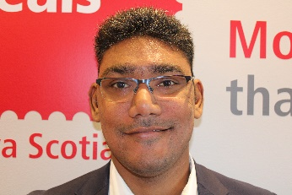
Darren Persaud
Darren Persaud lives and works in Halifax Nova Scotia. He has successfully completed his Construction Engineer Certificate at the College of Anguilla in Turks and Caicos Islands and has been supported with his employment goals in Halifax by both Building Futures and Easter Seals Nova Scotia. Darren is currently employed by Mr. Lube and Events East Group and is an incredibly dedicated employee. Darrens strong motivation is clear as he continually advocates for himself and others to live equitably not only within their careers, but in every aspect of their life.


Sheryl Peters
Sheryl is a Winnipeg-based social researcher, non-profit programs coordinator, and artist. She has experienced life-long invisible disabilities. Her previous work focused on social equity, a social justice approach to autism and disability, health and well-being of women and older adults, person-centred health care, and decolonizing/community-based approaches to research and community work. Sheryl’s creative projects include digital video and community arts - most notably digital storytelling projects with Autistic people, their families and educators, and Indigenous women and girls.

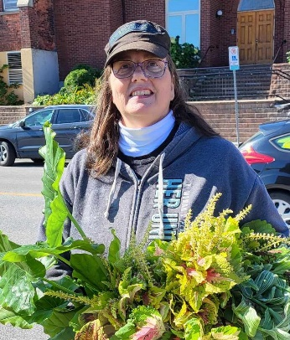
Arlene Phillips
Arlene Phillips is active in the Ontario Public Service Employees Union, currently on the Provincial Human Rights Committee for OPSEU Region Six, Vice President for local 669 and Facilitator for Anti-Black Racism. Former Treasurer for the North Bay and District Labour Council and active on the North Bay Waste Resources Committee. Last but not least, she is the VP of the Workers with Disabilities for the Canadian Labour Congress. Arlene was taken out of Special Education classes in Grade One, as she was functioning well enough to blend in with the regular part of the class. Arlene was officially labeled in Grade nine with learning differences. In grade ten, she was put into a special classes that helped her to identify and correct what was going on in her brain. She graduated Highschool with Honours, graduated from University of Toronto with a Bachelor of Arts, Sociology degree and earned a diploma in Alternate Dispute Resolution from Canadore College. An activist for learning differences (and other things) especially helping navigate her child through the public and post-secondary education systems.

Susan Pogue
Susan Pogue is a Career Counsellor at York University and provides individual career counselling services, webinars, and presentations, to York students and recent graduates who are seeking help with their academic and career exploration, and career transition planning. Susan earned a Master of Education (Counselling Psychology) degree from Western University and is a registered member with the College of Registered Psychotherapists of Ontario and the Canadian Counselling and Psychotherapy Association. Susan’s approach to career counselling is based on Narrative Therapy and her areas of interest include supporting students with disabilities transitioning from school to work, helping mature students achieve their academic and career goals, and supporting graduate, and PhD students exploring careers outside of academia.


Elisha Ram
Elisha Ram was appointed Senior Assistant Deputy Minister (SADM) of Employment and Social Development Canada’s (ESDC) Income Security and Social Development Branch (ISSD) and Policy Horizons Canada on January 18, 2023. Elisha has been working in the Public Service of Canada for over 25 years. He joined ESDC in 2018 where he served as Associate Assistant Deputy Minister (AADM) of the Skills and Employment Branch and then as AADM of the Strategic and Service Policy Branch.
Elisha has been fortunate to have worked on a variety of challenging economic and fiscal policy files throughout his career. Particularly, he provided exceptional leadership throughout the pandemic in developing and implementing critical income support programs for Canadians, such as the Canada Emergency Response Benefit (CERB) and the Canada Recovery Benefit, as well as new flexibilities in the Employment Insurance program.
Prior to joining ESDC, Elisha worked at the Department of Finance Canada, where he provided policy advice on a wide range of issues including personal income tax policy, fiscal policy, research and innovation, natural resources and the environment, risk capital, the public debt program, and the housing finance system.
Elisha holds a Masters’ degree in economics from Western University. Outside of his professional life, Elisha has a deep interest in housing issues and has worked with local not-for-profit organizations to help increase access to affordable housing in the Ottawa area.
Elisha Ram a été nommé sous-ministre adjoint principal (SMAP) de la Direction générale de la sécurité du revenu et du développement social (DGSRDS) et Horizons politiques Canada d'Emploi et Développement social Canada (EDSC) le 18 janvier 2023. Elisha travaille dans la fonction publique du Canada depuis plus de 25 ans. Il a rejoint EDSC en 2018 où il a occupé le poste de sous-ministre adjoint délégué (SMAD) à la Direction générale des compétences et de l'emploi, puis le poste de SMAD à la Direction générale des politiques stratégiques et de service.
Elisha a eu la chance de travailler sur divers dossiers complexes en matière de politiques économiques et fiscales au cours de sa carrière. Il a notamment fait preuve d’un leadership exceptionnel pendant la pandémie dans l’élaboration et la mise en œuvre de programmes primordiaux de soutien au revenu pour les Canadiens, comme la Prestation canadienne d’urgence (PCU) et la Prestation canadienne de la relance économique, de même que dans l’instauration de mesures assouplies dans le Régime d’assurance-emploi.
Avant de rejoindre EDSC, Elisha a travaillé au ministère des Finances du Canada, où il a fourni des conseils en matière de politique sur un large éventail de questions, notamment la politique de l'impôt sur le revenu des particuliers, la politique fiscale, la recherche et l'innovation, les ressources naturelles et l'environnement, le capital de risque, le programme de la dette publique, et le système de financement de l'habitation.
Elisha est titulaire d'une maîtrise en économie de l'Université Western. En dehors de sa vie professionnelle, Elisha a un intérêt profond pour les enjeux liés au logement et a travaillé avec des organismes à but non lucratif locaux pour aider à accroître l'accès à des logements abordables dans la région d'Ottawa.

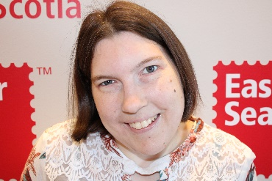
Christine Riley
Christine Riley grew up in Halifax Nova Scotia. She successfully completed the Achieve Program through the Nova Scotia Community College, LIT training at Club Inclusion, and employment workshops through Reachability and Easter Seals Nova Scotia. At The New Leaf Reverse Job Fair in 2021 she connected with Delectable Desserts, a local bakery in Dartmouth Nova Scotia, and she has been working there ever since. This was a great match as she loves to bake and continues to refine her skills. Christine has a very active life participating in sport, recreation, employment, and spending time with family and friends. She wants to share her story in hopes that it will help others who have disabilities find meaningful employment. “Always believe in yourself and have a great attitude about it.”

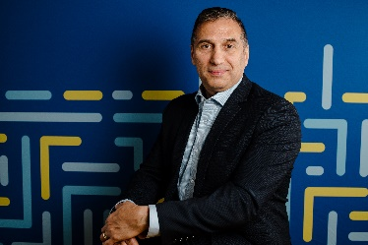
Philip Rizcallah
Since 2019, Philip Rizcallah is the Chief Executive Officer and Deputy Minister of Accessibility Standards Canada. Throughout this time, he has led this departmental corporation in setting initial policy, governance, and accreditation of the organization. He has also spearheaded the development of several accessibility standards to deliver on its mandate to help achieve a barrier free Canada by 2040.
Between 2014 and 2019, Mr. Rizcallah led teams at the National Research Council of Canada as Program Director, and prior to that spent 15 years as Manger then Director for the Building Regulations Resource Unit. His main responsibilities included Codes Canada, which covers accessibility requirements for buildings.
Known for his ability to effectively and efficiently manage programs involving multidisciplinary teams, Mr. Rizcallah has led strategic project proposals, secured financial commitments and built teams to execute these projects. He has developed and leveraged client relationships with many strategic government and construction industry partners including Canadian accessibility groups.
Between 2010 and 2018, Mr. Rizcallah was a key player with the Regulatory Reconciliation Cooperation Table (RCT), and federal representative with the Federal Provincial Territorial Working Group. While in this role, he worked to align National Codes in the country, introduce freely accessible codes and contributed to the development of the ongoing RCT Agreement, which will be key in harmonizing accessibility requirements across Canada. A registered Professional Engineer in the province of Ontario, Mr. Rizcallah holds a Bachelor of Mechanical Engineering (Technical University of Nova Scotia) and a Bachelor of Science, Honours Mathematics (Dalhousie University).

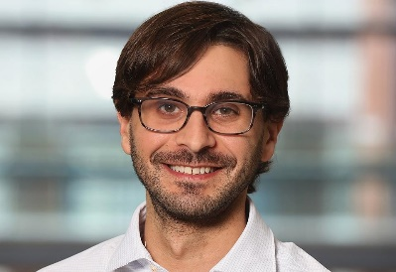
Dan Samosh
Dan Samosh is an Assistant Professor of Employment Relations at Queen’s University. His research is focused on the career success and work experiences of persons with disabilities, including three foci: 1) leadership emergence of persons with disabilities, 2) disability stigma and social identity, and 3) workplace inclusion of persons with disabilities. Dan applies a multi-method approach in his work, using both qualitative and quantitative methods. His research is applied, with practical implications for individuals, organizations, and policymakers.

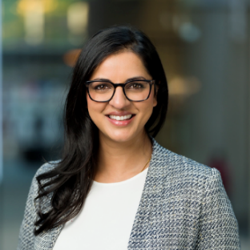
Shilpa R. Sharma
Shilpa is Senior Manager of Corporate Innovation at MaRS where she leads national Innovation Challenges, helping Canadian companies attract and reward impactful solutions for society's most pressing problems. She brings 16+ years global experience in equity and social impact working as a researcher, educator, program strategist and innovation consultant. Shilpa has a PhD in Education, advancing values-based systems.

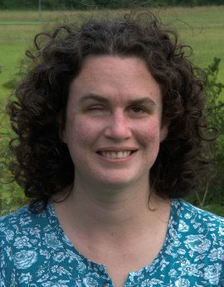
Ashley Shaw
Ashley Shaw is a Masters student in the Community Psychology program at Wilfrid Laurier University. The Social Science and Humanities Research Council awarded her a Masters scholarship to study workplace inclusion and accessibility, as well as employment-related interventions for adults who are blind and visually impaired. She is also a recipient of the Ontario Graduate Scholarship. She has worked as a Strategic Writer and Research Associate with the Canadian National Institute for the Blind (CNIB), and as the Wilfrid Laurier University Library Web Accessibility Advisor. Ashley currently works as the Clinical Performance and Evaluation Analyst for Vision Loss Rehabilitation Canada

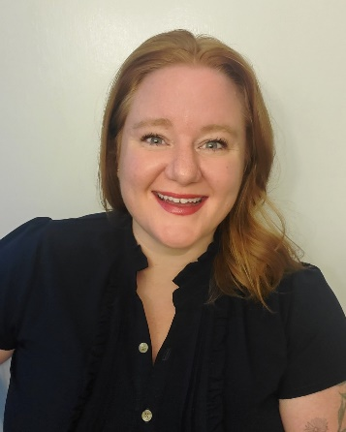
Mélanie Stafford
Mélanie Stafford (MSW, RSW) is the National Representative for the Harassment and Violence Initiative of the Human Rights Department for the Canadian Labour Congress (CLC). She comes to this work as a community activist and organizer- along with having served as Board President for la Maison d’amitié, Ontario’s largest francophone women’s shelter, Mélanie co-founded Overdose Prevention Ottawa, the city’s first unsanctioned safe consumption site.
In 2020, Mélanie was awarded United Way’s Community Builder Award for the mutual aid work she coordinated during the pandemic. Her work is informed by her experiences of living with invisible disabilities and is shaped by liberation and Indigenization movements.

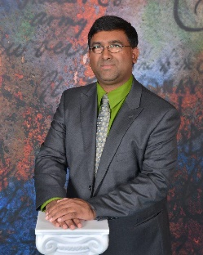
Mahadeo Sukhai
Dr. Mahadeo Sukhai is the world’s first congenitally blind biomedical research scientist. Mahadeo is the Head of Research and Chief Accessibility Officer for the CNIB (Canadian National Institute for the Blind), having previously served as a research scientist at the University Health Network in Toronto. Dr. Sukhai is the Principal Investigator for and co-author of "Creating a Culture of Accessibility in the Sciences," a book based on his groundbreaking work on access to science within higher education, and serves as the principal investigator for national projects to understand the student experience for persons with disabilities, and to examine accessibility and inclusion within science education and healthcare.

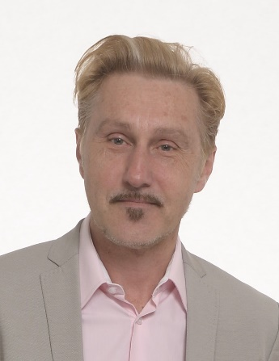
Emile Tompa
Dr. Emile Tompa is a senior scientist at the Institute for Work & Health. He holds appointments as an associate professor in the Department of Economics at McMaster University and as an assistant professor at the Dalla Lana School of Public Health at the University of Toronto. He is also director of the Centre for Research on Work Disability Policy, a seven-year initiative funded by a Social Sciences and Humanities Research Council Partnership Grant. Tompa is a labour and health economist with an MBA from the University of British Columbia, an MA in economics from the University of Toronto, and a PhD in economics from McMaster University. Tompa’s research interests include the consequences of occupational health and safety system design on the health and well-being of individuals and populations, the economic evaluation of workplace interventions for improving the health and well-being of workers, the economic burden of adverse health conditions and disability, and the analysis of disability policy systems.

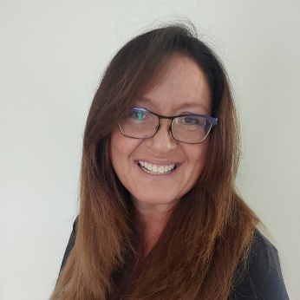
Valerie Vanderwyk

Working with the Aboriginal Apprenticeship Board, Valerie was brought on to the team as a Community Engagement Coordinator to assist with the organization’s national expansion to the provinces of British Columbia, Alberta, Saskatchewan and New Brunswick. Engaged in ensuring that Indigenous youth and their communities received equitable consideration for education and employment opportunities in apprenticeship, Valerie coordinates with stakeholders for the inclusion of Indigenous people with partners. With a deep passion for Occupational Health and Safety, Valerie is a Training Services Representative with the province of Ontario’s designated training centre – Workers Health and Safety Centre. This work is fundamental in ensuring safety for workers through meaningful training and a fundamental understanding of compliance with legislation and regulations across all sectors. Valerie is also the Indigenous Outreach and Training Liaison for the Centre. Recently, Valerie was named Chair of the Technical Committee with the Canadian Standard Association (CSA) for the development of a national standard in Equity, Diversity, Inclusion and Accessibility in Apprentice Programs.
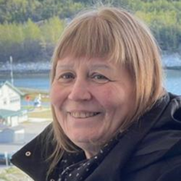
Heather Walkus
Heather Walkus is honoured to be the National Chairperson of the Council of Canadians with Disabilities (CCD) The only National Human Rights Disability Organization run by people and Organizations representing intersectional and cross disability issues for over 46 years. A Community Developer, Organizer, and Social Justice Activist with over 5 decades of experience working in social justice intersecting with identity and cross-disability Human Rights issues both in Canada and Internationally. Heather has over 30 years background in using Universal and Accessible Design, including how accessible design translates into organizational design and personal development in decolonization. Heather uses story telling in trauma informed work and has worked using sports to design disability and culturally appropriate programs and games that are geared to reducing trauma and build self-confidence within children, young adults, and families worldwide. Heather’s two favorite quotes: “Freeing yourself was one thing, claiming ownership of that freed self was another.” - Toni Morrison “If changing the world is not joyful, why bother.” - Heather Walkus

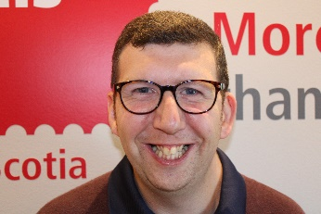
Matt Walsh
Matt Walsh has participated in the Special Olympics for seventeen years in a variety of different sports such as floor hockey, basketball, track, soccer, and skating. He is currently employed with Mastermind Toys. He has found that surrounding himself with Special Olympics Coaches, Job Coaches, friends, and family has been very inspiring in helping him reach his goals. Matt thinks it is important for other Canadians to learn about The New Leaf Reverse Job Fair and understand the push for equality within employment. His favourite quote is “If you can dream it, you can do it” – Walt Disney. I dream of an inclusive world, and I am doing my part to make it happen. Inclusion means that everyone has their own place in the world and can take part in the same activities as everyone else.

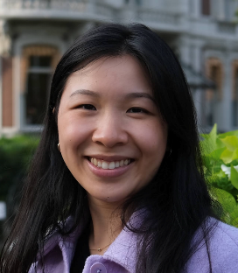
Sunny Wang
Sunny first joined Realize in 2018 as a student working in the HIV and Aging Program. From there, she found her calling in public health work, particularly in improving health services access through education, community-based programming and research, and policy change. She has experience working in non-profit, research, and education. Sunny is especially passionate about youth mental health and sexual health. She holds a Master of Public Health in Health Services from the University of Washington.


Keenan Wellar
Keenan Wellar has served as Co-Leader and Director of Communications for charitable organization LiveWorkPlay since 1997. LiveWorkPlay has earned numerous accolades, including Ottawa Board of Trade’s Best Non-Profit of 2019. Keenan has a Master’s in Applied Linguistics also holds degrees in History and Education with Ontario Teacher Certification. Keenan engages in a variety of advocacy initiatives related to community inclusion, housing, and employment. He enjoys kayaking and nature photography as well as the local music scene and sports. He serves as LiveWorkPlay events host as well as media spokesperson, with more than 200 radio, TV, and print appearances.


Scott White
Scott is a survivor of the LGBT Purge and a Veteran of the Canadian Armed Forces. He is currently a doctoral candidate in the Critical Disability Studies Program at York University, and graduate of the OISE/UofT Department of Applied Psychology and Human Development. Scott’s employment history is as a licensed Psychotherapist and Certified Teacher in the Province of Ontario. His research interest is in the area of Workplace Equity. He is currently working on a project called WorkABILITY, which is focused understanding employee retention and career advancement related to accessibility standards.

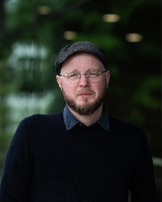
Evan Wicklund
Evan Wicklund is a Senior Research Officer and the Manitoba Office Lead at the Canadian Centre on Disability Studies (o/a Eviance) and a former Instructor in the Disability and Community Support Program at Red River College. Evan has over ten years of experience working in the disability field in a variety of capacities, including research, advocacy, education, employment, and community living. He is currently a Vanier Scholar and PhD student in Sociology at Carleton University.
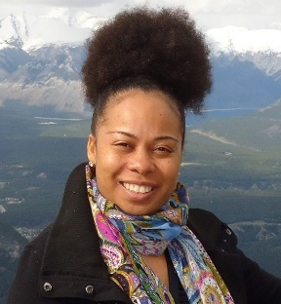
Tammy C. Yates-Rajaduray
Tammy C. Yates-Rajaduray is the Executive Director of Realize, which hosts the Secretariat of the National Episodic Disabilities Forum. In 2015, Tammy became the first black female Executive Director of a national organization in Canada’s HIV response, as well as among Canada’s national disability organizations. Tammy is currently the Chair of the National Advocates Group in Canada's HIV response, Co-Chair of the National Guiding Circle - HIV, Disability and Deaf Communities and serves as a member of the Government of Canada's CPP-D Client and Stakeholder Roundtable, the Canadian Feminist Disability Coalition, the Advisory Council for the Law, Disability and Social Change Project at the University of Windsor and serves as a Steering Committee Member for the Pan-Canadian Disability Coalition. She has worked for over 16 years in the field of program management. Prior to joining Realize, Tammy was the National Program Manager of the United Nations Population Fund (UNFPA) Trinidad & Tobago Branch Office. She has extensive experience in Gender & Development and Sexual & Reproductive Health, including HIV/AIDS, having worked previously as a Program Officer with the Secretariat of the Caribbean Regional Network of Persons Living With HIV (CRN+) and serving as Chair of the Gender Theme Group of the United Nations System in Trinidad & Tobago. She is a graduate of Wolfson College, Cambridge University, England and the University of the West Indies, St. Augustine, Trinidad.

