Disability & Work in Canada 2021 conference
Biographies of Speakers and Panel Participants


Kate Brown (McMaster University) is currently the Accessibility Program Manager within the Equity and Inclusion Office at McMaster University. Since 2017, she has combined professional and scholarly approaches to translating Accessibility for Ontarians with Disabilities Act (2005) legislation into university culture, underpinning this work with an intentional focus on disability inclusion and co-design approaches with communities of students, staff, and faculty with disabilities. Kate has a passion for creating meaningful work and study opportunities for and with students with disabilities, and as such, created an inaugural User Testing for Web Accessibility pilot in 2020, developed from previous student-partner research and with funding from the Career Access Professional Services Program at McMaster University. This pilot focuses on recruiting, training and working with Disabled students who use assistive technologies, to engage in quality assurance processes for web accessibility at the university.


Shelley Fletcher (People First of Canada) [no bio]

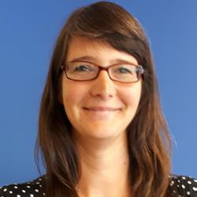
Dr. Helen Anderson (Arthritis Society) is Director of Information and Support at the Arthritis Society. She oversees the development, implementation and evaluation of educational resources and tools to support people living with arthritis. Helen holds a PhD in Theory and Policy Studies in Education from the University of Toronto, with a focus on anti-discrimination education. In previous roles, Helen has worked collaboratively to remove barriers and improve access for persons with disabilities as Manager of Global Citizenship, Equity and Inclusion Programs at Centennial College and as Manager of Adult Education, Curriculum and Research at the equity education non-profit Harmony Movement.


Anna Paz Arellano (Canadian Council on Rehabilitation and Work) has worked with CCRW’s Youth the Future program in Montréal since 2018. Her background in education and social work, in combination with her upbringing as a minority person of colour and resident/immigrant in different countries guides her way of connecting with the world and those around her. She is passionate about education (including her own), supporting and encouraging those who are marginalized, and the simple power of kindness. She is honored to work with the wonderful, capable youth who participate in the YTF program!

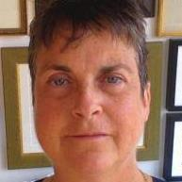
Chloë Atkins (The PROUD Project, University of Toronto) is the primary investigator of the PROUD Project. Dr. Atkins has research interests in disability, bioethics, vulnerable minority identities, human rights, phenomenological research and narrative scholarship. Atkins holds a PhD in Political Science (Political Theory) and a postdoctorate from Cornell University Law School in feminist legal jurisprudence. Atkins is the author of My Imaginary Illness (Cornell 2010), awarded 3 prizes including The American Journal of Nursing’s Book of The Year (2011).

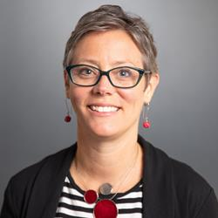
Stephanie Austin (Office of Public Service Accessibility) has been working in the federal public service since 2006 in a variety of social policy roles. She has a PhD in psychology and has worked in community settings to advance equity in health. Since 2018, Stephanie has worked in the Office of Public Service Accessibility in the Treasury Board of Canada Secretariat. She has built a dynamic team of employees with lived experience of disability who have led the co-development and implementation of Nothing Without Us: An Accessibility Strategy for the Public Service of Canada.

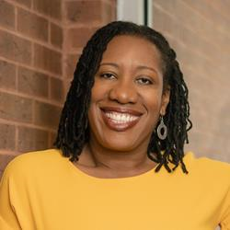
Amuna Baraka-Clarke (LOFT Community Services) is passionate about access. She has spent three decades in the not-for-profit sector strengthening systems and dismantling barriers in organizations. As the Sr. Director, People & Culture at LOFT Community Services she sees the support of inclusive, healthy and equitable communities as an essential component of achieving our mission and intended impacts. Amuna holds a Masters degree in Public Policy, Administration and Law, as well as CHRL and Prosci Change Management certifications. And, she believes that we should all use our powers for good.

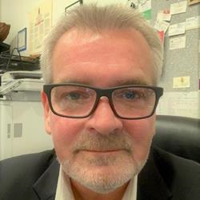
Neil Belanger (B.C. Aboriginal Network on Disability Society) has over 30 years of experience working within in Canada’s Indigenous and non-Indigenous disability and health sectors. For the past ten years, Neil has been the Executive Director of the British Columbia Aboriginal Network on Disability Society or BCANDS, an Indigenous disability organization holding Special Consultative Status with the United Nations. BCANDS provides a variety of programs and services relating to Indigenous disability across Canada. BCANDS work has been highlighted through numerous provincial, national and international awards and recognition, the most recent being the Zero Project International Award presented to the Society in Vienna, Austria, in 2019. In addition to his work at BCANDS, Neil serves in a variety of disability related advisory roles.

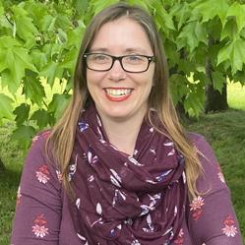
Tammy Bernasky (Canadian Centre on Disability Studies, operating as Eviance) holds a PhD in Critical Disability Studies from York University, specializing in gender-based violence in the disability community. Recognizing the intersectional nature of oppression, she is committed to qualitative research practices that center the voices of people with disabilities.

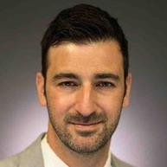
Francis Bilodeau (Government of Canada) is Senior Assistant Deputy Minister, Strategy and Innovation Policy Sector, at the department of Innovation, Science and Economic Development Canada (ISED). Prior to joining ISED, Francis held several senior positions in the Government of Canada, including servings as the Government of Canada’s Chief Information Officer of Canada, the Assistant Secretary of Digital Policy and Services at the Treasury Board Secretariat, and the founding Assistant Deputy Minister for the Privy Council Office’s Results and Delivery Unit. Francis has also previously held positions at the Treasury Board Secretariat, where he was Executive Director in the Government Operations Sector, and Infrastructure Canada, where he held various executive positions and helped lead the development and implementation of multiple generations of federal infrastructure programming. Francis holds a degree in mechanical engineering as well as a master’s degree in business administration.
Francis Bilodeau est sous-ministre adjoint principal, Secteur de la stratégie et de la politique d'innovation, au ministère de l'Innovation, de la Science et du Développement économique du Canada (ISDE). Avant de se joindre à ISDE, Francis a occupé plusieurs postes de haut niveau au sein du gouvernement du Canada, notamment celui de dirigeant principal de l'information du gouvernement du Canada, de secrétaire adjoint de la Politique et des services numériques au Secrétariat du Conseil du Trésor et de sous-ministre adjoint fondateur de l'Unité des résultats et de la prestation du Bureau du Conseil privé. Il a également déjà travaillé pour le Secrétariat du Conseil du Trésor, où il était directeur exécutif du Secteur des opérations gouvernementales, et pour Infrastructure Canada, où il a occupé divers postes de direction et aidé à diriger l’élaboration et la mise en œuvre de plusieurs générations de programmation d’infrastructure fédéraux. M. Bilodeau est titulaire d’un diplôme en génie mécanique et d’une maîtrise en administration des affaires.

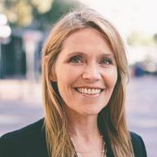
Jenny Blome (Rick Hansen Foundation) has over a decade of experience in project management and UI design with innovative companies such as Apple. Working as the director of the built environment for the Rick Hansen Foundation, she was the architect of the RHF Accessibility Certification Rating Survey. Jenny now works with large private and government organizations to develop corporate accessibility standards, to assess and rate the current accessibility of facilities, and to follow best practice accessibility standards for all new construction projects. Past projects include organizations such as Sunnyhill Children’s Health Centre, National Capital Commission, Canadian Museum of Science and Technology, CN Tower, Concert Properties, Colliers International, University of Toronto, Infrastructure Ontario, Vancouver International Airport, BC Parks, Canadian Border Security Agency, Canada Post and Government of Canada Public Works. Her qualifications include a Bachelor of Science in Business Administration, University of Colorado, and Certification in Universal Design, University of Buffalo.

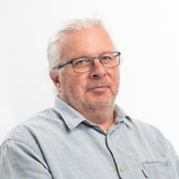
Normand Boucher (Centre interdisciplinaire de recherche en réadaptation et intégration sociale (CIRRIS)/Université Laval) est politologue et sociologue et ses intérêts touchent la problématique de la recherche participative dans l’analyse des transformations des pratiques et des politiques entourant le phénomène du handicap et la citoyenneté. Ses travaux ont porté sur la problématique du travail et l’emploi ainsi que le développement de politiques publiques à même de soutenir les personnes ayant des incapacités.

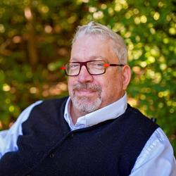
Max Brault (BDO Canada & Every Canadian Counts) has recently joined BDO, where he will be leading consulting on matters pertaining to accessibility. He has guided the federal government towards their most ambitious legislation towards persons with disabilities, The Accessible Canada Act. Max is not afraid to challenge the norm and push boundaries to make positive changes for the community. As the Vice President of the Strategy & Operations Practice Group, he has progressive ambitions to identify accessibility issues in Canada, for corporations, governments, and non-governmental agencies, and to provide strategic solutions to address them

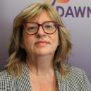
Bonnie Brayton (DAWN-RAFH Canada) is the National Executive Director of the DisAbled Women’s Network (DAWN), who recently celebrated 35 years in service Bonnie is a recognized leader in both the feminist and disability movements in Canada and internationally. Ms. Brayton is also a founding member of the Ending Violence Association of Canada and served on the Steering Committee of La Maison Parent-Roback, from 2008-15. Ms. Brayton serves on the Advisory Committee for the Jarislowsky Chair in Families and Work at Live Work Well Research Centre at the University of Guelph. She is also the Partner Liaison for a seven-year initiative based at the University of Guelph called “Engendering Disability-Inclusive Development” (EDID). From 2016 to 2021, Ms. Brayton served as a member of the Federal Minister’s Advisory Council on Gender-Based Violence (WAGE). During 2020 and 2021, Ms. Brayton also served Disability Advisory Group the DAG for Minister Carla Qualtrough.
Bonnie has also contributed to several anthologies including A BOLD VISION and LIVING THE EDGES, a DisAbled Women’s Reader and the newest release (2021) from Inanna publications STILL LIVING THE EDGES.

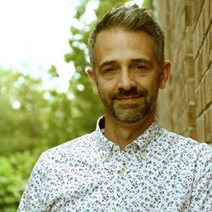
Jason Brommet (Microsoft) Today, people are an organization’s most important asset. Empowering each of them and their organizations to be their best and bring their best is more critical than ever. The modern workplace is an inclusive, creative and culture-centric environment. As the Lead of the Modern Work and Security business in Canada, Jason (Jay) leads the team that is responsible for enabling organizations to amplify the ingenuity of their people with secure, collaborative platforms and tools that accelerate business growth and success. Within the Modern Work portfolio, Jay oversees productivity platforms such as Microsoft Teams; Employee Experience Platforms including Microsoft Viva; alongside Microsoft’s market-leading security and compliance tools. Jay’s work frequently involves detailing the future of the workplace, including culture development, prioritization of people, employee wellbeing and the innovative use of technology. The Modern Work team also works with and across Microsoft’s sales and delivery teams, and their market-leading ecosystem of partners. Jay is also an advocate for technology enabling inclusivity and accessibility, and leads Microsoft Canada’s Commercial Accessibility Initiative.
Previously, Jay led Commercial Channel Strategy and Programs in Canada, working across their ecosystem of over 14,000 partners to build the capacity, capability and growth of the Microsoft Channel, to enable organizations of all sizes to drive digital transformation. Broadly, he and his team were responsible for delivering on Microsoft’s promise of partnership, stewarding the Microsoft Partner Network.
Since joining Microsoft in 2003, Jay has held a variety of roles spanning Product Marketing, Business Development, Segment Marketing and Sales Leadership. Before joining the Microsoft Canada team, he worked in the marketing services industry, developing and leading teams delivering strategic sales and marketing programs in B2C and B2B environments, across diverse industry verticals such as publishing, telecommunications and technology.

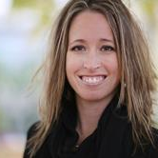
Dr. Alexis Buettgen (McMaster University) is an experienced community-engaged scholar with over 15 years of experience in community-based participatory research and evaluation as a Senior Researcher at several community-based research organizations and organizations of people with disabilities (OPDs). Prior to this, Dr. Buettgen worked in a variety of community settings providing direct support to individuals with various experiences of oppression and marginalization, including people with various disabilities. These community experiences have informed her research program to critically examine various ways of knowing, subjective well-being, and intersectional approaches to promote equity, and social and environmental justice. She is dedicated to participatory and collaborative research examining the influence of economic and political environments on the progressive realization of disability rights. Her work connects the local with the global through fieldwork carried out at local, national, regional and international levels.

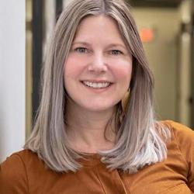
Renate Burwash (Gateway Association) is the Director of Diversity & Inclusion Consulting at Gateway Association. With over 20 years of workplace and community inclusion experience, Renate leads Gateway’s supported employment program which she co-created to support jobseekers living with disabilities and mental health barriers. Renate promotes inclusivity in every aspect and by having a deep appreciation of cultural, generational, racial, religious, socioeconomic, disability, gender expressive, and educational diversity that influence workplace culture and success. Her practice is informed by over 20 years of collaborating with small to large size employers, community groups, government, and people who live with barriers to employment, to continually look for, and develop innovative approaches to inclusion. She brings a deep understanding of the barriers to workplace inclusion and inclusive cultures from both the employer and service seekers’ perspectives and has developed solutions to help employers to get beyond them.

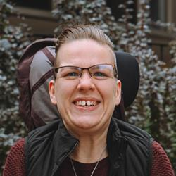
Chloée C. Godin-Jacques (Eviance) is a white settler doctoral student at Western University's Faculty of Education and a Research Associate with Eviance. She is a disabled activist, community-based researcher, and social entrepreneur. Chloée's research interests lie at the intersections of activism, disability, and sexuality.

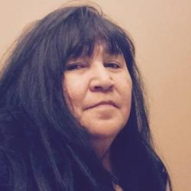
Laura Calmwind (Traditional Knowledge Keeper and Practitioner) is a member of Kitchernuhamykoosib Inninuwug (KI). She is the proud mother of five children and grandmother to eight grandchildren. Laura is fluent in her Indigenous language Anishnabemowin and is a certified native language instructor. She’s been teaching Indigenous language for more than 8 years.
Laura has worked with First Nation for over 30 years in various capacities. As an Indigenous Knowledge Keeper and practitioner, Laura has received knowledge and instruction from Elders and Knowledge Keepers in a variety of traditional areas and is committed to pass the knowledge to interested peoples.
Laura is a graduate of Lakehead University and is currently working on the design and delivery of training programs for Indigenous Peoples that are rooted in Indigenous Knowledge, Land Based Learning and Western Education and Training methodologies.

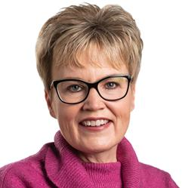
Krista Carr (Inclusion Canada) is a long-time advocate in the inclusion movement. She is the Executive Vice President (CEO) of Inclusion Canada, one of Canada’s 10 largest charitable organizations. Inclusion Canada is a national federation of 300 local and 13 Provincial/Territorial Associations working on behalf of approximately 1 million Canadians with a developmental disability and their families.
Krista has over 25 years of experience in the non-profit sector as a champion of inclusion. Before joining Inclusion Canada, she was the Executive Director of the New Brunswick Association for Community Living (NBACL), a leading provincial non-profit organization that works with people with an intellectual disability and their families to accomplish the mission of full inclusion across the lifespan.
In her current role, Krista is responsible for leading the Inclusion Canada National organization, the Inclusion Canada Foundation, Inclusive Education Canada (IEC).
In addition to her extensive work portfolio, Krista sits on a number of provincial and national disability-related boards and committees. This includes the COVID Disability Advisory Group (CDAG), chaired by the honourable Carla Qualtrough, Minister of Employment and Disability Inclusion. Krista offers a unique perspective on disability-related supports and services, both nationally and internationally.
Krista is a graduate of the University of New Brunswick (UNB) where she earned a Bachelor’s in Business Administration (BBA) and several diplomas in Human Resources and Management from UNB’s College of Extended Learning. She is fluently bilingual and works on behalf of CACL’s federation in both French and English. She currently resides in New Brunswick with her husband and two daughters.

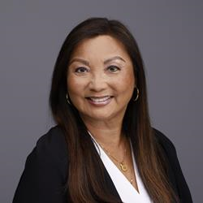
Lily Chang (Canadian Labour Congress) was elected Secretary-Treasurer of the Canadian Labour Congress (CLC) at the 29th Constitutional Convention in 2021. Prior to this, Lily worked as Treasurer and elected officer for CUPE Local 79 for almost two decades. She is the first worker of East Asian descent elected to office in Canada’s largest central labour body.
As CLC’s Secretary-Treasurer, Lily oversees the organization’s finances. She has also been tasked with guiding the work of the Human Rights Department (including Indigenous and Disability Rights working groups), and representing the CLC at the International Labour Organization.

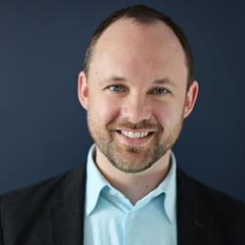
Mark Chapeskie (Electricity Human Resources Canada) As Vice President of Program Development, Mark leads the project and program delivery teams at Electricity Human Resources Canada. Mark has managed research and programs to transfer skills from regulated occupations into unregulated occupations while minimizing jobseeker retraining. Mark has also worked in the international development field in sub-Saharan Africa where he focused on local economic development initiatives and judicial reform. In his spare time, Mark volunteers with organizations such as the Canadian Academy of Health Sciences, QuickStart Autism and Chairs the Autism Family Advisory Committee at the Children’s Hospital of Eastern Ontario.

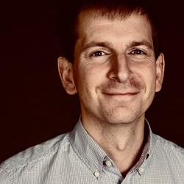
Jonathan Chapnick (Portage Legal Services) (he/him) is a workplace lawyer and chartered human resources professional (CPHR). Before starting his own law practice, he worked for unions and employers in Ontario and BC for 15 years, including as legal counsel for the Hospital Employees' Union, Senior Advisor – Workplace Mental Health at the University of British Columbia, and Director of Human Resources and Labour Relations at RainCity Housing and Support Society. In addition to his law practice, Jon is a member of the BC Employment Standards Tribunal and BC’s Patient Care Quality Review Board. He’s also on the roster of Harassment and Violence Prevention Investigators established by the Canadian government to investigate occurrences of harassment and violence in federally-regulated workplaces. His areas of expertise include workplace mental health and substance use, disability-related workplace accommodation, and health sector labour relations.

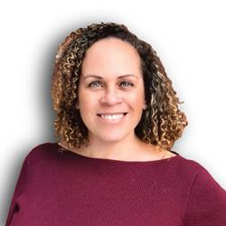
Karen Clarke (ASpectrum) ASpectrum was founded in 2020 by Karen Clarke, who has over 15 years of experience in the labour market sector directly related to career and counselling with individuals facing complex barriers to employment. Her team currently includes 12 coaches curated from professional backgrounds including social work, special education and human resources. Several of ASpectrum’s coaches identify as neurodivergent individuals.

Karen’s son and business partner, Julien Clarke is a neurodivergent individual and recent graduate of the University of Toronto with a Bachelor of Science Degree in Psychology.
Karen is a recent recipient of 2021 Bell Let’s Talk Start-up Award and an RBC Canadian Women Entrepreneur Award Nominee
For more information please contact: Karen Clarke at klclarke@aspectrum.ca

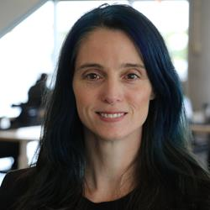
Tara Connolly (READ Initiative, Carleton University) is a Transitions Specialist with over 20 years experience consulting on the use of inclusive practices to support accessibility in a variety of settings. She has worked with school boards, post-secondary institutions, government agencies and healthcare settings as a content expert, to build capacity in accessible practices. In her counselling practice, Tara supports a neurodiversity of thinkers, in particular adults and youth on the Spectrum, to thrive on their own terms and co-creates meaningful strategies that facilitate the transitions into and throughout adulthood.

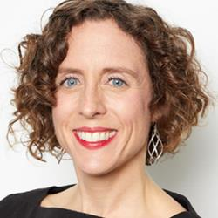
Amélie Coulombe-Boulet (VIA Rail Canada) Expert in traditional and digital marketing, specialized in HR marketing and employer branding. Experienced manager of multi-disciplinary teams and multi-channel projects (PMP certification). Proven skills in content production, communication, and planning (Master's degree in management).

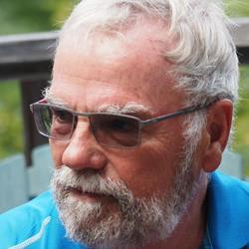
Dr. William Cowie (Every Canadian Counts) has been a social justice advocate throughout his career both as an international development professional and in his volunteer work with persons with disabilities. He has undertaken meta evaluations linked to the strategic planning and implementation process, notably for the International Trade Centre in Geneva in addition to his over 10 years’ experience as an RBM and Performance Management trainer including for ICAO, CIDA as well as specialized training (project management, risk management, professional international affairs management) for Departments, Agencies and Universities in Canada and overseas (Indonesia, Kuwait, Iraq).
Dr. Cowie is past President of the Canadian Association of Development Professionals, the Society for International Development (Ottawa) and was also President of a major social service organization for persons with disabilities. He has overseen and driven organizational strategic and policy initiatives of national significance while as President of a development oriented NGO helping it to gain a reputation as a forward looking and imaginative contributor to development policy discourse.
Dr Cowie holds both a Ph.D. and a Masters from the London School of Economics, London UK, in Development Economics and Geography (1982). He has been a lecturer at the University of Toronto, Ottawa and Carleton Universities specializing in global economics and is currently a professional trainer for the Norman Paterson School of International Affairs, Carleton University.
In recent years as head of the Every Canadian Counts Coalition, Dr. Cowie has focused on addressing the needs of people with disabilities through his advocacy for a national disability insurance program.


Linda Crockett (Canadian Institute of Workplace Bullying Resources) is known for pioneering the first and only full-service workplace bullying and harassment resource center in Canada! And for spearheading regional and national awareness with active government leader endorsement since 2010. She has won awards from GOA and the University of Calgary for her services. Linda’s clinical and professional training includes a master’s degree specializing in workplace bullying and trauma. She is a certified trauma therapist and social worker with 33 years of experience in her profession. Linda has designed two aspects of services for all professions and industries. One is for leaders offering consultations, coaching, and training. And the other is her repair and recovery clinic. The clinic offers a safe, nonjudgmental, confidential space for services of education, training, advocacy, coaching, and/or treatment. Linda wears many hats e.g., coach, teacher, advocate, and counsellor. These hats are necessary to appropriately serve the complexities our individual (complainants, witnesses, or respondents) or groups of employees, experience. Linda is an active member of the International Association on Workplace Bullying and Harassment Association, and a proud alumnus of the Workplace Bullying Institute in the USA.


Lacey Croft (University of Guelph) is a PhD candidate in Sociology at York University. Starting from the standpoint of displaced workers, her dissertation research tells the story of workers’ struggles and strategies for dealing with chronic and traumatic stress following a factory closure. Lacey bridges her research on workplace stress with teaching, both as a sessional instructor in Labour Studies and trauma-informed yoga teacher.

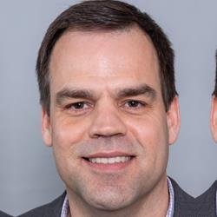
Shawn de Raaf (Social Research and Demonstration Corporation) (MA) has been a researcher with SRDC since 1998, covering a wide range of topics related to employment, training, income security and community economic development. Mr. de Raaf's current project portfolio involves research in a variety of thematic areas, including connecting people with disabilities to employment; supporting employers in achieving their diversity, equity and inclusion objectives; piloting new approaches to essential skills training; and measuring the long-term impact of social purpose organizations.


Elizabeth Desjardins (Innovation, Science and Economic Development Canada) I am an Ottawa girl, born and raised, a wife and proud mother of 2 girls. I studied Criminology at the University of Ottawa and have been a Federal Public Servant for the last 17 years, mostly working in Human Resources. I have worked on the Innovative Recruitment & Assessment Team for the last 3 years and my favourite aspect of our mandate is facilitating diverse recruitment practices, and helping the Federal Public Service remain representative of the Public that we serve.


Maddy Dever (Canadian Autism Spectrum Disorder Alliance) (they/them) is an Autistic adult and parent of five children with four also on the Autistic living in Carleton Place in rural Eastern Ontario. Maddy advocates with both provincial and federal governments for inclusion and acceptance of Autistic individuals and for Autistic people to have their own voice in policy decisions. Maddy is a former member of the Ontario Autism Program Advisory Panel, and a current member of the Ontario Autism Program Implementation Working group. Maddy is also on the board of directors of CASDA (Canadian Autism Spectrum Disorder Alliance).

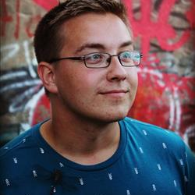
Mitchell Drydak (CCRW) Holding a degree in Political Science from the University of Guelph, Ontario, I found myself in the Newfoundland social services field in late 2019. Working closely with End Homelessness St. John’s I discovered that an intersectional, wrap around approach was important to help clients achieve a steady life situation. Coming to CCRW in mid 2021, I have brought my expertise and knowledge to CCRW as an Employment Facilitator running the Youth the Future Program. Realizing that I can use the same wrap around style with clients at CCRW as well, we have found great success in setting up our youth in steady, healthy employment situations.

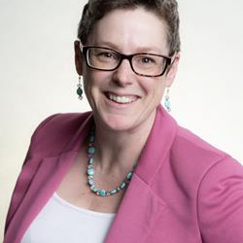
Tammy Dunnett (Relationship Revolution) is an ex target of workplace bullying turned communication and leadership coach to create psychologically safe workplaces.
As the CEO and Founder of Relationship Revolution, she works with employees and leaders to close the gap from where they are to where they want to be. Tammy is changing the way leadership is done to create better workplaces by elevating and empowering conversations that matter.


Kory Earle (People First of Canada) is a young disability rights advocate who lives in Ontario, Canada. Kory is the current past president of People First of Canada and has been involved with the organization since 2006 on the local, provincial, and national level.


Melissa Egan (Realize) is the National Lead, Episodic Disabilities at Realize. She has worked in the field of health and HIV for over 15 years as an educator and facilitator, developing and delivering workshops to diverse audiences across Canada. Melissa brings a commitment to inclusion, diversity, equity and accessibility to her work and she has worked extensively with marginalized, 2SLGBTQ+, and Indigenous people.

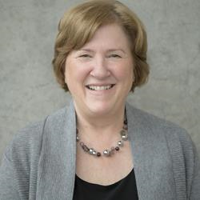
Doramy Ehling (Rick Hansen Foundation) As CEO, Doramy Ehling leads the Rick Hansen Foundation (RHF) in its’ vision to create an inclusive world where people with disabilities are living to their full potential.
Prior to her appointment as CEO in December, 2018, Doramy held the position of Chief Operating Officer of the Foundation and supported the development of several innovations including the Rick Hansen Institute and the RHF Accessibility Certification™ program.
Previous to joining the Rick Hansen Foundation, Doramy held several positions within the Government of Canada at Canadian Heritage, which included portfolios within Sport Canada, and the 2010 Federal Secretariat for the 2010 Olympic and Paralympic Games.
An active volunteer in the sport community over the past 30 years, Doramy has served on the Boards of Volleyball BC, Sport BC and the Sport Medicine Council of Canada. Currently Doramy is Chair for the Host Committee of the National Women’s Volleyball Training Centre.


Steven Estey (Self-employed) is an International Human Rights consultant, with a focus on the human rights of people with disabilities. In June of 2020 Steven finished a very successful two-year term as interim National Coordinator of the Council of Canadians with Disabilities (CCD). He is also a former Human Rights Officer at Disabled Peoples’ International (DPI) a Canadian based NGO that has worked for over 30 years to advance the Human Rights of Persons with Disabilities around the world.
Steven has travelled widely, for more than 25 years in many countries around the world. He has worked with Disabled Peoples' Organizations, Human Rights Institutions, Governments, Intergovernmental Organizations and United Nations Agencies to advance disability rights. Over time he has gained wide experience in the areas of international cooperation, economic development, human rights and disability. He has testified before several parliamentary committees in Canada and spoken on Human Rights and people with disabilities at the United Nations and in many countries around the world.
From 2003, until the successful conclusion of the negotiations in 2006, Steven was advisor to the Canadian Government delegation to the United Nations, which drafted the new Convention on the Rights of People with Disabilities (CRPD). From 2007 until 2010 he led DPIs work to encourage Governments around the world to sign and ratify the CRPD.
Since 2010, when he left DPI, Steven has devoted his time to projects strategically aimed at the effective implementation of the CRPD and related to the full realization of disability rights and the effective implementation of the CRPD around the world.
Steven has a Bachelor’s degree in Philosophy from St. Francis Xavier and a Master’s in International Development Studies from Saint Mary’s; both Universities are in Nova Scotia.
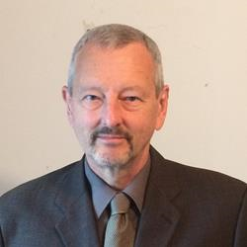
Alec Farquhar (Centre for Research on Work Disability Policy) is a lawyer with a long career in workers’ compensation, disability and employment and occupational health and safety. He is currently Chair, Engagement, for the Centre for Research in Work Disability Policy and member of the steering committee for Disability and Work Canada. He is also a member of the Canadian Standards Association Strategic Steering Committee for Occupational Health and Safety, which includes the CSA Disability Management Standard. Previously, Alec was the Director of the Ontario Ministry of Labour’s Occupational Health and Safety Branch, Director of the Office of the Worker Adviser and Managing Director of the Occupational Health Clinics for Ontario Workers. Alec has worked extensively on employer/worker partnerships around the recruitment, inclusion and accommodation of persons with disabilities. Alec has a long history of working with vulnerable worker communities including immigrant, racialized and indigenous workers, women and young workers. He is fluent in Italian and French which has helped him connect directly with those communities. A graduate of Princeton University, Alec has an L.L.B. from the University of Toronto Faculty of Law. He is currently a member of the Ontario Bar Association Workers’ Compensation Section Executive.


Isabelle Feillou (Université Laval) est ergonome, professeure adjointe au département des relations industrielles de l'Université Laval et chercheure au centre interdisciplinaire de recherche en réadaptation et intégration sociale (CIRRIS). Dans ses recherches, elle s'intéresse notamment à la contribution de l'ergonomie à la conception d'environnements et d'organisations capacitantes pour les usagers et les travailleurs, aux situations de handicap au travail et à la santé durable du personnel de santé, des usagers et de leurs proches, plus particulièrement en CHSLD ou en maisons alternatives.


Gordon Fletcher (People First of Canada) is the past president and current treasurer of People First of Canada. He has been involved with the People First movement since 1985 on the local, provincial, and national level. He is also the co-chair of the IC/PCF Joint Task Force on Deinstitutionalization.

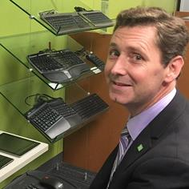
Bert Floyd (TD Bank) The Assistive Technologies team helps accommodate and support employees with disabilities who leverage specialized technology to interact effectively with bank systems. We are also responsible to promote IT accessibility standards and work with vendors and project teams across the organization to ensure accessibility is fully considered in the design of customer and employee-facing technology. Bert is passionate about reducing barriers to employment and helping people put their abilities to work.

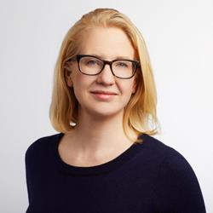
Naomi Fraser (Social Research and Demonstration Corporation) joined SRDC in 2021 as a Senior Research Associate, with a background in public policy research, program evaluation, and human-centered design and service transformation. Over her career, she has worked in provincial and federal government and public university settings, with a focus on social policy. Naomi holds a PhD in Communication and Cultural Studies from York University and has cultivated a lifelong interest exploring the intersection of politics, technology, and social change.


Corrine Gannon (CCRW) as a person with Lived Experience has worker as a Disability and Community Development Specialist for over 30 years. She worked in K-12 education system for 14 years becoming the first Unionized Rehabilitation Practitioner. Completed the first Alberta Department of Justice Needs Assessment for victim’ with disabilities. Corrine has been instrumental in policy and legislations changes. Presently she sits on the National Board of Directors for CCRW and the Edmonton Learning Disability Association’s Board of Directors. Corrine has consults on various Alberta Government committees exploring transitional processes for Albertans facing barriers related to their disabilities. She developed a Social Enterprise within a Disability Employment organization providing Educational and Employment based accommodation supporting the hiring and retention of job seekers with disabilities. Corrine also developed 3 Specialized assessments that support positive employment outcomes for both the Albertans and the Employers. Corrine has worked both as a community member and Government employee supporting change across all Alberta’s Ministries Alberta Education, Income Support, AISH, PDD and Children Services serving employment destined Albertans with disabilities. Corrine’s passion is directed at opening doors, building networks, sharing resources and tools needed to support Skill Devolvement and Employment for Albertans and Canadians transitioning from School to Employment and from youth to adult services.


Dr. Rebecca Gewurtz (McMaster University) is an Associate Professor in the School of Rehabilitation Science and an Adjunct Scientist at the Institute for Work and Health. She holds a Ph.D. from the University of Toronto and completed a collaborative program through the in Health Services and Policy Research. Her research focuses on work disability policy, income insecurity, and employment among people living with disabilities, with a focus on mental illness and other episodic disabilities. She has been examining the experiences of various stakeholders including people with disabilities, service providers, co-workers and employers as people with disabilities are hired and accommodated in diverse workplaces, as well as the impact and coordination of income security benefits.

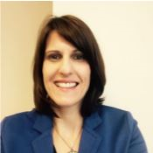
Helen Grantis (Public Service Commission) is a specialist in accessible and inclusive assessment and staffing at the Personnel Psychology Centre, Public Service Commission of Canada. Helen has over 15 years experience working within the fields of disability accommodation, accessibility and Diversity and Inclusion. She has advised managers, human resource advisors and job applicants to ensure a more inclusive and barrier free hiring process. She has been a part of the Accessibility Task Team at Employment and Social Development Canada and consulted on the Accessible Canada Act.

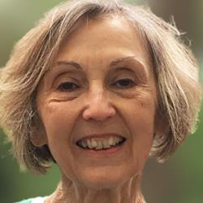
Deanna Groetzinger (Neurological Health Charities of Canada) directs Neurological Health Charities Canada (NHCC), a coalition of organizations that represents people with brain diseases, disorders and injuries in Canada. She serves on the CIHR Institute of Neurosciences, Mental Health and Addiction Advisory Board and on the Steering Committee for the Canadian Brain Research Strategy. She has an MA from the University of Waterloo in political science with a specialty in communications theory. She has contributed to several articles in major journals focusing on the ethics and brain-computer interfacing.

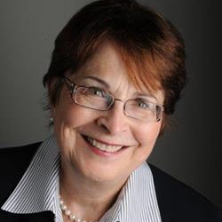
Mary Gusella (LiveWorkPlay.ca) retired as Chief Commissioner of the Canadian Human Rights Commissions following a 36-year Public Service career.
Her public sector experience includes serving as a Deputy Minister, a Chairperson of both a Crown corporation and a private sector corporation under the Canada Not-for-profit Corporations Act (CNPCA), Head of Agency, CEO of a Crown Corporation, Chair of a bi-national (Canada/US) organization, and Commissioner of the Public Service Commission as well as 14 years serving on boards of directors.
Mary’s directorship roles included 7 years as Chair of the Board of the Commission for Complaints for Telecommunications Services, a unique stakeholder-led, industry-funded organization with the independent authority to resolve complaints, Director on the Board of the Ontario Human Rights Legal Support Centre and Commissioner of the Ontario Human Rights Commission until end of 2019.
In 2009 to 2013, she completed international work in Tanzania advising the President’s Office, Ethics Secretariat, on reforms to the Public leaders Ethics and Code of Conduct legislation and working with the President’s Office, Public Service Management Ethics Division on social marketing to advance ethical behaviour.
Mary is a volunteer with LiveWorkPlay since 2014 and Chair of the Federal Employment Strategy Group under the Inclusive Employment Initiative.
In 2015, she was awarded the Prime Minister’s Outstanding Achievement Award, the Public Service’s highest award, for “Outstanding contribution to the Public Service of Canada.” She Received the Queen’s Jubilee Medal and was inducted into the Honour Society of the University of Ottawa Law School. Mary received the United Way Community Builder’s Award in 2002.

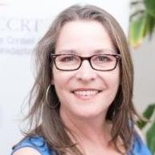
Maureen Haan (Canadian Council on Rehabilitation and Work, CCRW) has been the President & CEO of CCRW since 2012. CCRW is the only national organization with the sole vision of equitable and meaningful employment for people with disabilities, in operation for over 40 years. CCRW provides direct services focusing on employment engagement through CCRW best practices and proven results. Maureen has been very active in the cross-disability sector, currently focusing on employment issues. She has been involved with numerous committees and groups that increase awareness of and access for the disability sector and the Deaf community, including involvement with Civil Society on the UN Convention of Rights for Persons with Disabilities (CRPD), and as a Board member on the Accessibility Standards Canada. Maureen was appointed to the COVID-19 Disability Advisory Group (CDAG) during the COVID-19 pandemic and continues to serve in the Minister Disability Advisory Group (MDAG).

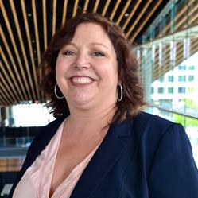
Jillian Hardie (Challenge Disability Resource Group) As the Executive Director of Yukon’s Largest NGO, Jillian overseas the operation of 2 employment programs, 3 residential programs, 2 social enterprises and is in the process of constructing the Cornerstone Affordable and Supportive Housing Development, a 46 unit mixed use building. With over 30 years in the disability sector, Jillian has a foundational believe that safe, respectable, stable and affordable housing is the cornerstone to physical and financial security while moving forward on the employment continuum.


Elisabeth Harrison (ReVision Centre, University of Guelph) (she/her, they/them) is a research associate at the Re·Vision Centre at the University of Guelph, where she works on the Bodies in Translation and From InVisibility to Inclusion research grants. They are completing their PhD in Critical Disability Studies at York University.

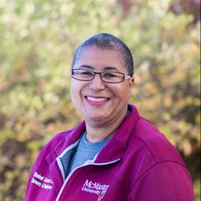
Katherine Hesson-Bolton (Student Success Centre, McMaster University) In 2018, the Student Success Centre launched the Career Access Professional Services (CAPS), with an increased focus on inclusive employment, accommodation supports and equity principles. The team takes an individualized approach when working with students, alumni, campus and community partners.
Katherine’s consultative approach combines business relationship building skills, job placement, accommodation supports, and retention services.
She is responsible for identifying, developing, and cultivating relationships to increase employment and experiential opportunities for equity-deserving students, alumni, and those with barriers to employment.
Katherine’s career started formally as an ASL Interpreter. Her work has spanned front-line, freelance, and senior level roles with March of Dimes Canada, Canadian Helen Keller Centre, Canadian Deafblind Association, Canadian Hearing Society, Canadian National Institute for the Blind, and Mohawk College Accessible Learning Services.

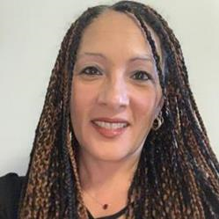
TerriLynn Hulett (City of Toronto) is a multi-racial womxn with a visible disability who works at the City of Toronto in the People & Equity Division, Diversity & Inclusion People Experience, as an Accessibility Talent Specialist. With over 20 years of employment services experience working within the cross-disability community as a vocational professional and manager, TerriLynn has also been a strong accessibility DNI advocate throughout her career in other areas including sports and recreation, access to accessible information, accessible technology and workplace accommodations.

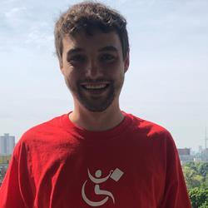
Stephen Irish (Canadian Council on Rehabilitation and Work) I have a passion for supporting others in reaching their full potential. Since joining the team at the Canadian Council on Rehabilitation and Work, I have had the pleasure to work directly with jobseekers, staff, and employers. I believe Disability Confidence is a journey, not a destination, and I am thrilled to be able to support all stakeholders in this journey!

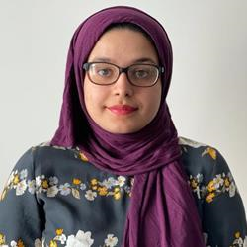
Mah-E-Leqa Jadgal (Eviance) is a Youth Leadership Intern with Eviance. Mah-E-Leqa completed a Bachelor of Science degree in Medical Sciences from Brock University with an undergraduate thesis in healthcare quality improvement. Mah-E-Leqa is working with the Eviance youth leadership program to develop her leadership skills as an emerging voice in the disabilities field. She is interested in disability leadership, federal disability policy, universal design, and accessibility in the sciences at a post-secondary level.


Khushbo Jaria (The Aga Khan Council for Canada) I am presently, working towards my masters in the area of newcomers with PAD-disabilities. I have spent ten years as a navigator transitioning newcomers with PAN-disabilities through community programs and government systems that are not user friendly, coherent, easy to navigate nor inclusive. In my role as a navigator, I transition individuals with the intend of leveling the playing field as they attain skill development and move to secure employment needed to achieve self-efficiency. My personal goal is to enhance the understanding of the existences of disability within the multicultural groups and the need and awareness of cultural traditions when working with individuals.

Dr. Arif Jetha (Institute for Work & Health) is a Scientist at the Institute for Work & Health and an Assistant Professor at the University of Toronto. His research spans population health, systems science and social policy to examine how the future of work will impact the labour market engagement of vulnerable workers including people living with disabilities and young workers. Dr. Jetha’s research also examines the role of the work environment in creating challenges and opportunities for young workers with disabilities during the school-to-work transition. Dr. Jetha was the recent recipient of the Stars Early Career Salary Award from the Arthritis Society. He is a mixed-methodologist and has experience leading interdisciplinary research and partnership teams.

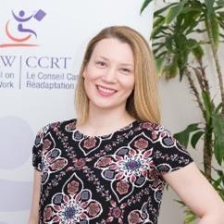
Meghan Kelly (CCRW) is the National Manager, Business Solutions of The Canadian Council on Rehabilitation and Work (CCRW). She has been working with CCRW since 2013 and has been involved on varying levels of the organizations programs and services. Meghan’s most recent area of focus at CCRW has been concentrated in expanding CCRW’s Business Solutions department and its suite of customized professional business services. In her role Meghan connects with Business across the country, uncovers their specific need as it relates to accessibility, disability and work, and develops customized CCRW services that will support them in hiring and retaining persons with disabilities. Meghan currently works out of the CCRW Office in St. John’s Newfoundland.


Murteza Khan (BBDN) is the CEO and a Founding Trustee of Bangladesh Business & Disability Network (BBDN), which is a group of representatives from business, non-governmental and disabled peoples organizations, working collaboratively to build a disability inclusive labour market system. Previous to co-founding BBDN, Murteza worked at A.K.Khan Group and A.K.Khan Foundation, where he led the initiative to set up a rehabilitation center in Chattogram, Bangladesh through a partnership with Center for the Rehabilitation of the Paralysed (CRP).

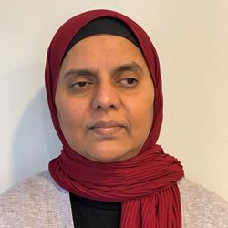
Rabia Khedr is dedicated to equity and justice for persons with disabilities, women and diverse communities. She is the National Director of Disability Without Poverty and CEO of DEEN Support Services.
A founder of Race and Disability Canada, she is also a board member of the Muslim Council of Peel and the Federation of Muslim Women. Rabia recently served as a Director on the board of Accessibility Standards Canada, as a member of the Minister’s Disability Advisory Group and previously served as a Commissioner for the Ontario Human Rights Commission.
A motivational speaker and a documentary commentator, Rabia has campaigned in municipal elections to serve as a city councillor in Mississauga.
Rabia has received numerous awards for her humanitarian services, including a Queen Elizabeth II Diamond Jubilee Metal.
Rabia holds a Bachelor of Arts (University of Toronto) and a Master of Arts (York University). Rabia is a married mother of four young adults, has siblings with disabilities and is blind.


Jonathan Lai (Canadian Autism Spectrum Alliance) is the Executive Director at the Canadian Autism Spectrum Disorders Alliance and an adjunct faculty member at the Institute of Health Policy, Management and Evaluation (IHPME) in the Dalla Lana School of Public Health at the University of Toronto.

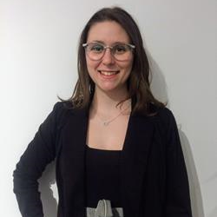
Kim Lajoie (Université Laval) Je suis étudiante à la maîtrise avec mémoire en relations industrielles à l'Université Laval. Je suis diplômé universitaire d'un baccalauréat en administration des affaires : management et gestion de personne. Je travaille comme responsable des ressources humaines dans l’entreprise familiale. Je m’intéresse grandement à l’inclusion, la diversité et le bien-être au travail.

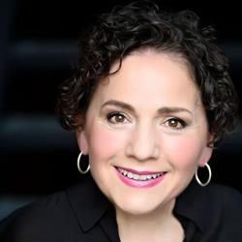
Yazmine Laroche (Treasury Board of Canada Secretariat) is Canada’s first Deputy Minister of Public Service Accessibility. In this role, she is responsible for overseeing the efforts of the Canadian public service to meet the requirements of the Accessible Canada Act. A career public servant with extensive experience, she has served in a variety of leadership roles in many different federal departments and agencies. She most recently served as the Associate Deputy Minister, Transport and Infrastructure.
Yazmine is proud to be the Deputy Minister Champion for Federal Employees with Disabilities and the Deputy Minister Champion for her alma mater, Carleton University, from whom she received an honorary doctorate in 2019. She is a board member and the past chair of Muscular Dystrophy Canada. She was awarded the Queen Elizabeth II Diamond Jubilee Medal in recognition of her charitable work and her efforts on behalf of people with disabilities.

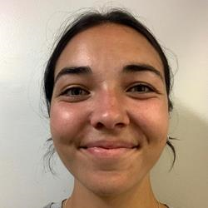
Savanah Laurence (University Laval - Étudiante en ergonomie et auxiliaire de recherche) Je suis présentement étudiante en ergonomie à la maitrise à l'Université Laval à Québec. J'ai complété un baccalauréat en psychologie à l'Université de Sherbrooke. Je travaille également comme intervenante dans un centre d'hébergement pour hommes en situations de difficulté. Dans ce centre, plusieurs hommes en situation de handicap y vivent comme ils ont peu de ressources propres à leur situation.

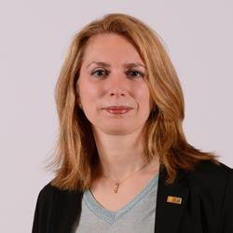
Aline Lechaume (Université Laval) est professeure au Département des relations industrielles de l’Université Laval. Elle s’intéresse aux parcours d’insertion socioprofessionnelle des personnes immigrantes et des diversités, aux politiques publiques et programmes d’immigration et d’emploi et aux inégalités sociales. Elle est membre de plusieurs chaires et groupes de recherche (CRIDE, DYMIG, EDIQ, CRJ).

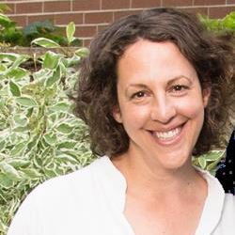
Marni Lifshen (CCRW) is a researcher and Knowledge Exchange professional. Prior to joining CCRW, she has worked at the Institute for Work & Health, the Centre for Aging and Brain Health Innovation, and St. Michael’s Hospital. Her interest lies in sharing evidence and narrative-based information widely, to support progress and change. She lives in Toronto with a house full of children and a dog. It goes without saying that said house is loud and messy
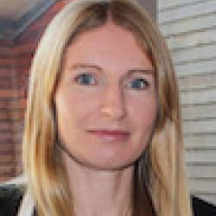
Dr. Sally Lindsay (Holland Bloorview Kids Rehabilitation Hospital) is a Senior Scientist at Bloorview Research Institute, Holland Bloorview Kids Rehabilitation Hospital and an Associate Professor in the Departments of Occupational Science and Occupational Therapy, University of Toronto. Her PhD is in the Sociology of Work and Health. Her research focuses on the social inclusion and participation of children and youth with disabilities, especially as they transition to adulthood and into the workplace.

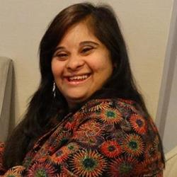
Dewlyn Lobo (People First of Canada) is the current president of People First of Canada and has been involved with the organization in many roles since 2008. Dewlyn is passionate about inclusion for people labeled with an intellectual or developmental disability and works tirelessly to share to this message.

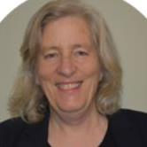
Anne MacRae (Independent Living Canada) brings to this position over 30 years of experience in the Not-for-Profit Sector, Federal and Provincial Governments as an advocate for people with disabilities. She herself is profoundly hard of hearing and currently resides in Dartmouth, Nova Scotia with her husband, well-known activist Steven Estey and their 24-year-old son Isai who lives with Cerebral Palsy.

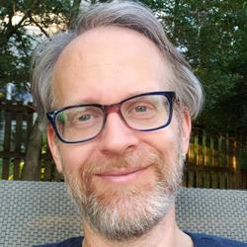
Eppo Maertens (ESDC) is very proud to have participated in every Disability and Work in Canada Conference since its inception.
He is the Policy Director of the Labour Market Inclusion and Accessibility division within the Employment Program Policy and Design Directorate at Employment and Social Development Canada. His responsibilities include the policy management of the Opportunities Fund for Persons with Disabilities and the Employment Strategy for Canadians with Disabilities.
Eppo has experience in policy analysis and development, federal-provincial/territorial relations, investigations, compliance and communications. He holds an MA in Journalism and a BA in Economics from the University of Western Ontario.
Eppo Maertens est très fier d'avoir participé à chaque conférence sur les personnes handicapées et le travail au Canada depuis sa création.
Il est directeur des politiques de la division d’Inclusion et accessibilité au marché du travail au sein de La Direction générale de l'Élaboration et de la conception de politiques de programmes d'emploi à Emploi et développement social Canada. Ses responsabilités comprennent la gestion stratégique du Fonds d'intégration pour les personnes handicapées et de la Stratégie d'emploi pour les Canadiens ayant un handicap.
Eppo a de l'expérience dans l'analyse et l'élaboration de politiques, les relations fédérales-provinciales/territoriales, les enquêtes, la conformité et les communications. Il détient une maîtrise en journalisme et un baccalauréat en économie de l'Université de Western Ontario.


Kristiann Man (CCRW) joined CCRW in October 2020 in the role of Knowledge Translation Specialist. Kristiann completed a Master's degree specializing in community-based quality participation among persons with disabilities at Queen's University, and is applying her background in implementation science in the context of the Disability Confidence project at CCRW.


Steve Mantis (Ontario Network of Injured Workers Groups) was injured in an industrial accident in 1978 losing his left arm. He went through the Workers Compensation system and saw first-hand how it failed for many injured workers. It became apparent that many workers with a permanent disability became chronically unemployed and lived a life in poverty and depression. He has been active ever since working to improve the lives of injured and disabled workers across Canada.
Steve is the Founding member of the Thunder Bay & District Injured Workers Support Group, the Ontario Network of Injured Workers Groups and the Canadian Injured Workers Alliance. He is presently serving as Chair of the Research Action Committee of the Ontario Network of Injured Workers Groups (ONIWG) and sits on the Executive Committee of the Centre for Research on Work Disability Policy.


Brittany Manu (Toronto Transit Commission, TTC) As a Black woman, advocate and cultural connector working at the Toronto Transit Commission (TTC) as an Anti-racism, Policy Consultant in the newly established Racial Equity Office, Brittany Manu has over a decade of experience championing intersectionality and founding movements like Reaction4Inclusion and Black Voices United; centering the experiences of youth with intellectual disabilities and Black individuals from the Sight Loss community. As a curator and Community-based artist Brittany also taps into creative and innovative approaches to addressing systemic barriers to access and Inclusion. Currently Brittany sits on the Board of Directors of Both Community Living Ontario and Tangled Arts Disability.

Jonathan Marchand (Coop ASSIST – Quebec Cooperative for Independent Living) [no bio]


Jasmine Marchant (BC Partners in Workforce Innovation) I am currently an Inclusive Workforce Consultant with BC Partners in Workforce Innovation (BC WiN). I’m focused on Diversity & Inclusion strategies, supporting BC employers hire people with diverse abilities and removing barriers to employment. With over 20 years’ experience working as a Human Resources Professional in Tourism, Hospitality and Food and Beverage sectors. I also have extensive skills and experience in the areas of strategic planning, managing execution, employee and labour relations and training and development.

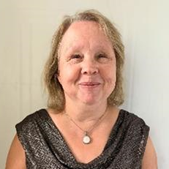
Melanie Marsden (Circle insights) “She Carries the Light Woman,” her Indigenous name, is registered with Alderville First Nation (Ojibway and Mohawk), is a Consultant for Circle Insights. Melanie was also a Project Manager - Accessibility Specialist at Springtide Resources. She holds a degree in the field of Social Work and is currently in the process of completing her Master of Indigenous field of study stream at Wilfred Laurier University. Melanie uses an intersectional approach as a self-identified Indigenous person that is blind, and a proud parent of 3 and a grandmother of one.
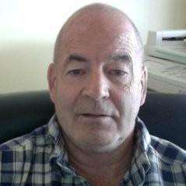
Bud Massey has extensive experience facilitating and working with disadvantaged peoples in Manitoba, Saskatchewan, Alberta and British Columbia. Bud has served youth at risk, Social Service clients, First Nations, Métis, seniors and youth. As a business owner for more than 40 years, Bud has been a partner in Lokken Associates and the Owner Operator of The Alberta Career Institute, taught supervisory skills and entrepreneurship, owned and operated a Human Resource Consulting Company, and has 25 years experience as a human resource specialist. With over 30 years as a life change agent, Bud helps groups and individuals facilitate positive change. Bud worked successfully with municipal, provincial and the federal governments, non-profits, aboriginal organizations, Métis settlements and First Nation Reserves, and recently served as a Councillor/Reeve for the County of Westlock, Alberta. He has designed and delivered life change programs and skill development programs for small and large businesses, and served as a business and human resources consultant which assisted businesses and the BC Métis nation success. Bud also enjoyed a successful career as a curriculum developer, proposal writer and staff trainer in Life Skills, supervisory and staff development, human resources and customer service, and has extensive experience in Labour Relations in a variety of positions. In addition Bud has worked in heavy industry and retail, and has taken extensive training in labour relations, counselling and business, he has several years experience in the field of adult education, group facilitation and addictions counselling. Bud believes in social change and always puts his belief into action to help others achieve their goals.


Carrly McDiarmid (Statistics Canada) I am an analyst working within the Disability and Accessibility Program at Statistics Canada. I have worked on the disability and accessibility team for over 2 years now and have been with Statistics Canada since 2013.

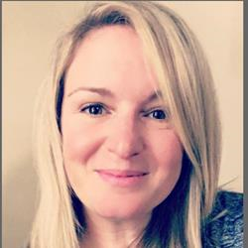
Michelle McDonald (Brain Injury Canada) with over two decades of experience working in non-profit sector, Michelle has spent the last 11 years leading organizations in their missions of ensuring those living with the effects of acquired brain injury are valued, supported and engaged in their communities. As Executive Director of Brain Injury Canada, she has led the organization in a new strategic direction, solidifying its position as a credible information source, knowledge mobilizer and ally for those with lived experience, families, healthcare/service providers, as well as the medical and research community. Michelle is Chair of the Governing Council for Neurological Health Charities Canada and a member of the Executive Committee of the Canadian Traumatic Brain Injury Research Consortium.

Monique Mercier (Kindful Psychology) is a registered psychological associate with the College of Psychologists of Ontario and a provider with the WSIB Community Mental Health Program. She is the owner/founder of Kindful Psychology Services in Thunder Bay, Ontario. Monique has experience working with adults struggling with stress, burnout, anxiety, depression, and trauma. She is also a trained Mindful Self-Compassion teacher through the Centre for Mindful Self-Compassion. She is currently focusing her practice at Kindful Psychology on clinical assessment/intervention, supervision, facilitating groups, and consulting services with organizations on staff resilience-building.


Christine Morin (CRISPESH) had been teaching psycho-social intervention at Cegep du Vieux Montreal in the Department of Special Care Counseling for over 15 years now.
She has been a researcher in the field of inclusion since 2015 and is interested in a variety of topics tied to Inclusion, namely Inclusive Education in Post-Secondary institutions, Inclusive practices and employment of people experiencing disability and reflexive professional development towards inclusion.

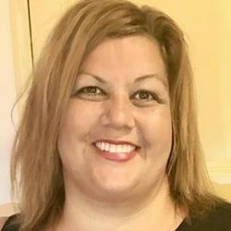
Tammy Morris (EY Canada) leads the Neurodiversity Centers for Excellence (NCoE) team for EY Canada. The NCoE network includes a talent team focused on delivering emerging technology and business solutions to EY clients. Tammy is also responsible for the development and integration of neuro-inclusive strategy and accessibility for EY internally, as well as for EY Clients, supporting their talent efforts as part of our EY Consulting practice. She is a member of the leadership team for the AccessAbilities Professional Network within the firm and represents EY on the Canadian Accessibilities Network Advisory Board.

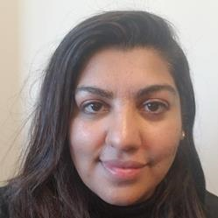
Kay Nasir (Institute for Work & Health) is a research associate at the Institute for Work & Health. She is experienced in survey design and administration, project coordination and qualitative research, including focus group facilitation and conducting interviews. She is currently supporting two projects led by Dr. Arif Jetha, including a Delphi study on the future of work and young people with disabilities and an intersectional study exploring the employment experiences of young workers in Ontario. Nasir completed her undergraduate education at York University. Her research interests include the health effects of income inequality and mental health in the workplace.

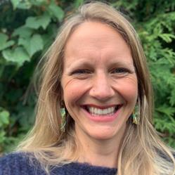
Anna Nelson (LiveWorkPlay.ca) is the Director of Employment Supports at LiveWorkPlay. Anna joined LiveWorkPlay in 2017 and before that worked in a variety of leadership roles in the developmental services sector and taught part time in the Developmental Services Worker program at Confederation College. Anna has an undergraduate degree in Psychology from McGill University and a Masters of Education in Community Rehabilitation and Disability Studies from the University of Calgary. She is passionate about building more inclusive and welcoming communities for all and is a proud mom of two, loves spending time with family and friends, and loves being in the forest- hiking, x-country skiiing, canoeing, camping and any adventure!

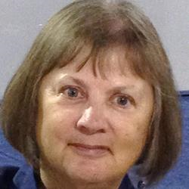
Margaret Oldfield (Independent Disability Scholar) a social scientist, received her PhD in rehabilitation science from the University of Toronto. Her own experience with chronic illness inspired her scholarship. Dr. Oldfield’s research focuses on changing workplaces and policy to enable people with chronic illnesses to remain employed. Through the lens of critical disability studies, she also explores the experiences of residents of long-term-care facilities. Dr. Oldfield’s publications and presentations can be viewed at https://www.researchgate.net/profile/Margaret_Oldfield


Keya Osborne (CNIB) has worked with the CNIB GTA Foundation for 4 years as a Program Lead and Youth Empowerment Program Coordinator, providing service delivery for youth with sight loss. Keya's current role at CNIB has afforded her to utilize her fashion experience and love of art which inspired her to create a fashion styling and make up specifically catered to address the needs of youth with sight loss to create diverse life enhancing programs not traditionally geared to the vision loss community.
In response to the current racial injustice within the black community Keya along with the Team Lead of Advocacy created a program called Black Voices United, giving a space for employees and participants from the sight loss community identifying as black to share in their experiences.


Sahana Parameswara (Gateway Association) is the Executive Director, Gateway Association. Settler on Treaty 6 territory, Sahana works diligently to be a strong ally to the disability community and the various intersections occupied by the members of this community. Her international experience and varied background enables her to bring collaborative action, anti oppressive practice and accessible consent to the world of equity, diversity and inclusion. Her other identities are feminist, mom and queer woman of colour.

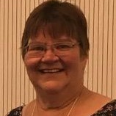
Janet Paterson (ONIWG) I am an injured worker who has had multiple permanent injuries. I am an advocate for workers who have been injured or made sick in their workplaces, fighting for a compensation system that is there to meet all the needs that these workers require to maximize their recoveries. I believe that all persons should have the opportunity to work and the work should fit the abilities of each person.

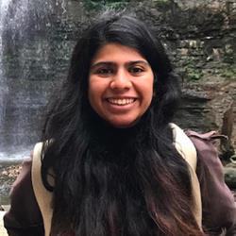
Aditi Pathengay (McMaster University) I'm a Biotechnology and a Business student at McMaster University. I volunteer as a User Tester, where I developed my passion for learning and improving assistive technology. I am also a Project Coordinator for a group that aims to improve how different people interact with information.
Aside from all this, I love to cook and hike!

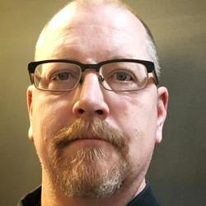
Todd Peters (River City ReManufacturing) River City Remanufacturing was established in 1999 and is currently located in Winnipeg, Manitoba. We are a lumber manufacturer of crating and pallet parts which is exported to Crate and Pallet makers in the United States. We currently have a staff of 30 and we hope to expand our second shift.
Bottom line is, people need to work and we need people. Starting out is the hardest part for both the Employee and Employer in everyday life, thus the need for human resource positions, “head hunter” companies etc. It’s hard to build up the courage for an interview and it’s hard for a company to trust this person will actually be the right person for the position. In our situation we also understand that our line of work is not something kids dream of doing (** side note from my 17 year old daughter who brought her friend to work with her on bring your kid to work day – said to me – why couldn’t you have been a vet or a lawyer?!?!?). I have a simple motto – “make me miss you” which means do a great job and I’ll do everything in my power to help you while you’re here and then going onto your next stage in life. But that’s only if you get the start of course.
With all that being said, the Disability & Work in Canada initiative is important as it brings awareness to both employees and employers. I believe it also helps bridge the unnecessary gap of courage and trust between the two as well.

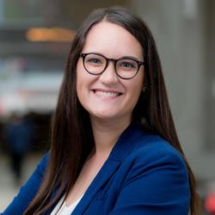
Louise Pichette (MaRS Discovery District) leads delivery of Innovation Adoption projects for MaRS Partner Solutions. She is responsible for initiatives that address critical innovation needs for partners including governments, agencies, not-for-profits and corporates. Louise is currently the lead for the MaRS and CIBC Inclusive Design Challenge, a 5-year project addressing barriers to employment for persons with disabilities. Louise holds a Master’s Degree in Management of Innovation from the University of Toronto and was selected as the Class of 2018 Valedictorian. She also holds B. ScH in Life Sciences from Queen’s University.

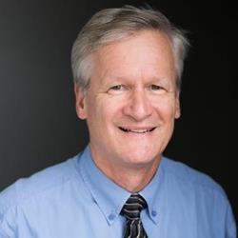
Ken Pike (New Brunswick Association for Community Living) has served as Director of Social Policy for the New Brunswick Association for Community Living for over 25 years and has been an advocate in the Community Living movement for over 30 years. Ken is a retired member of the Law Society of New Brunswick and a member of the Canadian Bar Association. Ken has also worked extensively on public policy issues affecting people with a disability including social assistance reform and poverty, disability support programming, housing, employment, health and inclusive education.
Ken has also authored or co-authored several books, resources, discussion papers and policy briefs on disability issues. In 2021, Ken was inducted into the Order of New Brunswick, the highest civilian recognition in the province of New Brunswick.

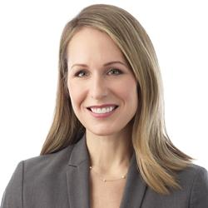
Cheryl Pooran (PooranLaw Professional Corporation) is a human rights, labour and employment lawyer whose practice is dedicated to supporting people with disabilities and not-for-profit organizations that support inclusion in the community. Cheryl provides strategic legal advice and representation in all aspects of the employment relationship, including: collective bargaining and grievance arbitration, wrongful dismissal litigation, accommodations and human rights, and of course Covid-19 response strategy. Cheryl also teaches Health and Human Rights at York University and is the author of Inspiring Possibilities: A Legal Guide to Engaging Support Workers for People with Disabilities, an E-book published by Community Living Ontario with funding from the Law Foundation of Ontario.

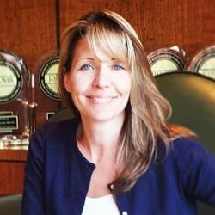
Jennifer Popkey (TD Bank Group) is a member of TD Bank's Diversity Sourcing team within Diversity & Inclusion, focused on meeting and supporting great candidates with disabilities from across Canada grow their careers with TD. She is also a qualified Sign Language Interpreter, and has worked and volunteered in the PWD space for over 20 years.

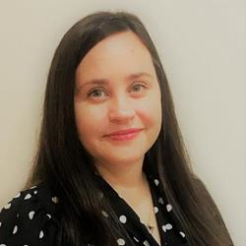
Wendy Porch (Centre for Independent Living in Toronto) is the Executive Director of the Centre for Independent Living in Toronto (www.cilt.ca). CILT is a consumer-controlled community-based resource centre that operates on the philosophy of the independent living movement to support choice, autonomy and control for people with disabilities. Wendy has been working in the field of accessibility, disability, human rights and education for more than 25 years and is a life-long disability rights advocate. She is a member of the City of Toronto’s Accessibility Advisory Committee, and is the Chair of the City of Toronto’s Accessibility Task Force on COVID-19 Vaccines.

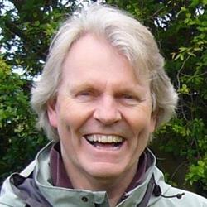
Michael J. Prince (University of Victoria) is the Lansdowne Professor of Social Policy at the University of Victoria. A long time community activist and volunteer, Prince is currently a member of the Canadian Disability Advisory Group to the federal Minister of Disability and Inclusion.

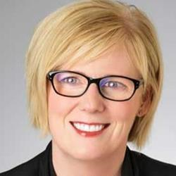
Carla Qualtrough (Government of Canada) A successful lawyer, dedicated volunteer, and Paralympic swimmer, the Honourable Carla Qualtrough’s commitment to addressing inequality and championing diversity makes her a strong voice in government.
Carla was re-elected as the Member of Parliament for Delta, BC on October 21st 2019. She served as the Minister of Sport and Persons with Disabilities and the Minister of Public Services and Procurement and Accessibility. Today, she serves as the Minister of Employment, Workforce Development and Disability Inclusion.
Before entering politics, Carla was a successful human rights lawyer who practiced at both the federal and provincial levels. She also chaired the Minister’s Council on Employment and Accessibility in British Columbia, was an adjudicator with the Workers’ Compensation Appeals Tribunal, and is a past President of the Canadian Paralympic Committee.
Throughout the COVID-19 pandemic, Minister Qualtrough has been a leader within the Government of Canada’s emergency response. She led the creation and implementation of the historic Canada Emergency Response Benefit (CERB), the Canada Emergency Student Benefit (CESB), a one-time disability payment to Canadians with disabilities, and made significant improvements and investments in the Temporary Foreign Worker Program. Minister Qualtrough continues her work to provide comprehensive support to workers, students and persons with disabilities whose lives have been significantly impacted by this pandemic.


John Rae brings a broad combination of community, government and union involvements to all of his varied activities. John took early retirement from the Ontario Public Service in 2005 after a 24-year career, during which time he was a Consultant with the Centre for Disability and Work, an Education Officer with the Employment Equity Commission, and prior to retirement a Program Officer with the Accessibility Directorate of Ontario.
John brought his community perspective to the Canadian labour movement where he served in elective positions at the local, provincial and national levels.

During the past 36 years, John has been a board member of many human and disability rights organizations, including Co-chair of the Coalition on Human Rights for the Handicapped, which secured the first human rights coverage for persons with disabilities in Ontario.
Following four and a half years as President of the Alliance for Equality of Blind Canadians (AEBC), he was elected its 1st Vice-President in 2007 where he received AEBC’s annual CCD Award. John was re-elected to this position in 2008 and 2010.
John is AEBC’s rep to the Council of Canadians With Disabilities where he serves as its 1st Vice Chair. He is also Co Chair of its Technology Committee, and a member of its International and Social Policy Committees.
In 2009, he was elected to the Board of ARCH Disability Law Centre.

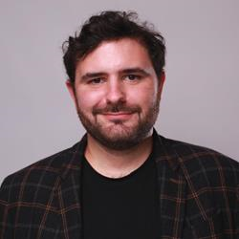
Samuel Ragot (Institute for Research and Development on Inclusion and Society, IRIS) Through his role at IRIS, Samuel aims to accelerate the development of better social policies for people with intellectual disability and their families across Canada.

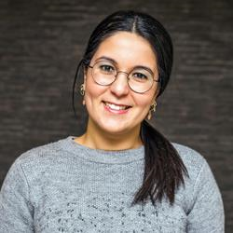
Ikrame Rguioui est titulaire d’une maitrise en criminologie de L’Université Libre de Bruxelles en Belgique. Elle cumule des expériences professionnelles auprès de populations vulnérables dont notamment des personnes judiciarisées, des jeunes en difficultés ou encore des femmes victimes de harcèlement au travail. Elle est présentement coordonnatrice du Comité consultatif femmes dont le mandat est de promouvoir l’intégration et le maintien en emploi de toutes les femmes au Québec. A ce titre, le CCF formule des avis et des recommandations à la Commission des partenaires du marché du travail (CPMT), au ministère du travail, de l’Emploi et de la Solidarité sociale et à Emploi-Québec, en lien avec la Stratégie d’intervention d’Emploi-Québec vis-à-vis de la main-d’œuvre féminine. Le CCF réalise également des études et autres documents informatifs sur les enjeux femmes et emploi.

Marie-Ève Rioux-Massie (Université Laval) [no bio]


Rose-Marie Rivard (Innovation, Science and Economic Development Canada) has been working in the Federal Public Service for almost 5 years in different contracts from administration to graphic design.
Her journey after high school started as a graphic design student from 2015 to 2017 then decided to head in the federal government and thanks to LiveWorkPlay, she got a casual contract as a Test Clerk in Public Service Commission from 2017 to 2018 then landed as a graphic designer for ISED’s Mental Heath Centre for the Workplace for 3 months. Since then, she has had administrative contracts in Correctional Canada and Canada Border Services Agency and now works as an Human Resources Coordinator in HR’S Classification Division in ISED. Her hobbies includes acrylic painting where she is has been taking Exploring Acrylics and Oils at the Ottawa School of Art since 2017 and having coffee with friends at a café.

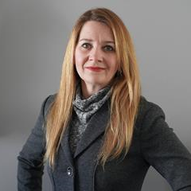
Dr. Vera Roberts (Inclusive Design Research Centre) is the Senior Manager Research, Consulting and Projects at the Inclusive Design Research Centre (IDRC) of OCAD University. Dr. Roberts’ primary focus is developing inclusive systems using participatory research approaches. Recent projects include ODD: Optimizing Disability with Diversity, We Count, Future of Work and Disability, Future of Work: Equitable Digital Systems, Morphic , BIG IDeA and Our Doors are Open. Dr. Roberts also coordinates, develops and provides consulting, custom research and training on inclusion and diversity to the public and private sector and is an instructor in research methods at OCAD University.

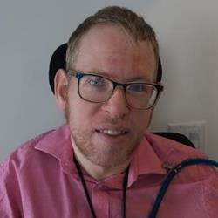
Tim Rose (CIBC) is an activist, writer and business professional who was lucky enough to be born with cerebral palsy. Raised to push the envelope, Tim has had the privilege of working and studying on three continents and experiencing different perspectives on disability and diversity throughout his life. Tim was proud to join see CIBC in 2017 to help the bank become a leader in accessibility among our peers in corporate Canada.

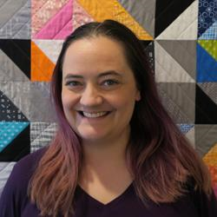
Natalie Rose (Left Turn Right Turn Accessibility) (PhD., M.Sc.OT) is a passionate disability and accessibility consultant with 10+ years of experience in accessibility, disability, research, and teaching. She combines her knowledge of global best practices for accessibility, with a focus on learning directly from people with disabilities. This gives her unique insights into the importance of accessibility and the barriers that people with disabilities experience.

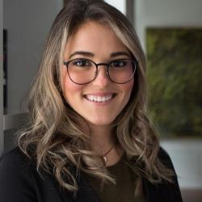
Katie Ross (MaRS Discovery District) is the Challenge Lead of the Inclusive Design Challenge: Support at Work at MaRS Discovery District. Katherine holds a Master’s Degree in Global Affairs and Public Policy from the Munk School of Global Affairs and Public Policy at the University of Toronto. She also holds BA in Media, Information, and Technoculture from Western University.

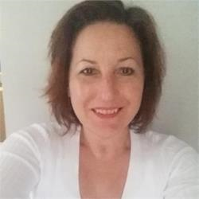
Dr. Charlotte Ross (Douglas College) (she/her) is a Registered Nurse, Registered Psychiatric Nurse, health researcher, and educator. She is a faculty member in the Baccalaureate of Sciences in Nursing Program, Health Sciences Faculty at Douglas College in Coquitlam, British Columbia, Canada. Her clinical background and teaching activities are focused in mental health and treatment of substance use problems. Her primary research areas include nurses’ health, mental wellness, and substance use.

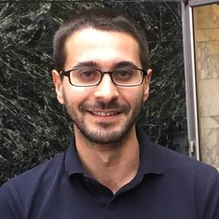
Dr. Dan Samosh (University of Toronto) is a Postdoctoral Research Fellow with the Centre for Industrial Relations and Human Resources at the University of Toronto and the Institute for Work and Health. He received his PhD in Organizational Behaviour from Queen’s University, his MSc in Strategy from Queen’s University, and his HBA from the Richard Ivey School of Business at Western University. Dr. Samosh uses qualitative and quantitative methods to explore research questions on the career advancement, leadership, and workplace inclusion of persons with disabilities.

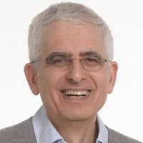
Dr. Ron Saunders (Institute for Work & Health) is a consultant in knowledge transfer and exchange (KTE). He retired at the end of 2017 as Director, KTE and Senior Scientist at the Institute for Work & Health (IWH) but currently holds an appointment as Adjunct Scientist with IWH. Before joining IWH, Ron was Vice-President, Research, at Canadian Policy Research Networks. Prior to that, he spent 17 years in the Ontario Public Service, most notably as Assistant Deputy Minister of Policy, Communications and Labour Management Services in the Ministry of Labour.
Ron also spent time in academia, teaching at the University of Toronto and the Queen’s University School of Policy Studies.

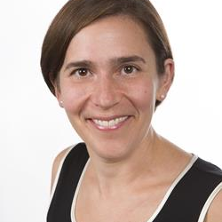
Dr. Deborah Scharf (Lakehead University) is a clinical and health psychologist whose research includes healthcare access for poor and underserved groups; behavioral health delivery systems (integrated care); tobacco use, treatment, and policy; behavioral healthcare services for injured workers, military personnel and veterans; and innovations in in vivo electronic data capture. Dr. Scharf provides clinical services to injured workers in her psychology private practice and trains graduate students to do the same.

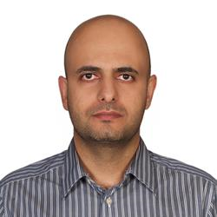
Ali Shamaee (Institute for Work & Health) is a foresight strategist and project coordinator at the Institute for Work & Health. He is currently working with Dr. Arif Jetha on a project examining how the future of work may positively and negatively affect young people with disabilities.
As a foresight strategist, he incorporates multidisciplinary approaches of design and futures studies to help multiple stakeholders make better sense of the future and design corresponding policies and strategies. He has conducted several foresight projects over the last 10 years.
He holds a master's of design (MDes) in strategic foresight and innovation from OCAD University in Toronto. He also holds a master's degree in the management of technology.


Gregor Sharp (The Angus Reid Institute) is a Senior Research Associate at the Angus Reid Institute. He holds a PhD in Political Science from the University of British Columbia.

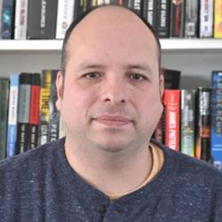
Carlos Sosa (United Food and Commercial Works Local 832) resides in Winnipeg Manitoba. He is a graduate of the University of Winnipeg where he obtained a Bachelor's of Arts majoring in conflict resolution studies, Politics and Urban and Inner City Studies. He is a support worker that supports people with intellectual disabilities who live independently in the community and is a member of the United Food and Commercial Workers local 832. He is currently a member of his workplace's health and safety committee and bargaining committee. He first got involved in the disability community when he first joined the board of the National Educational Association of Disabled Students (NEADS) in 2010 and subsequently became involved in the Manitoba League of Persons with Disabilities and the Council of Canadians with Disabilities. Carlos is currently a member of the board of Inclusion Canada where he Co-Chairs their ad hoc committee on legal capacity. He has also played a critical role in working with community groups to ensure that people with disabilities have access to critical public services including libraries and recreational activities. In the fall of 2020, Carlos was selected to be a part of CBC Abilicrew for Excellence Program (CAPE) where he got the opportunity to bring disability perspectives to the airwaves as an intern for CBC Manitoba. Carlos also played a critical role in facilitating a partnership between Ready Willing and Able and the United Food and Commercial Workers Local 832 which has facilitated a joint pilot project at Loblaw's with the goal of hiring and retaining people with disabilities.

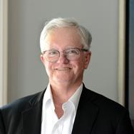
John Stapleton (Open Policy) worked for the Ontario Government in the Ministry of Community and Social Services for 28 years in the areas of social assistance policy and operations. During his early career, John was senior policy advisor to the Social Assistance Review Committee. His more recent government work concerned the implementation of the National Child Benefit.
He is a Commissioner with the Ontario Soldiers’ Aid Commission and is a volunteer with West Neighbourhood House and WoodGreen Community Services of Toronto.

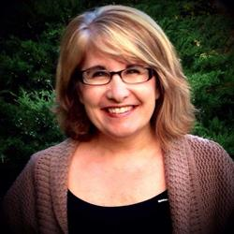
Tara Steeves (CCRW) has been with CCRW for more than a year. She has 30+ years experience working within developmental asset programming pertaining to young adults, disabilities and barriers to employability. Over the years, her expertise has been within the Criminal Justice System reducing risk factors for individuals within restorative justice practices.
Tara is a mother of four, a grandmother and is passionate about Global Humanitarian Aid Supports. In her spare time she oversees a project for volunteers who work globally to meet the needs of those living in extreme poverty with a focus on disability.

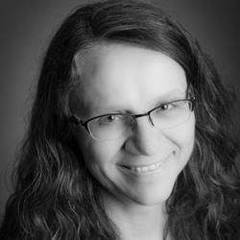
Deborah Stienstra (University of Guelph) holds the Jarislowsky Chair in Families and Work at the University of Guelph, where she is the Director of the Live Work Well Research Centre and Professor of Political Science. She is the author of About Canada: Disability Rights (Fernwood, 2020). Her research and publications explore the intersections of disabilities, gender, childhood, and Indigenousness, identifying barriers to, as well as possibilities for, engagement and transformative change. Her work also contributes to comparative and trans/international research and theory related to intersectional disability rights and justice.


Dr. Mahadeo Sukhai (CNIB) is the world’s first congenitally blind biomedical research scientist. Mahadeo is the Head of Research and Chief Accessibility Officer for the CNIB (Canadian National Institute for the Blind), having previously served as a research scientist at the University Health Network in Toronto. Dr. Sukhai is the Principal Investigator for and co-author of "Creating a Culture of Accessibility in the Sciences," a book based on his groundbreaking work on access to science within higher education, and serves as the principal investigator for national projects to understand the student experience for persons with disabilities, and to examine accessibility and inclusion within science education and healthcare.

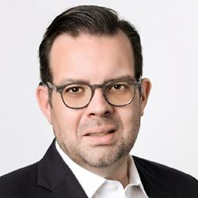
Christopher T. Sutton (Wavefront Centre for Communication Accessibility), MBA, was appointed to the position of Chief Executive Officer at Wavefront Centre for Communication Accessibility on April 1, 2020. Christopher has over 20 years of cross-functional and progressive management and leadership experience, working with some of the largest organizations serving people with disabilities in the United States and Canada. Christopher’s career has spanned across the not-for-profit, public and start-up sectors where he has worked in various leadership capacities in business development, fundraising, government and stakeholder relations, marketing and communications, and sales. Christopher was born with a profound hearing loss and grew up using hearing aids; in 2008, to expand his communication options, he underwent surgery to obtain a cochlear implant. Christopher is fluent in English and ASL.


Terrence Syvenky (Momentum Employment Supports) Director of Services at Momentum Employment Supports, is an accomplished professional with diverse experiences in business development. Terry has a University of Alberta Degree in Sociology and Psychology, along with further study in Conflict Resolution, Adult Education, Facilitation, Training, Coaching and Leadership. He uses he skills to navigate his clients with disabilities through the transitions of learning, skill development, employment, accessing supports and accommodations needed to heighten his clients job readiness skills and develop their self-regulation awareness and executive functioning skills often required to merge into the employment culture and maintain employment retentions. Terry is also a skilled mediator who supports those in conflict through difficult conversations to rebuild trust and arrive at satisfying resolutions, and has earned a reputation for providing effective navigation through challenging transitions, engaging facilitation and impactful coaching. Through his mediation and negotiation experiences, Terry has developed cultural awareness of Canadian Indigenous (First Nations, Metis, Inuit) peoples, and an understanding of the interests of government, business, and community stakeholders. His mission is to inspire others by facilitating transformational experiences.


Dr. Emile Tompa (Institute for Work & Health, Director, Centre for Research on Work Disability Policy, CRWDP) is a senior scientist at the Institute for Work & Health. He holds appointments as an Associate Professor in the Department of Economics at McMaster University and as an Assistant Professor at the Dalla Lana School of Public Health at the University of Toronto. He also has an appointment at Pacific Coast University where he is area lead for research and sits on the curriculum and ethics committees. Tompa is Director of the Centre for Research on Work Disability Policy, an eight-year, pan-Canadian initiative funded by a Social Sciences and Humanities Research Council Partnership Grant. Tompa is a labour and health economist with an MBA from the University of British Columbia, an MA in economics from the University of Toronto, and a PhD in economics from McMaster University. Tompa is an associate editor for BMC Public Health, and is on the editorial boards of the Journal of Occupational Rehabilitation and the Scandinavian Journal of Work Environment and Health. He also sits on the National Stakeholder Advisory Panel of the Canadian Labour-Market Information Council. Tompa’s research interests include the consequences of occupational health and safety system design on the health and well-being of individuals and populations, the economic evaluation of workplace interventions for improving the health and well-being of workers, the economic burden of occupational injury and illness, and the analysis of disability policy systems.


Stefan Tromel (International Labour Organization) Since August 2013, Senior Disability Specialist in the International Labour Organization.
Between 2008 and 2013, Executive Director of the International Disability Alliance between 1999 and 2004, Director of the European Disability Forum (EDF).
Was actively involved in the negotiation process of the UN Convention on the Rights of Persons with Disabilities (2002-2006).

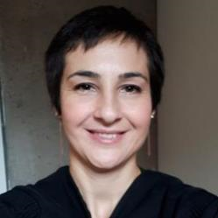
Yasemin Tuncer (DAWN Canada) is an immigrant neuroqueer woman located in Tiohtià:ke (Montreal). She has worked as an instructor at college, and a video game translator but wanting to see real changes in society, after indulging in Communications at Concordia, dove into the world of NGOs. She is interested in intergenerational trauma, intersectionality and feminism. She now works at DAWN Canada as Youth Initiatives Coordinator and considers herself lucky to give voice to young disabled women and gender diverse youth daily.

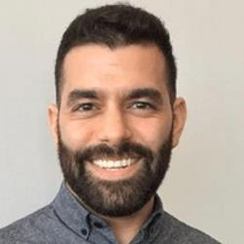
Faraz Vahid Shahidi (Institute for Work & Health) is an Associate Scientist at the Institute for Work & Health and an Assistant Professor in the Dalla Lana School of Public Health at the University of Toronto. Faraz is a social epidemiologist with interdisciplinary training in population health, social policy, and political economy. His research examines the nature and causes of health inequalities, with a focus on the role that societal conditions play in shaping the health and safety of working people. He has a PhD in social and behavioural health sciences from the University of Toronto and an MPhil in comparative social policy from the University of Oxford.

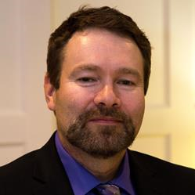
Bob Vansickle (Bob Vansickle & Associates) has worked in the field assisting persons with a disability to find employment for close to 30 years. He has been a speaker at numerous provincial and national conferences. Bob is also one of the founding members and the Past Chair of the Board of the Ontario Disability Employment Network. He now operates Bob Vansickle & Associates to provide operational planning and training to engage managers and team members to learn and develop the strategies and skills to lead, manage and deliver highly successful employment services.

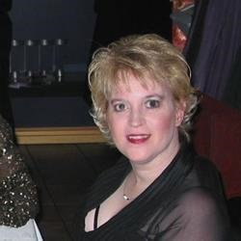
Marcy Vautour (Disabilities without Limits) My mission is to help the voiceless, marginalized and disabled obtain their vision. I do that with the help of my team at Disabilities without Limits.
We bring hope and understanding to those with visible and invisible disabilities so that they can move beyond WITHOUT limits. When they come to us, many are: heard, helped, and hired.

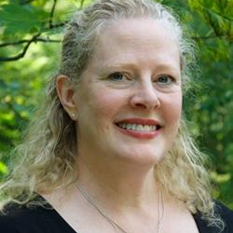
Dr. Barbara Virley (Layla Care) C. Psych. has worked as a clinical psychologist for more than 20 years in the Ottawa community in hospitals, school boards, and private clinics. She is currently the Manager of Clinical Services at Layla Care, a human-first, tech-powered company that empowers Canadians to take greater control of their mental health by bridging the gap between seeking care and finding the right care.


Corey Walker (Canadian Autism Spectrum Disorders Alliance) is an autistic self-advocate from Prince George, BC. He was diagnosed with Asperger's in 2001, while in his early 20's, and since then he has made it his life's mission to empower autistics to live the best life possible. Currently, Corey is employed part-time with the Pacific Autism Family Network as a Program Facilitator for their EmploymentWorks program. Corey formerly served as the Project Lead for Sinneave Family Foundation on the Success in the Workplace: Strategies from Autistic Employees toolkit project.


Keenan Wellar (LiveWorkPlay.ca) has served as Co-Leader and Director of Communications for LiveWorkPlay since 1997. An outspoken champion for inclusion and authentic valued roles for people with intellectual disabilities and autistic persons, Keenan supports change locally in the Ottawa area community as well as provincially as a founding member of the From Presence To Citizenship initiative, nationally in partnership with housing, employment, and other advocacy organizations, and worldwide via Inclusion International and other allies. Keenan has a Masters in Applied Linguistics from Carleton University, is a certified Ontario Teacher, and is a BoardSource Certified Governance Trainer who enjoys kayaking and nature photography.

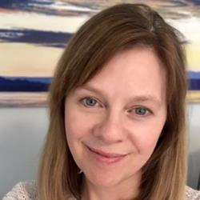
Andrea Whiteley (The PROUD Project, Department of Political Science, University of Toronto) has her PhD in Communications from the University of Calgary. Her dissertation research focused on open access to research. She has many years expertise in research project management and knowledge mobilization. She is a caregiver of a person with a degenerative neurological illness.

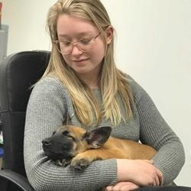
Lexi (Alexandria) Whyte (On Cue Animal Training) Hello! I am the owner and head trainer of a small business called On Cue Animal Training. My company is an animal training school Nova Scotia Canada. We work with all animals but mostly dogs. We specialize in behavioural issues such as anxiety and aggression. We currently have 3 employees who each have disabilities as well as myself who is also disabled. I am dedicated to giving people with disabilities a safe, enjoyable and rewarding career within my company.

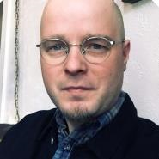
Evan Wicklund (Canadian Centre on Disability Studies, o/a Eviance) is a Senior Research Officer and the Manitoba Office Lead at the Canadian Centre on Disability Studies (o/a Eviance). He is also an Instructor in the Disability and Community Support Program at Red River College. He has a Masters Degree in Cultural Studies (Texts and Cultures) and a Bachelor of Arts (Honors) Degree in Disability Studies from the University of Winnipeg. Evan is the recipient of the Social Sciences and Humanities Research Council Joseph Armand Bombardier Canada Graduate Scholarship and has received the Gold Medal for Disability Studies (2018), the Inaugural Disability Studies Award (2017), and the Community Living Award (2013). Evan has ten years of experience working in the disability field in a variety of capacities, including research, advocacy, education, employment, and community living.

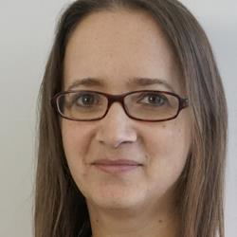
Cara Wilkie (Left Turn Right Turn Accessibility) (LLB, LLM) is the Principle of Left Turn Right Turn Accessibility. She is a seasoned disability rights advisor and policy analyst with 18 years’ experience implementing accessibility legislation, identifying barriers, reviewing best practices, and making plans for change. Cara has experience serving as an advisor to multiple public agencies, government, quasi-governmental and non-governmental organizations about accessibility legal obligations.


Byron Wood (Workers for Ethical Substance Use Policy, WESUP) (he/him) had a brief career as a Registered Nurse. After being diagnosed with a Substance Use Disorder he was required by his employer to participate in an addiction treatment & monitoring program. Because of his experience in what he found to be an unethical and harmful workplace program for nurses who have been diagnosed with Substance Use Disorder, he left the nursing profession. He quickly found out that many workplaces have harmful workplace substance use policies, and he created the non-profit organization Workers for Ethical Substance Use Policy (WESUP). Byron supports and advocates for other workers and fights for policy change.
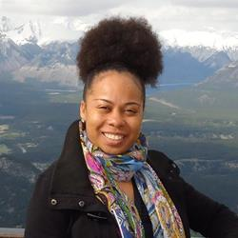
Tammy C. Yates (Realize) is the Executive Director of Realize, which hosts the Secretariat of the National Episodic Disabilities Forum. In 2015, she became the first black female Executive Director of a national organization in Canada’s HIV response, as well as among Canada’s national disability organizations. She has worked for over fifteen years in the field of program management. Prior to joining Realize, Tammy was the National Program Manager of the United Nations Population Fund (UNFPA) Trinidad & Tobago Branch Office. She has extensive experience in Gender & Development and Sexual & Reproductive Health, including HIV/AIDS, having worked previously as a Program Officer with the Secretariat of the Caribbean Regional Network of Persons Living With HIV (CRN+) and serving as Chair of the Gender Theme Group of the United Nations System in Trinidad & Tobago. She is a graduate of Wolfson College, Cambridge University, England and the University of the West Indies, St. Augustine, Trinidad.


Yvonne Yuan (Open Policy Ontario) is a public policy analyst and research associate at Open Policy Ontario, a social policy consultancy located in Scarborough. She is committed to policy analysis in small geographies and progressive policy advocacy in general. Over the last year, Yvonne worked extensively on the design of a new Canada Disability Benefit.

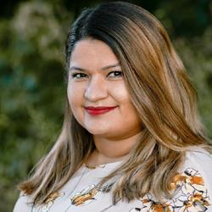
Ayesha Zubair (RBC Royal Bank) is a Senior Product Manager of Learning Strategy and Innovation at RBC, where she is responsible for Future of Work and Climate learning for the Enterprise. Over her 9 years career, Ayesha’s held increasingly senior roles in Diversity & Inclusion, Talent Sourcing, Employee Experience and Management Consulting in the Banking industry. Ayesha completed her Bachelors of Human Resource Management (BHRM) at York University in 2013 and has completed her Masters in Strategic Foresight and Innovation Design this year. She currently serves on the Accessibility Advisory Committee and Customer Experience Advisory Committee for Metrolinx, serves on the Quality of Care Committee of the Board of Trustees at Holland Bloorview Kids Rehabilitation Hospital and she is part of the Catalyst Council for the Holland Bloorview Foundation.

POSTER PRESENTATION SPEAK BIOS

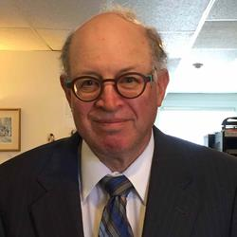
Richard Fink (Fink & Bornstein Professional Corporation) [No bio]

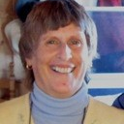
Dawne Fraser (Choice Empowerment Training) lives and creates options outside the systemic norms of society by the very virtue of her unique abilities. Her eclectic approach empowers each situation with deeper insight of true inclusion. She has developed skills, abilities and technology which have enabled her to participate well beyond the limits of her unique abilities. It is with this conviction Dawne provides Inclusion Awareness Training at community and train the trainer levels. Dawne has invented and designed the Synergistic Postural System 2006, enabling herself and others the choice and mobility ability to more fully participate at work, daily tasks and recreation.

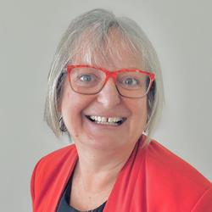
Nancy Gowan (Gowan Consulting) is a registered Occupational Therapist and Certified Disability Management Professional with experience working in industrial rehabilitation, mental health, accommodation and stay at work planning. She is the founder of a national health and disability management company offering support across Canada and now into the US. Over the more than 30 years, she has worked in partnership with employers, employees and unions to develop customized strategies that improve employee success, health and productivity.
She has presented at national and international forums on accommodation and disability management and regularly contributes to disability management education through workshops and training programs as well as online newsletters.
Among her many publications, dating back to 1990, Nancy coauthored a chapter on “Ergonomics in Disability Management” in Ergonomics for Therapists, 3rd edition, 2007. She has written the “Human Resource Managers Guide to Managing Disability in the Workplace” with Carswell, Thomson Reuter’s first edition published in 2010 and second edition published in 2016.


Julia Goyal [no bio]

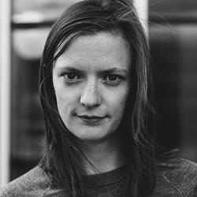
Brooke Leifso (NorQuest College, ACT! Program) (she/her) is a Disabled advocate, aritst, accessibility consultant and researcher based in Treaty 6 Territory/Edmonton/Amiskwaciy Waskahikan. She is the lead researcher for Autism CanTech!, an ESDC funded Autistic youth employment program hosted at NorQuest College (Edmonton) in partnership with colleges across the country. Brooke holds an MA in Expressive Arts - Conflict Transformation and Peacebuilding (EGS, Switzerland).


Jas Randhawa (CCRW) is the Partnership Specialist for the Disability Confidence Project at CCRW, and has been with the organization for over a year. Completing her Masters in Psychotherapy, Jas works to understand both the employee and employer perspective in building disability confidence.

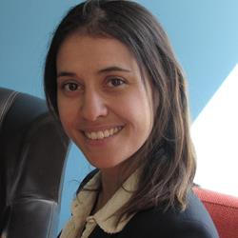
Antonella Scali (Canadian Psoriasis Network) is the Executive Director of the Canadian Psoriasis Network, a not-for-profit organization with the goal of improving the lives of people with psoriasis and psoriatic arthritis (psoriatic disease) in Canada. As a registered social worker, Antonella takes a holistic approach in her work to advance the health and social needs of people with psoriatic disease.

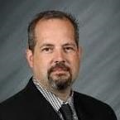
Dr. Cameron Stockdale (Work Wellness Institute) is an executive leader who has been researching the intersection between leadership, change management and strategic planning for over a decade. He has worked in a variety of different settings, including more than 25 years in the healthcare field related to ambulance services, home healthcare support and more recently been appointed to the Inquiry Committee of the BC College of Pharmacists. His doctoral dissertation concentrated on the antecedent requirements for positive change within the Canadian healthcare system and formed a series of recommendations which if adopted would result in increased patient care outcomes. For the past 2 years he has been the CEO of the Work Wellness Institute, and organization whose focus is to research topics related to occupational health and safety to create healthy, safe and inclusive workplaces for all workers. Dr. Stockdale has also been active in his professional associations, including been inducted into the Alpha Iota Sigma Honor Society for recognition of advanced scholarship during his doctoral studies. Dr. Stockdale is a founding member of the Alpha Iota Sigma Research Committee advancing interdisciplinary research and collaboration amongst academics addressing contemporary complex social issues. Aside from his undergraduate education as a paramedic and in recreation management Cameron holds a Doctor of Education degree from Creighton University, Master of Arts degree from the University of Guelph, Post Graduate Certificate from Harvard University and is currently a Master of Laws students and the University of Edinburgh.


Vanessa Tomas (University of Toronto, Bloorview Research Institute) is a Ph.D. candidate in the Rehabilitation Sciences Institute at the University of Toronto. She is conducting her Ph.D. research at Holland Bloorview Kids Rehabilitation Hospital working under the supervision of Dr. Sally Lindsay. Her research interests include Knowledge Translation (KT), patient engagement, the transition to adulthood and employment, youth and young adults with autism and other neurodevelopmental conditions, social determinants of health, and participation and inclusion.


Scott White (York University, Faculty of Health, School of Health Policy and Management, Critical Disability Studies Program) has worked in education and social services for 20 years and is a Registered Psychotherapist and an Ontario Certified Teacher. His doctoral research explores barriers to career advancement among leadership professionals who have a disability.

