Disability & Work in Canada 2025 Conference
Biographies of Speakers and Panel Participants

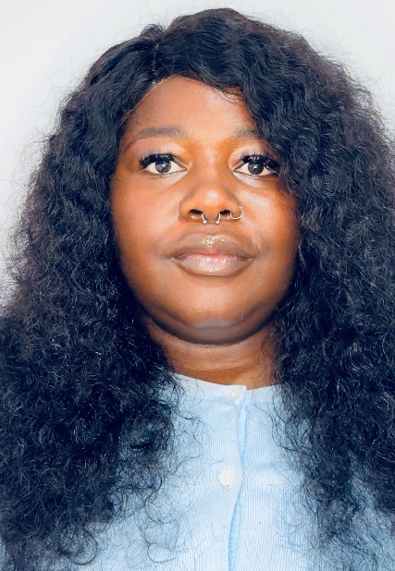
Ayomide (Joy) Adebayo-Oyetoro | Eviance
joy.adebayooyetoro@eviance.ca
Ayomide (Joy) Adebayo-Oyetoro is a Project Manager at Eviance with more than a decade of experience in project management, law, and non-profit leadership. Before joining Eviance, Joy worked with leading Canadian organizations including Moyo Health & Community Services, Egale Canada, and Up With Women, as well as in Nigeria, where she managed programs centering the voices of underrepresented groups, including racialized and 2SLGBTQI+ communities.
An internationally trained lawyer, Joy has completed part of her LLM studies at the University of Lagos and is currently requalifying as a lawyer in Canada. She is also a certified Project Management Professional (PMP).
Passionate about equity, intersectionality, and systemic change, Joy draws on her lived experience as a Black, neurodivergent, queer woman alongside her professional expertise to advance inclusive practices that build safer, fairer, and more accessible workplaces for people with disabilities.
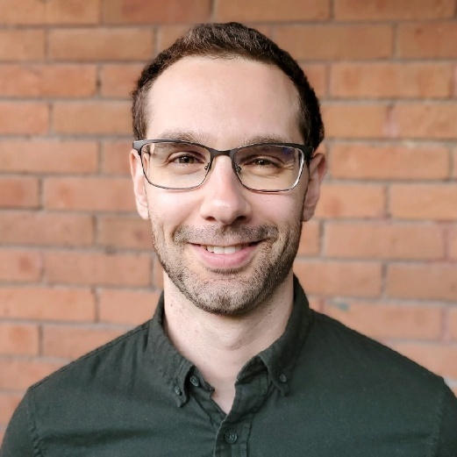
Aaron Baer
Aaron Baer runs multiple neurodivergent-friendly businesses, is a highly-sought after speaker and coach in the neurodiversity space, and has 3+ decades of lived experience with ADHD, autism, and other neurodivergences. He is Partner and Head of Corporate and Director of Training & Development with Renno & Co has partnered with The Sinneave Family Foundation’s NEUROInclusive Workforce team to deliver an Affinity Group for first-time people managers. This cohort-based program supports new leaders in building core management skills, such as delegation, giving and receiving feedback, and navigating difficult conversations, all through a neuroinclusive lens. In addition, Aaron has delivered multiple workshops to employers through our online Solutions Hub focused on neuroinclusion in practice, helping organizations and managers apply inclusive strategies in their day-to-day work.

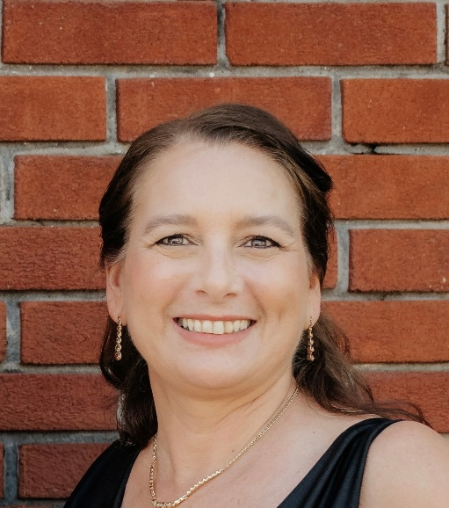
Lucille Berlinguette-Saumure | LBSAccessibility
Lucille is a bilingual, Métis woman who has lived experience with concurrent and episodic non-visible disabilities in the areas of hearing loss, mental health conditions and environmental sensitivities. With a background in Social Work, prior to creating her business called LBSAccessibility in 2024, Lucille dedicated 33 years to the City of Ottawa, fifteen of which was spent implementing the Accessibility for Ontarians with Disabilities Act (AODA), as well as local policies and programs that increased supports for residents, employees and visitors with disabilities. The goal at LBSAccessibility is to provide practical and comprehensive solutions that support legislative compliance while fostering a culture of inclusivity. In addition to her business, Lucille has participated in standard development committees at the Federal and Provincial levels. She is a certified professional with the International Association of Accessibility Professional (IAAP), completed the Rick Hanson Foundation Accessible Built Environment training, is a Governing Council member of the Canadian Accessibility Network (CAN) and was appointed to the Accessibility Standards Canada Board of Directors in 2025. Lucille believes that organizations who include people with a variety of disabilities in their decision making eliminates barriers and creates inclusive, virtual and built spaces for everyone. She encourages businesses to be accessibility champions and view their work through an accessibility lens.
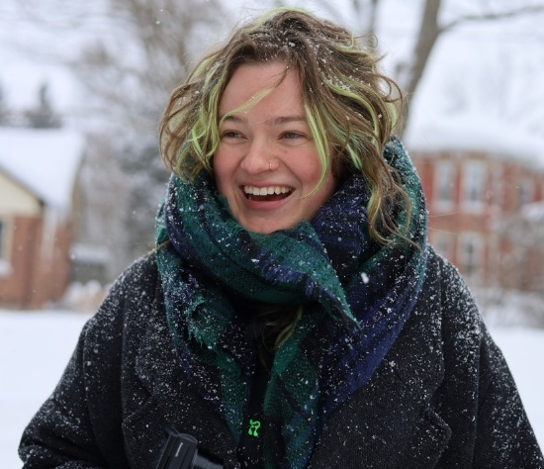
Olivia Boonstra | Eviance
olivia.boonstra@eviance.ca
Olivia Boonstra has been a Senior Research Officer at Eviance for the past 3 years. Olivia is devoted to intersectional research and disability justice and completed their Masters (MA) in Criminology and Social Justice at Toronto Metropolitan University (TMU). They have worked in community for the past ten years on various projects focused on harm reduction, anti-hate initiatives, prison abolition, student debt, climate justice, 2SLGBTQ+ rights, and gender empowerment and diversity. Olivia is committed to community based research and using research as a tool for systemic change.


Laura Bowman | Holland Bloorview Kids Rehabilitation Hospital
lbowman@hollandbloorview.ca
Laura Bowman is the Project Manager in charge of Research and Evaluation for Holland Bloorview Kids Rehabilitation Hospital’s Employment Pathways. In this role, she works with clinical, community, and policy-based partners to build disability-inclusive employment practices that enable connections between youth with disabilities and the workforce. Her work includes research, program and service evaluation, and knowledge mobilization, and draws from learning health systems, developmental, and occupational science approaches.
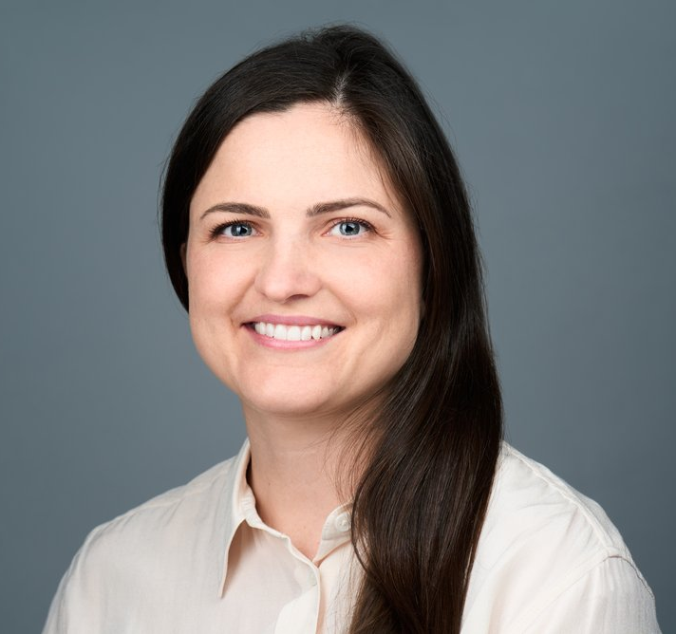
Emma Brown
Emma Brown is the Founder and CEO of Whimble, a Canadian caretech platform redefining accessibility through their platform for on-demand, client-directed care. Inspired by her brother’s lived experience with disability, she is building Whimble to ensure no one is left without support when they need it most. Since 2023, Whimble has delivered over 10,000 hours of care and partnered with organizations like Hockey Canada, Ottawa Tourism, Ottawa Bluesfest, and the Canadian National Exhibition to make major events more inclusive. With a background in engineering and nonprofit leadership, Emma is driving Whimble’s expansion across Canada and advocating for accessibility as both a human right and business advantage.

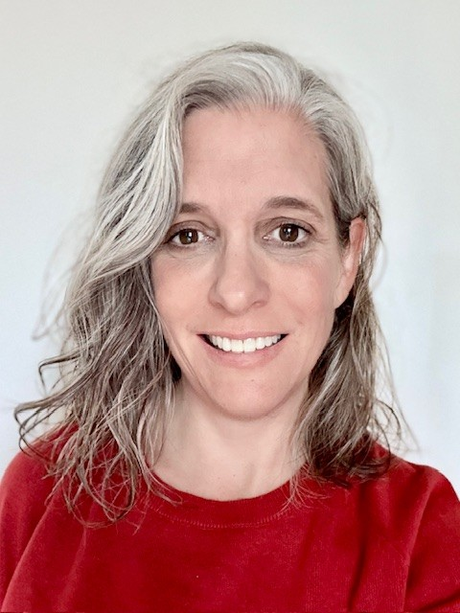
Jennifer Brown
Jennifer Brown is a frontline worker, union leader, and equity advocate with over 30 years of experience in the grocery retail sector. She serves on the executive board of UFCW 1518 and is the Human Rights, Equity, and Diversity (HRED) representative to UFCW Canada. As a worker with a disability and member of the 2SLGBTQ+ community, Jennifer brings lived experience to her advocacy for disability inclusion, workplace accommodation, and mental health. She also sits on the executive board of the Vancouver and District Labour Council and serves on committees focused on equity, political action, and social justice. Jennifer is committed to advancing fairness, accessibility, and dignity for all workers.

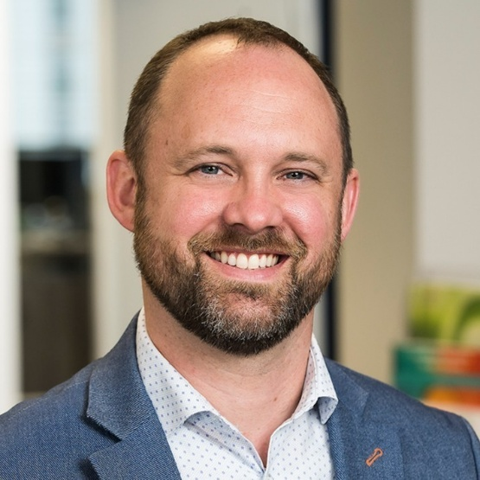
Mark Chapeskie | Vice President of Programs at Electricity Human Resources Canada (EHRC)
Mark leverages over two decades of experience to drive workforce development in the electricity sector. His expertise in research and program management has been crucial in creating strategies that bridge the gap between supply and demand for new workers, enhancing workforce mobility and adaptability.
At EHRC, Mark leads initiatives that attract and retain talent, with a strong focus on diversity, equity, and inclusion. His leadership has been key in launching programs that support youth engagement, career transitions, and continuous learning.
Mark’s role in conducting comprehensive labour market intelligence (LMI) provides valuable insights into emerging employment trends and skill gaps. This data-driven approach ensures that EHRC’s programs align with the industry’s current and future needs, positioning Canada as a leader in the global electricity market.
Mark holds a degree in Government from St. Lawrence University and a Masters in Human Security and Peacebuilding from Royal Roads University.

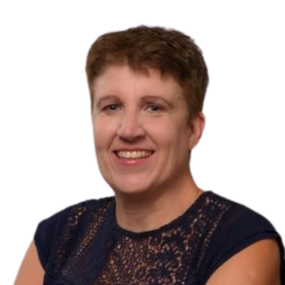
Nadine Charron
Nadine Charron is the Executive Director of the Accessibility, Accommodation, and Adaptive Computer Technology (AAACT) Program at Shared Services. With a wealth of experience in the field, Charron has dedicated her career to advancing accessibility and inclusion in various environments. Throughout her career, Charron has been a passionate advocate for the rights of individuals with disabilities, championing innovative solutions that enhance their access to technology and services. Her leadership has not only transformed organizational practices but has also inspired countless professionals to prioritize accessibility in their work. Charron’s commitment to fostering inclusive communities and her expertise in adaptive technology make her a sought-after speaker. She brings valuable insights and practical strategies for creating environments where everyone can thrive. Her work continues to make a significant impact, paving the way for a more equitable future. Charron holds a master’s degree in leadership and Adult Education, equipping her with the skills to drive meaningful change and empower individuals.

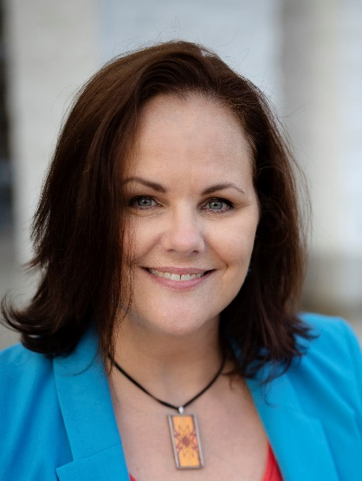
Andréane Chénier (Sounds like: An-Dray-Ann) | PhD, CRSP
Andréane is a CUPE National Health and Safety Representative from Northern Ontario. She assists CUPE members with a wide range of occupational health and safety problems by focusing on the connections between work and worker well-being. Her areas of focus include psychological health and safety, work-related violence and harassment, and conflict resolution. She is a neutral third party for conflict resolution based on common interests and a certified instructor for Mental Health First Aid.

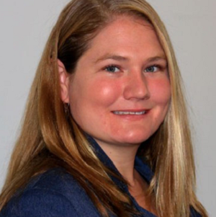
Lindsay Coffin (she/her) |Principal Research Associate | Conference Board of Canada
Lindsay is a Principal Research Associate for the Human Capital knowledge area at the Conference Board of Canada. She has been involved with numerous projects aimed at enhancing both human capital and workplace inclusion initiatives for Canadian organizations. Prior to joining the Conference Board of Canada, she researched mining industry labour market trends and inclusion initiatives with the Mining Industry Human Resources Council. Lindsay holds a B.Sc. in Earth Sciences and Chemistry from Carleton University, a Masters in Earth Sciences from the University of Ottawa, and an MBA from Carleton University.

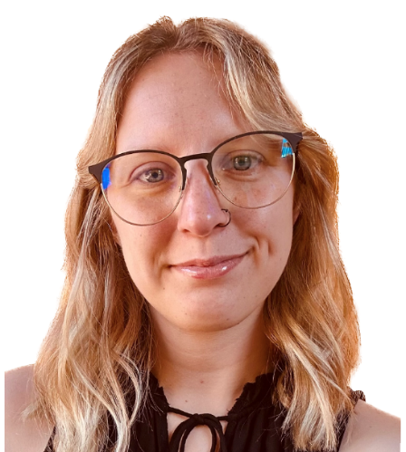
Nicole Collier | Eviance
nicole.collier@eviance.ca
Nicole Collier is a Research Officer at Eviance. She holds a Bachelor of Philosophy (BPhil) in Interdisciplinary Leadership from the University of New Brunswick, where she developed an interest in policy, entrepreneurship, and governance. Nicole comes to Eviance with previous project experience in the areas of food security, mental health advocacy, and community development, and is excited to further her knowledge and work in the area of disability justice and intersectionality.
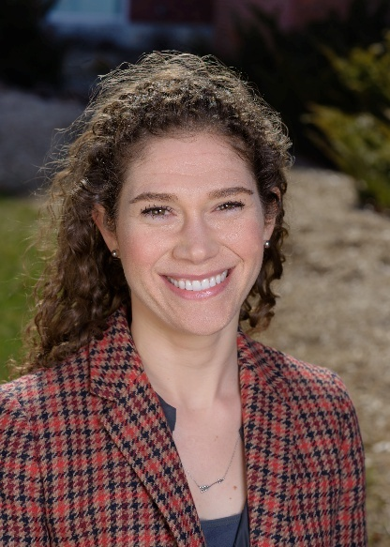
Meghan Crouch | Institute for Work & Health
Dr. Meghan Crouch is a research analyst at the Institute for Work & Health (IWH). She joined IWH in September 2023 and is part of the Inclusive Design for Employment Access’ Hub 3, Transitions to Work and Career Development team. As a qualitative health researcher, she is particularly interested in how technological advancements are changing the nature of work, employment, and working conditions and the implications for the health, safety, and well-being of workers.

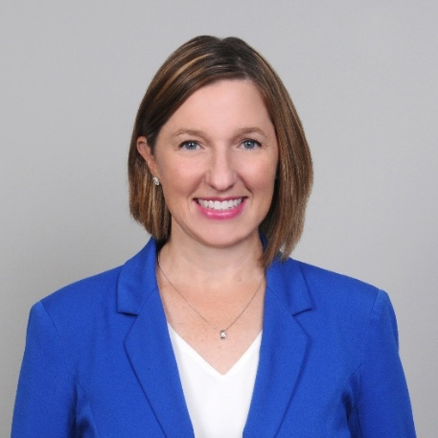
Mandi Crespo | BDO Canada
Mandi Crespo is the National Accessibility Leader at BDO Canada. She is a passionate accessibility advocate, leveraging her lived experience of disability and her expertise in inclusion to drive meaningful change for persons with disabilities. At BDO Canada, Mandi has been the Project Lead on more than 40 accessibility projects for organizations such as Accessibility Standards Canada, Coast Capital Credit Union, Canadian Tire Corporation, Capital One Canada, Employment and Social Development of Canada, TELUS, and the Trans Mountain Pipeline. She has also been a key contributor in driving accessibility and inclusion forward within BDO Canada, through her work drafting the firm’s inaugural accessibility plan and supporting internal systematic and cultural change.
Mandi was previously the Program Manager of the Canadian Accessibility Network (CAN) where she led initiatives to increase collaboration across Canada’s accessibility assets. Before joining CAN, Mandi spearheaded accessibility, benchmarking, strategy, planning, and change management efforts within post-secondary education. She specialized in managing large-scale projects related to accessibility, digital transformation, and university restructuring.
Mandi is a certified trainer and learning and development specialist. She has developed and facilitated courses for adult learners across the country.

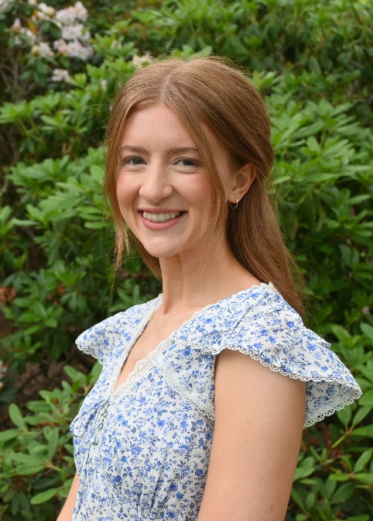
Hannah Dudney | Rehabilitation Sciences Institute, University of Toronto | Engineering Health Lab, KITE Research Institute, UHN
Hannah.Dudney@mail.utoronto.ca
Hannah Dudney is a PhD candidate (University of Toronto) and research associate (KITE) who has worked on park accessibility research for over four years, among other work on national accessibility standards and guidelines. She also has over nine years of experience working and volunteering for various disability organizations (currently CNIB). Hannah’s PhD projects aim to understand how Canadian park organizations can hire and retain more employees with disabilities. Hannah grounds her work in the lived experiences of people with disabilities and the needs of management to provoke conversation, foster critical thinking, and collaborate with change-makers in the workplace and beyond.

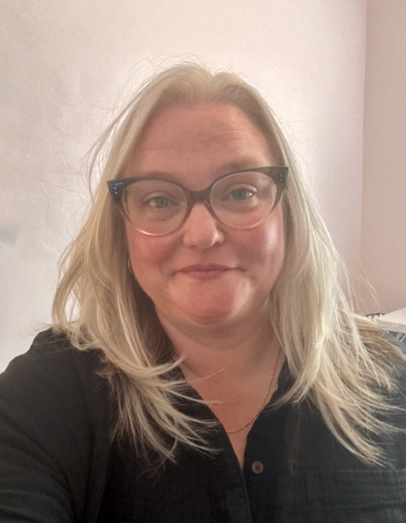
Melissa Egan | Co-Director National Programs | Realize
Melissa has over 20 years of experience in health education as a program lead, educator, and facilitator. She specializes in using community-engaged research to inform policy and practice, with a focus on creating lasting, inclusive change. Her work reflects a strong commitment to inclusion, diversity, equity, and accessibility, and she has collaborated extensively with 2SLGBTQIA+ communities and Indigenous peoples. Melissa holds a Master of Education from the University of Toronto.

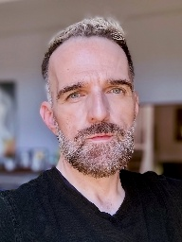
Frank Fagan | Assistant National Director, Ready Willing and Able
ffagan@inclusioncanada.ca
Frank Fagan comes from an extensive background in non-profit management and the arts. Frank has been with Ready, Willing and Able (RWA) since its inception in 2014; occupying the role of National Manager of Operations for the first 8 years and becoming the Assistant National Director as of 2022. As the Assistant National Director of RWA, Frank works with the National Director to manage and administer the overall activity of the program, in 30 primary communities across Canada. RWA works to build inclusive workplaces and increase the labour force participation of individuals on the autism spectrum or with an intellectual disability.

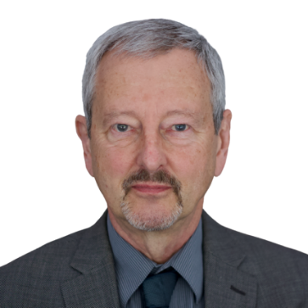
Alec Farquhar
Alec Farquhar is a lawyer with a long career in workers’ compensation and occupational health and safety law. He is the past co-lead of IDEA’s Engagement Activity Area and currently holds the position of Strategic Advisor to the initiative. Before retiring from public service in 2018, Farquhar was Director of the Office of the Worker Adviser at the Ontario Ministry of Labour, Immigration, Training and Skills Development (MLITSD) for six years, Managing Director at Occupational Health Clinics for Ontario Workers for five years, and Director of the Occupational Health and Safety Branch at the MLITSD for two years. In those roles, he worked extensively with vulnerable worker communities such as immigrant workers, women and young workers, and partnered with the employer community around dispute resolution, health and safety, and employment and retention of workers with disabilities.


Brian Foster | National Program Manager, Policy & Resource Development | Ready, Willing & Able
Brian has a diverse background in the social sciences, communications, media, politics, nonprofit operations, and academia. Brian has a PhD in history and social sciences from Carleton University, a Master’s from Western University, and a wealth of strategic and operational experience spanning nonprofits and private sector work over 17 years. For the last decade his work has focused on disability and the labour market, provincial disability policies, and housing. As the National Manager of Policy and Resource Development for Ready, Willing & Able, Brian spearheads the creation of resources for RWA and The Inclusive Workplace. He enjoys collaborating and engaging in discussions on inclusive policies from the local to the international.


Naomi Fraser
nfraser@srdc.org
Naomi Fraser (she/her) is a Principal Research Associate with the Social Research and Demonstration Corporation (SRDC), a national nonprofit dedicated to advancing policies and programs that improve the well-being of Canadians through research, experimentation, and evaluation. As research lead on the Neuroinclusive Employment Project with The Sinneave Family Foundation, she explored inclusive employment practices for people with disabilities, with a focus on neurodivergent individuals. Through evidence-based research and real-world examples from employers across Canada, Naomi and her team identified strategies employers are using to support neurodivergent workers and uncovered opportunities to further strengthen employment inclusion. The findings are aimed at helping organizations, employers, and policymakers design more effective, employer-focused initiatives with an emphasis on advancing neuroinclusion in the workplace

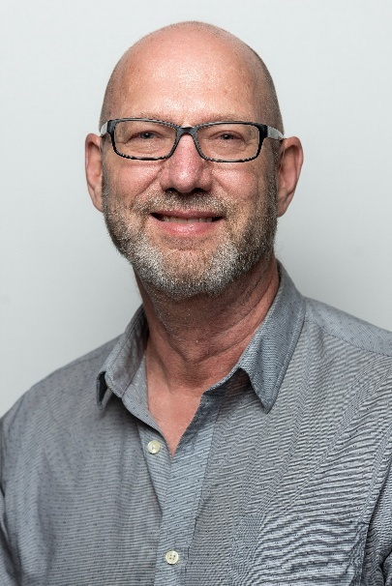
Marv Funk |Training and Education Director UFCW Canada
Learning has been Marv’s passion for three decades and he’s followed it down many paths. After earning his BA and Master of Organizational Psychology, he has practised what he learned at both Local and National levels. While working on research projects, strategic planning and comprehensive educational programs is important, he finds the solidarity developed when adults learn together has the greatest value. Networking with Local training representatives as the Chair of the Education Committee has resulted in many relevant and practical outcomes. As Director of Education for UFCW Canada, he considers it a privilege to work for all its members.


Karina Gaudier | Founder & CEO, Autism Workforce Solutions
Karina Gaudier is the Founder and CEO of Autism Workforce Solutions, a Canadian consulting firm dedicated to advancing neurodiversity inclusion in the workplace. An autistic professional with expertise in business, finance, and workforce development, Karina helps organizations redesign hiring, onboarding, and management practices to unlock the potential of autistic talent. Their upcoming book, A Practical Guide to Autism in the Workplace, offers actionable strategies for building barrier-free, inclusive organizations.

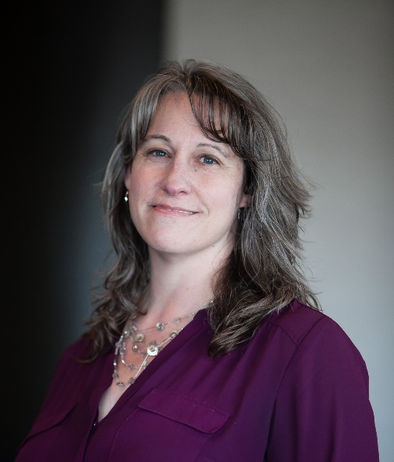
Joanna Goode
Joanna Goode (she/her) is the Executive Director at Canadian Association for Supported Employment, a national membership association committed to increasing the strength and diversity of the Canadian workforce through the inclusion of people who experience disability. She has over 30 years’ experience working for and leading non-profit organizations in service to the disability community and to increasing inclusion in Canada. Joanna has a Master’s of Leadership and Community Engagement from York University, as well as post grad certificates in Non-profit and Voluntary Sector Leadership and an undergraduate honours degree in Exceptionality in Human Learning.

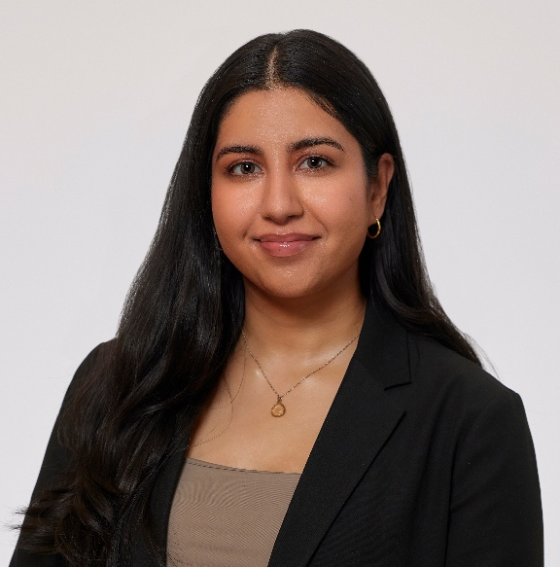
Eakam Grewal
Eakam Grewal completed her MSc in Rehabilitation Sciences at McMaster University. Her research focuses on understanding the intersecting identities of race and disability in the context of employment and is a research student with IDEA.


Jennefer Griffith
Jennefer Griffith is the Executive Director of Food Processing Skills Canada, where she has led the organization’s growth from a $150K initiative to a $20M+ national leader in workforce development, labour market intelligence, and training innovation. With over two decades of experience in the food and beverage manufacturing sector, Jennefer has launched groundbreaking programs including the Canadian Food Processors Institute, FoodSkills Library, and FoodCert. She is the architect behind Canada’s first Learning Recognition Framework for the industry and is currently leading national efforts in labour market analysis and post-secondary accreditation. As a passionate champion of inclusive employment, Jennefer designs strategic, results-driven training programs that boost organizational performance, improve workplace culture, and generate strong returns on investment. She cultivates high-level partnerships across government, academia, and industry to drive lasting impact. She is the 2024 Food Safety Professional of the Year and the 2023 recipient of the Excellence in Agriculture Award for Educational Development. She is an accomplished nonprofit executive and sector strategist. She serves on multiple national advisory committees and brings deep expertise in stakeholder engagement, cross-sector collaboration, and sustainable sector growth.

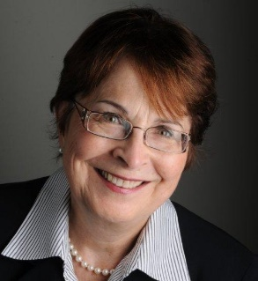
Mary Gusella | Volunteer Chair of the Federal Employment Strategy Group (FESG)
mary@liveworkplay.ca
Mary Gusella retired as Chief Commissioner of the Canadian Human Rights Commissions following a 36-year Public Service career. Her public sector experience includes serving as a Deputy Minister, a Chairperson of both a Crown corporation and a private sector corporation under the Canada Not-for-profit Corporations Act (CNPCA), Head of Agency, CEO of a Crown Corporation, Chair of a bi-national (Canada/US) organization, and Commissioner of the Public Service Commission as well as 14 years serving on boards of directors. Mary’s directorship roles included 7 years as Chair of the Board of the Commission for Complaints for Telecommunications Services, a unique stakeholder-led, industry-funded organization with the independent authority to resolve complaints, Director on the Board of the Ontario Human Rights Legal Support Centre and Commissioner of the Ontario Human Rights Commission until end of 2019. Mary has been a volunteer with LiveWorkPlay since 2014 and Chair of the Federal Employment Strategy Group under the Inclusive Employment Initiative. In 2015, she was awarded the Prime Minister’s Outstanding Achievement Award, the Public Service’s highest award, for “Outstanding contribution to the Public Service of Canada.” She Received the Queen’s Jubilee Medal and was inducted into the Honour Society of the University of Ottawa Law School. Mary received the United Way Community Builder’s Award in 2020.

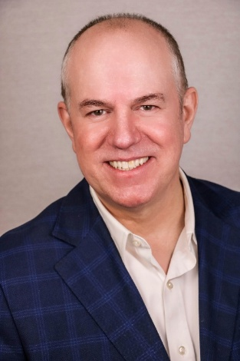
Rob Henderson | BioTalent
Rob Henderson is President and CEO of BioTalent Canada, where he’s led the organization’s growth into a national leader in bioscience talent development. With over 30 years of executive experience, Rob has helped connect thousands of Canadians to careers, championed workplace diversity, and advised governments on HR strategy. He’s a bilingual Quebec native, a biology graduate, and a passionate advocate for inclusion and the life sciences.

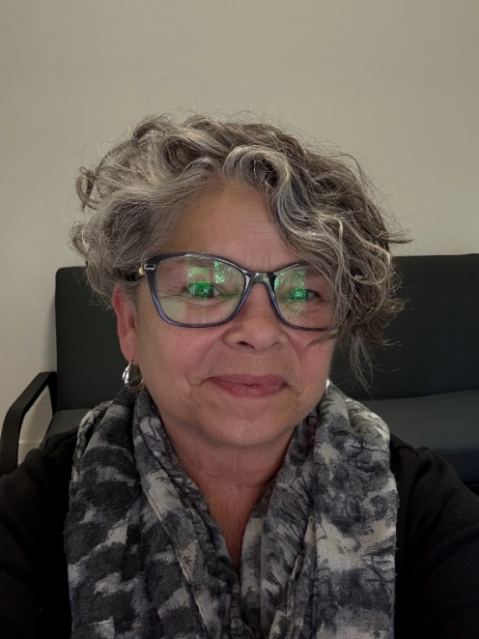
Beth Hutchison
Beth Hutchison is a proud Deaf mother of three Deaf adult children. With more than 35 years of experience in the Deaf community, she has worked across a wide range of fields, including Deaf literacy, ASL instruction, ASL translation, ASL interpreting, and mentoring ASL interpreters. Before retiring from her role as a VRS Manager with Asign, Beth chose to bring together her extensive experience to become a freelance Deaf Interpreter and ASL consultant, collaborating with various agencies across Canada. Her greatest joy is seeing her three children follow in her footsteps, continuing the family’s dedication to the Deaf community in breaking down barriers on a daily basis.

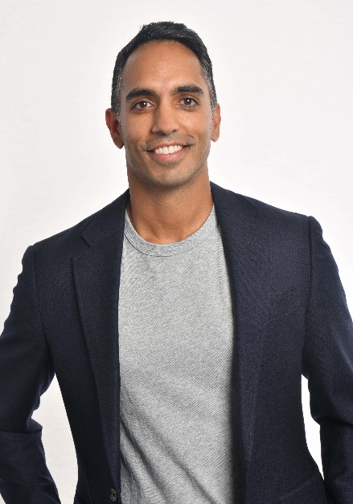
Dr. Arif Jetha
Dr. Arif Jetha is Associate Scientific Director at the Institute for Work & Health and Associate Professor at University of Toronto’s Dalla Lana School of Public Health. He researches how the future of work—particularly artificial intelligence—affects worker health, safety, and wellbeing. He directs the seven-year federally-funded Partnership on AI and the Quality of Work (PAIQ). Arif is co-lead of the Transitions to Work and Career Development hub within the Inclusive Design for Employment Access Social Innovation Laboratory.


Mathilde Lefebvre | M.A.P, Directrice | Centre de formation de l’alimentation et du commerce du Québec (CFACQ)
Mathilde Lefebvre’s career is resolutely focused on community service. After completing an integrated bachelor's degree in economics and politics at Université Laval, she carried out various consulting and communications mandates with Québec politicians of all government orders. She then changed direction by obtaining a master's degree in public administration, while holding key positions within non-profit organizations of varied missions. She now is the director of the Centre de formation de l'alimentation et du commerce du Québec (Québec’s Training Center for Food and Commerce Workers), a non-profit founded by UFCW 500. Mathilde uses her understanding of social issues and her knowledge of the community sector to build partnerships to develop members and future members' skills.

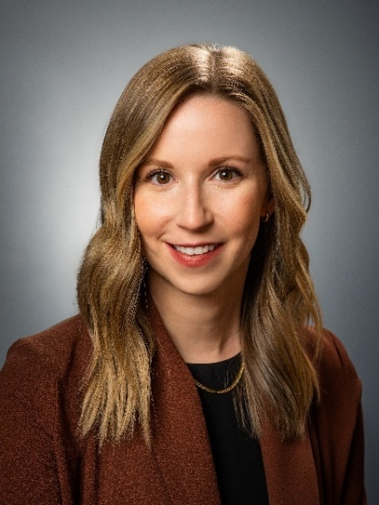
Mayme Lefurgey
Mayme is the Research Manager at CBDC Restigouche in Mi’gma’gi where she leads and collaborates on various national and regional qualitative and mixed-methods research projects, including with Hire for Talent. Hire for Talent is a Canada-wide awareness campaign that aims to increase employer awareness about disability inclusion in the workplace and provides resources to help employers to help build their capacities to be inclusive employers.
Mayme is also an Adjunct Professor at the Department of Sociology at the University of New Brunswick and holds a Ph.D. in Gender, Sexuality & Women’s Studies (collaborative program in Transitional Justice & Post-Conflict Reconstruction) from Western University.


Lisa Liskovoi
Lisa Liskovoi is an inclusive designer and digital accessibility specialist at OCAD University’s Inclusive Design Research Centre, where she leads accessibility consulting, training, and standards work. She has contributed to national ICT accessibility guidelines and published research in psychology.

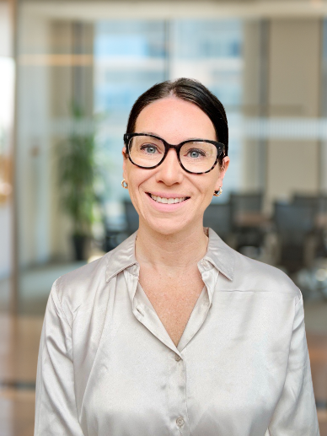
Sheri Little | CCRW
slittle@ccrw.org
Sheri Little is the National Director of Programs at CCRW, bringing over a decade of experience in the employment sector. With more than five years dedicated to program development, she has led initiatives focused on closing the employment gap between persons with and without disabilities, helping individuals find meaningful employment. Sheri has contributed to the development of programs that have positively influenced employment opportunities across the country. At the DWC, she is eager to share her insights, supporting and inspiring fellow professionals to advance employment equity for all.

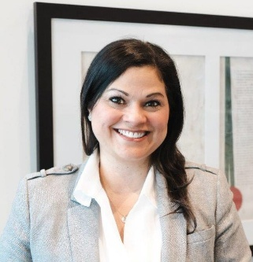
Lina Lopez
Lina Lopez is a highly experienced Project Manager leading complex initiatives in standards development, occupational health and safety, and inclusive workplace practices. At CSA Group, she works in the Health and Safety Standards Division, where she manages national and international standards projects focused on psychological health, disability management, equity, and occupational health and safety.
Lina has over 20 years of experience in project and program management across sectors including healthcare, publishing, and standards development. She is a passionate advocate for accessibility and inclusion, helping ensure that standards reflect the needs of all workers, including people with disabilities.
Her strategic relationship-building skills and results-driven leadership have contributed to the development of impactful national standards, research publications, and educational programming. Lina holds a BA (Honours) in Psychology from York University, and a post-diploma certification in corporate communications and event management.


Emmanuelle Lopez-Bastos | National Coordinator for Human Rights, Equity and Diversity | UFCW Canada
Emmanuelle (She/Her) works and plays on territory stewarded by Mississaugas of the Credit First Nation. As UFCW Canada’s National Human Rights, Equity and Diversity Co-ordinator, Emmanuelle leads national equity-focused strategic programming and advocacy initiatives dedicated to building worker power through an anti-oppressive, intersectional, and feminist approach. Emmanuelle has a 25+ year track record of representing injured workers, mobilizing anti-ableist strategies and leading activism to strengthen disability inclusion on the job and in society at large. She is a proud member of the Accessible Standards Canada Technical Committee on Employment. She also serves as Chair of the union’s national Human Rights, Equity and Diversity Committee, the UFCW Canada national Indigenous Committee and she is an Executive Committee member of UFCW OUTreach, the union’s 2SLGBTQ+ constituency group.

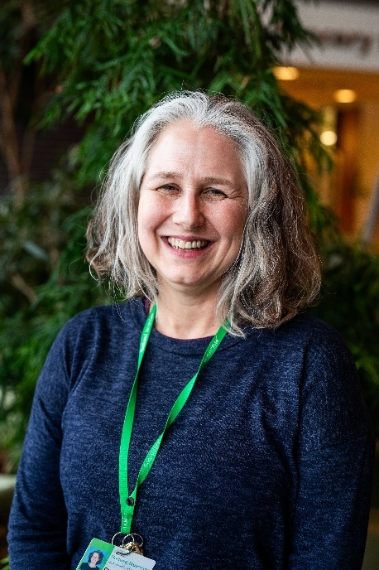
Carolyn McDougall | Holland Bloorview Kids Rehabilitation Hospital
cmcdougall@hollandbloorview.ca
Carolyn McDougall is the Manager of Holland Bloorview Kids Rehabilitation Hospital’s Employment Pathways, supporting 60+ high school aged youth with disabilities annually to get critical early work experiences. She is also the Business Liaison for Holland Bloorview’s co-site host role for Project SEARCH Toronto and supports coordination amongst Canada’s Project SEARCH sites. Carolyn's research and community partnership interests relate to: work-based learning, transitions to adulthood, life skills, family involvement and systems coordination.


Douglas (Doug) McConnachie | Chief Financial Officer and Assistant Deputy Minister, Corporate Management Sector | Innovation Science and Economic Development
douglas.mcconnachie@ised-isde.gc.ca
Douglas (Doug) McConnachie was appointed Chief Financial Officer and Assistant Deputy Minister, Corporate Management Sector at Innovation, Science and Economic Development (ISED) in October 2019. In this role, he is accountable for the stewardship of a voted appropriation of over $8.5B as well as the provision of human resources, corporate planning, accommodation and security management services to roughly 6,500 FTEs throughout Canada. Doug has 30 years of experience in public sector management and corporate finance and has served in senior management roles at Environment and Climate Change Canada, Public Safety Canada and Public Services and Procurement Canada. He is a Chartered Professional Accountant who holds a Master of Business Administration from McGill University and a Bachelor of Arts from Queen’s University.
Doug is a champion of diversity, equity, inclusion and accessibility, having led ISED’s strategy to increase representation and inclusion of individuals from equity-deserving groups by removing barriers to hiring, retention, development and promotion and by fostering an anti-racist and discrimination-free workplace.
Doug and his wife have an amazing and enigmatic son who is on the autism spectrum as well as two strong and independent daughters who are adopted from Colombia.


Alfred McLeod
Alfred MacLeod was appointed to the position of Assistant Deputy Minister of Public Service Accessibility at Treasury Board of Canada Secretariat in October 2018. From 2017 to 2018, McLeod was Assistant Deputy Minister at Public Services and Procurement Canada, where he oversaw the Canada Post Corporation Review. Previously, McLeod was Assistant Deputy Minister of PSPC’s Policy, Planning and Communications Branch. Other experience includes a 2-year Executive Interchange with CBC/Radio-Canada as Executive Director of Corporate Affairs, as well as previous Assistant Deputy Minister positions at the Privy Council Office and Citizenship and Immigration Canada. Before joining the federal public service, McLeod was Senior Vice-President, Public Policy, at EKOS Research Associates Inc. Alfred holds bachelor’s degrees in history and education from Acadia University, and a MPhil (Politics) from the University of Exeter. He is a graduate of the Australia and New Zealand School of Government’s Executive Fellows Program.


Tanya McLeod
Tanya McLeod (she/her) is President of The Sinneave Family Foundation in Calgary, Alberta; a national organization committed to providing value to the community by coordinating and investing in a portfolio of purposeful initiatives and projects aimed at enhancing opportunities in education, employment and housing for Autistic youth and adults. Tanya is pleased to lead the national EmploymentWorks Project that has two streams of activity. The first stream supports working age Autistic Canadians and persons with disabilities to prepare for, get and keep jobs and the second stream supports employers to advance neuroinclusion in their workplaces. She has also championed collective efforts toward enhancing economic inclusion of persons with disabilities through networked initiatives including Worktopia, the Alberta Employment First Network, and Autism Alberta’s Alliance Employment Community of Practice. Tanya is committed to working with community to influence systems and policies to better understand and meet the needs of Autistic Canadians.


Angeli Mehrotra
Angeli Mehrotra is an EDI Employment Engagement Specialist at the University of Guelph. With over 15 years of experience in equity, diversity, and inclusion in employment, she has built her career in the not-for-profit sector, working to connect employers, community partners, and job seekers in ways that foster growth and opportunity. Since joining the University in 2021, Angeli has focused on supporting equity-deserving students, creating meaningful partnerships, and ensuring they have access to the resources they need to succeed. She is passionate about building inclusive pathways and helping students, employers, and community partners work together to reach their goals.

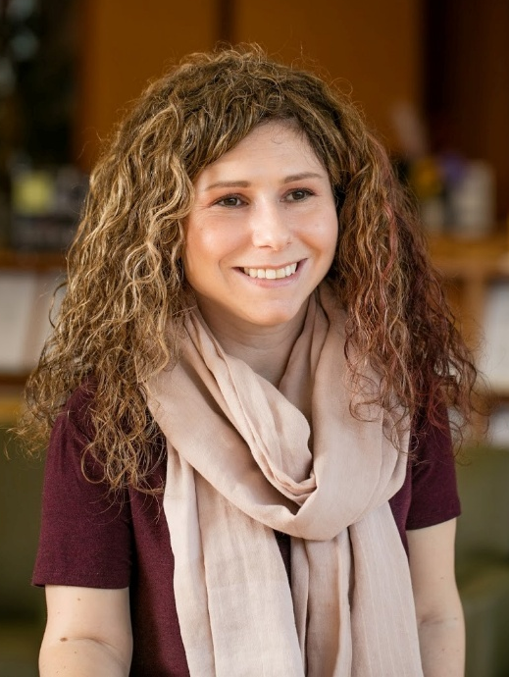
Dolly Menna-Dack | Holland Bloorview Kids Rehabilitation Hospital
dmennadack@hollandbloorview.ca
Dolly is the Senior Bioethicist and Manager of the Youth Engagement Strategy at Holland Bloorview Kids Rehabilitation Hospital. She is particularly interested in ethical issues that arise in both clinical care and research with children and youth with chronic illness and disabilities. Dolly is a nationally and internationally sought after leader in Lived Experience roles and has been leading Youth Engagement Strategy at Holland Bloorview since its inception in 2012. She has a Clinical Team Investigator appointment with the Bloorview Research Institute and collaborates with research teams that focus on patient partnership in the healthcare and research, as well as youth employment.


Elizabeth Mohler
Elizabeth Mohler (ABD) is a doctoral candidate at Western University in the department of Health and Rehabilitation Science, Occupational Science Field; she holds a 4-year SSHRC fellowship. Her work discourses and practices within Direct Funding shape how disabled persons access services, and in what ways service users resist and negotiate these discourses.
Elizabeth holds a BA from Wilfrid Laurier Brantford in Contemporary Studies and an MSC from Western University in Occupational Science. Elizabeth runs a consulting business (EM Disability Consulting) where she helps companies develop accessibility plans under the Accessible Canada Act and the Accessibility for Ontarians with Disabilities Act.
Elizabeth currently is the vice-president for the Society of Graduate Students at Western University. Elizabeth brings a human approach to activism, and her work in this space includes sitting on the Canadian Institute of Health Research External Advisory Committee on Accessibility and Systemic Ableism; co-authoring a book on accessibility in the sciences; and, presenting for large and small groups on accessibility and inclusion within higher education.

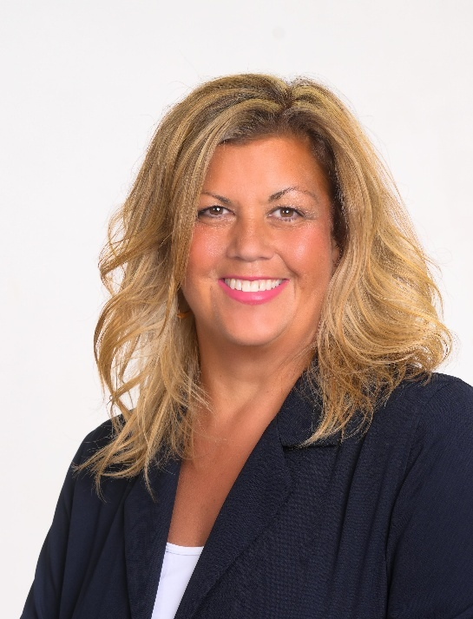
Tammy Morris | Accessibility & Neuroinclusion Leader | EY Canada
Tammy Morris is a dynamic and seasoned leader dedicated to advancing innovation and fostering inclusion. As Leader of Canada’s Accessibility and Neuroinclusion Consulting practice, she empowers EY Clients with customized methodologies to assess, design, and scale forward-thinking initiatives within their organizations. With a diverse background spanning non-profit management, healthcare, academia, and consulting for major G360 firms in the private sector and across industry, Tammy is deeply committed to celebrating our collective belonging.
Tammy has been a catalyst for systemic change across various organizations and industries, playing a pivotal role in building high-performing diverse teams in fields such as AI, data science, cybersecurity, and engineering. In clinical and healthcare administration settings Tammy worked to create innovative healthcare programs and opportunities for those most impacted by disability, including their families and support systems. Tammy has been a professor of graduate studies in Communication Sciences and Special Education at the University of Michigan, Eastern Michigan University, and Wayne State University.
Engaging with the disability community, Tammy leads EY Canada’s Abilities Network internally and represents EY on the Canadian Accessibility Network Advisory, the Supported Employment Alliance, and Canadian Business Disability Inclusion Network board. Working with many academic and nonprofit partners, she is an active member of domain area committees and research projects focused on accessibility and inclusive employment to build a more inclusive working world.
Tammy is enthusiastic about facilitating conversations that create opportunities for all, positioning businesses at the forefront of inclusivity and innovation that benefits all of us.

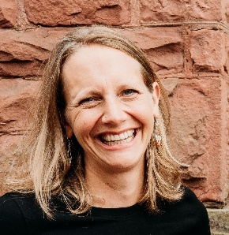
Anna Nelson | Director of Employment Supports | LiveWorkPlay
anna@liveworkplay.ca
Anna Nelson is the Director of Employment Supports at LiveWorkPlay, where she leads initiatives that create pathways to employment for people with intellectual disabilities and autistic job seekers. Since joining LiveWorkPlay in 2017, Anna has been at the forefront of advancing inclusive hiring practices, working closely with public and private sector employers to turn awareness into action. Anna believes that true progress in inclusive employment is measured not only by opportunities created but by seeing individuals thrive and grow within their roles. This belief fuels her daily work to dismantle barriers and foster lasting workplace inclusion. Anna is the mother of two active children and an avid outdoors enthusiast who enjoys trail running, hiking, camping, canoeing, cross-country skiing, and exploring the wilderness.


Jeffrey Normore | CCRW
jnormore@ccrw.org
Jeffrey Normore is the Director of Digital Operations at the Canadian Council on Rehabilitation and Work (CCRW). Jeffrey oversees the organization’s IT, CRM, cybersecurity, eLearning, websites, and digital marketing. Jeffrey is driven by a passion to leverage accessible and inclusive technology to promote and support meaningful and equitable employment for people with disabilities across Canada. Jeffrey has worked over a decade in the non-profit sector and also serves as the Chair of the Government of Newfoundland and Labrador’s Accessibility Standard Advisory Board.

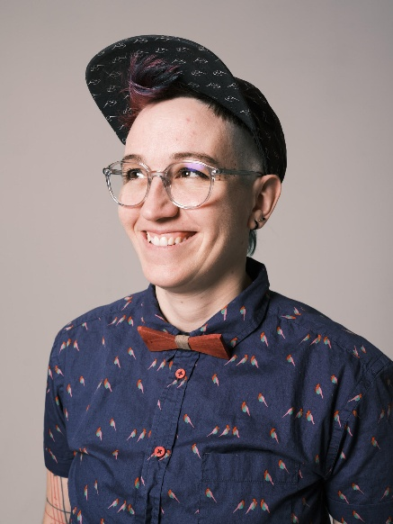
LN
LN (il.they.them) is a parent, PhD candidate, carpenter, executive director, barber, speaker: previous teammates forebodingly gave them the nickname Polyvalent Platypus. Navigating life as a trans non-binary, neurodivergent and disabled worker and researcher has shaped their inclusive and caring manager's posture. Challenging statuquo, be it for better care, more social justice or to foster innovations to change society comes naturally for them.


Nkem Ogbonna
Nkem Ogbonna (they/them) is a queer, non-binary, neurodiverse, first-generation Nigerian committed to advancing equity using a Black Feminist Disability framework in community-based research and person-centred health advocacy. They aim develop transformative public health and policy solutions that centre the lived experiences of their communities, pulling from their community-based research highlighting the experiences of a) disabled students navigating post-secondary, b) young ACB women navigating the justice and employment systems, and c) the sexual and reproductive health of Black women and gender-diverse people with disabilities during the COVID-19 pandemic. Previously, as a hospital-based Inclusion, Diversity, Equity, Accessibility, and Anti-Racism (IDEAA) Consultant, Nkem worked with healthcare professionals to actualize anti-oppressive and intersectional frameworks into institutional culture and hospital policies. Currently, they are the Manager of the National Black Disability Coalition at the Ase Community Foundation for Black Canadians with Disabilities, collaborating with advocates and partners across Canada to address systemic inequities, build national support networks, and expand leadership opportunities through research, advocacy, and community engagement.


Francis Pineda
Francis Pineda is passionate about workers’ health and safety. He is the current Regional Coordinator, Training & Development at Prevention Link. He previously worked as a Community Legal Worker to support injured workers with navigating the Workplace Safety & Insurance Board. Both through his Bachelor of Arts in Disability Studies and in his ongoing efforts across workplaces, Francis believes that every worker deserves fair and safe working conditions.

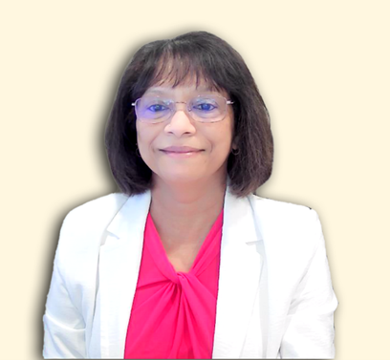
Rohini Peris | President & CEO, Environmental Health Association of Canada and the Environmental Health Association of Québec
Rohini Peris is a nationally recognized leader and advocate for people living with Multiple Chemical Sensitivity (MCS). As President and CEO of the Environmental Health Association of Québec and the Environmental Health Association of Canada, she has spent nearly 30 years advancing awareness, policy reform, and support systems for individuals affected by Multiple Chemical Sensitivity. A passionate and strategic changemaker, Rohini has led national collaborations to promote inclusion and accessibility for people with MCS. She brings lived experience to her leadership, combining empathy with evidence-based advocacy to influence lasting change. Her initiatives span education, policy, research, and community outreach, including the development of best practices for MCS accommodation.

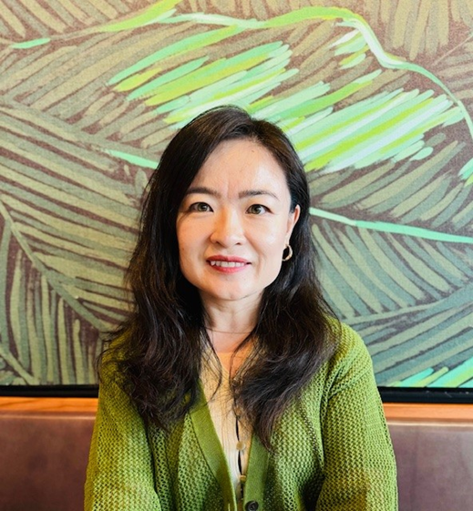
Jiaxuan (Jasmine) Qi
Jiaxuan (Jasmine) Qi is the Director of Workforce Inclusion at Tourism HR Canada, where she leads transformative initiatives to integrate equity-deserving groups into the tourism workforce and promote Diversity, Equity, Inclusion and Accessibility (DEIA) within workplaces. With a strategic approach, Jasmine designs and manages high-impact projects, develops compelling proposals, and conducts thorough policy research and analysis. Her passion for fostering inclusivity drives her mission to create a community where everyone feels they belong. Jasmine brings a wealth of expertise in diversity, equity, and inclusion, human resource management, stakeholder engagement, immigrant settlement and integration, career development, employment counseling, mentorship, and program and proposal development. Her vast experience ensures that she not only leads with purpose but also advocates effectively for inclusive workplaces across the tourism sector.
As a visible minority immigrant woman, Jasmine is deeply committed to championing DEIA within both workplaces and the wider community. She believes in creating equitable opportunities for all and is dedicated to empowering individuals to realize their full potential. Jasmine's work reflects her unwavering belief in the power of inclusion to transform lives and strengthen communities.

Bob Rae
Bob Rae is the Ambassador and Permanent Representative of Canada to the United Nations in New York. He has served in this post since August 4, 2020. Since assuming this role has been active in all aspects of the work of the UN, culminating in his election to the Presidency of the Economic and Social Council (ECOSOC) for 2024-25, the second Canadian to assume this role, and joins Lester Pearson (President of the General Assembly 1952-53) and George Davidson (ECOSOC 1958-59) as Canadians elected in their personal capacity to preside over UN Charter bodies.

Lori Riding | Halton Healthcare
lriding@haltonhealthcare.com
Lori Riding is a Certified Disability Management Professional with 20 years of experience in both the private and public sectors, most recently in healthcare. She is passionate about supporting workers in safe and sustainable return-to-work plans, including modified duties and accommodations. She is committed to helping individuals succeed by highlighting their strengths and fostering inclusive, supportive workplaces.

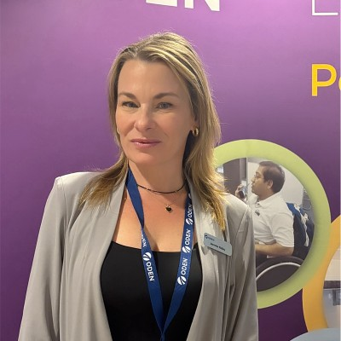
Jenn Ridley | Ontario Disability Employment Network (ODEN)
jridley@odenetwork.com
Jenn Ridley is a seasoned employment professional with over 15 years of experience in both non-profit and private sectors. She has held roles ranging from Job Developer to Talent Acquisition Manager, with expertise in inclusive hiring, capacity building, and partnership development. Now at the Ontario Disability Employment Network (ODEN), Jenn brings a deep personal and professional commitment to breaking down barriers and creating meaningful employment opportunities for people who have a disability.

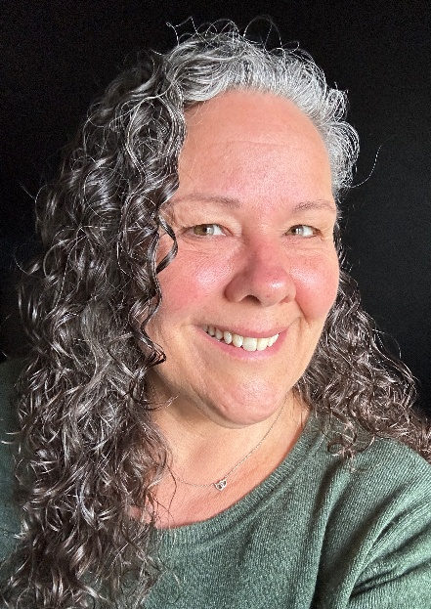
Connie Russell | Director of Community Support Services, Silent Voice Canada
c.russell@silentvoice.ca
Connie Russell is the Director of Community Support Services at Silent Voice Canada, bringing over 30 years of leadership experience supporting the Deaf community. She is a passionate advocate for accessibility, inclusion, and equity, overseeing essential programs that support Deaf and Hard of Hearing individuals—including newcomers—in accessing the resources and opportunities they need to thrive. Connie believes that when workplaces include Deaf talent, they become stronger, more innovative, and more equitable.

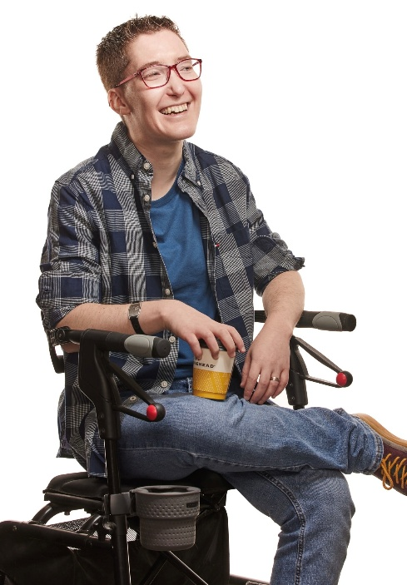
Zoey Schvan
Hi! My name is Zoey Schvan (they/them), I'm a disabled entrepreneur with a rare condition called familial dysautonomia. My experiences being disabled in the business world inspired my business, Spoonie Table.
I work to create a safe space for other spoonies, by offering coaching, speaking, writing, and access testing. I'm always looking to connect and collaborate with like-minded people!


Claudia Sendanyoye | She/Her
Claudia Sendanyoye is an accessibility advisor and systems-change specialist advancing anti-ableist and anti-sanist policies and practices across healthcare, research, employment and post-secondary education. Currently as an Accessibility Research Associate at IDEA-STEM, she works on inclusive science initiatives that address systemic barriers and promote disability justice. Claudia contributes to provincial, national and international accessibility dialogues through her advisory roles with CAMH, Ontario’s Mental Health and Addictions Centre of Excellence, the National Black Disability Coalition, and CERC’s IDEA Global Research Innovation Advisory Committee.


Vanessa Sinclair | CCRW
vsinclair@ccrw.org
Vanessa Sinclair, PhD is the Director of Research and Evaluation at the Canadian Council on Rehabilitation and Work (CCRW). Vanessa is a social scientist and community-based researcher whose research interests include workplace inclusion; stigma, attitudes, and attitude change; and labour market participation. She received her doctorate in social psychology at Western University and has been leading CCRW’s disability and employment research initiatives for the past 4 years.


Dr. Mahadeo Sukhai | He/Him
Dr. Mahadeo Sukhai is the world’s first congenitally blind geneticist. Currently the Chief Operating Officer of IDEA-STEM, an organization dedicated to improving the accessibility of science, technology, engineering, mathematics and healthcare education, research, training and work, Mahadeo has more than 20 years’ experience as an accessibility and inclusion professional, and as a researcher within this space, as well as more than 25 years’ experience as a scientist, researcher and educator in the medical sciences and healthcare related disciplines. Dr. Sukhai is a leading expert on accessibility of postsecondary education and employment for persons with disabilities. Dr. Sukhai is one of the originators of the discipline of and discourse on accessibility and inclusion in the sciences and in healthcare. He is the Chair of the Employment Technical Committee for Accessibility Standards Canada, tasked with developing accessible employment standards, as well as the External Co-Chair of the Canadian Institutes of Health Research Expert Advisory Committee on Accessibility and Systemic Ableism. Mahadeo also serves on the Boards for Health Data Research Network Canada and the Institute of Neurodiversity Canada and is a member of the steering committee for Disability and Work in Canada. Dr. Sukhai currently holds adjunct faculty appointments in Queen’s Heath Sciences at Queen’s University (Kingston, ON); the Faculty of Business and Information Technology at Ontario Tech University (Oshawa, ON); and, in Inclusive Design at OCAD University (Toronto, ON). Mahadeo coaches and consults on accessibility and inclusion strategy, on inclusive leadership practice, and on conducting scientific research in accessible and inclusive ways.

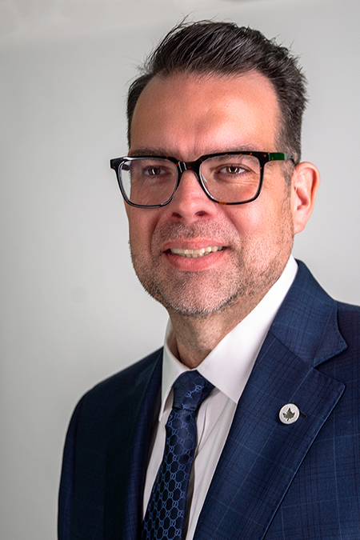
Christopher T. Sutton
Christopher T. Sutton was appointed Accessibility Commissioner at the Canadian Human Rights Commission in May 2025. Mr. Sutton's work is influenced by both his professional expertise and lived experiences of advocating for accessibility as a fundamental human right in Canada. Before his appointment to the Commission, Mr. Sutton served as the Chief Executive Officer of Wavefront Centre for Communication Accessibility, where he spearheaded initiatives focused on hearing healthcare, accessible communication, and inclusive technology solutions. Under his leadership, Wavefront Centre significantly expanded its programs and services, strengthened strategic relationships, and emerged as a national leader in communications accessibility. A recognized thought leader in inclusion, diversity, equity, and accessibility, he has also held leadership roles across the not-for-profit, public, and start-up sectors in both Canada and the United States. Throughout his career, Mr. Sutton has worked closely with disability communities to ensure that accessibility policies are intersectional and inclusive. He has played a significant role in shaping Canada's accessibility policies and legislation at both the federal and provincial levels, including the Accessible Canada Act and the Accessible British Columbia Act.
Originally from St. John's, Newfoundland and Labrador, Mr. Sutton holds a Bachelor of Arts in Political Science from Gallaudet University and an MBA from the Ivey Business School at the University of Western Ontario.

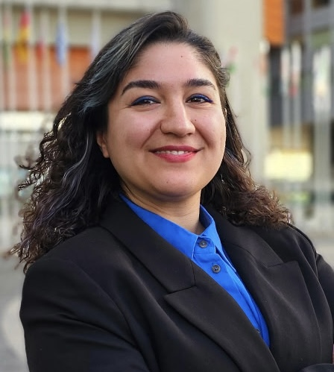
Mahsa Tahzibi | Community and Employment Specialist, Silent Voice Canada
employment@silentvoice.ca
Mahsa Tahzibi is a Community and Employment Specialist at Silent Voice Canada, with expertise in employment advocacy, community engagement, and culturally accessible services for Deaf individuals. She is committed to advancing Deaf rights and equity, particularly in employment and healthcare access for Deaf newcomers. Mahsa’s work highlights how Deaf professionals contribute innovation, creativity, and inclusive solutions within today’s workplaces.

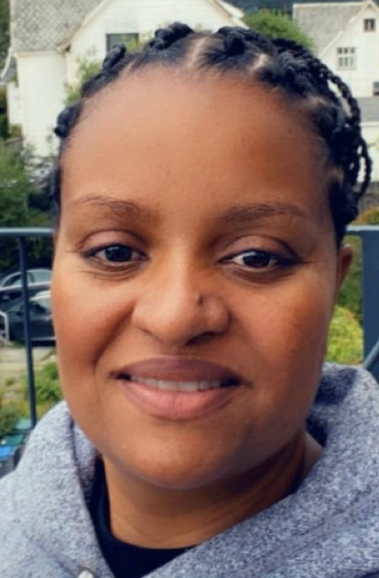
Mihret Tekle | Settlement Worker, Silent Voice Canada
m.tekle@silentvoice.ca
Mihret Tekle is a Settlement Worker at Silent Voice Canada, where she supports Deaf newcomers in building meaningful and independent lives in Canada. Originally from Eritrea, she draws on her lived experience as a Deaf immigrant to guide and empower others throughout their settlement journey. Mihret’s story demonstrates how inclusion, mentorship, and accessible workplaces strengthen both individual success and Canada’s diverse, innovative workforce


Emile Tompa
Emile Tompa is the is Executive Director of IDEA, co-lead of IDEA’s Hub on Workplace Systems and Partnerships, and a Senior Scientist at the Institute for Work & Health (IWH). A labour and heath economist, Tompa holds appointments as Associate Professor in the Department of Economics at McMaster University and as Assistant Professor at the Dalla Lana School of Public Health at the University of Toronto. Tompa’s current research focuses on analyzing the nature and impact of disability, health and safety systems, conducting economic evaluations of workplace interventions for primary and secondary prevention, and understanding the impact of labour market experiences on health and well-being. Tompa has a PhD in labour and health economics from McMaster University, an MBA from the University of British Columbia, and an MA in economics from the University of Toronto.


Sunny Wang | Knowledge to Action Officer | Realize
Sunny is a curious and dynamic public health professional who leads the monitoring and evaluation of Realize’s initiatives centred on employment and disability. She is dedicated to improving resource access through education, story-telling, and policy change. Sunny is particularly interested in the ways policy affect women’s health and social mobility. She is grateful to hold a Master of Public Health from the University of Washington and a Bachelor of Science from the University of Toronto.

Jennifer Way | March of Dimes Canada
jway@marchofdimes.ca
Jennifer Way is the Senior Manager for Skills Development and Employment - March of Dimes Canada, with over 20 years of experience supporting individuals with disabilities in finding meaningful work. She believes that building strong community relationships and collaboration is the key to driving real change in inclusive employment. Jennifer is passionate about experiential skills development as a powerful way to prepare people with disabilities for success in the workforce.
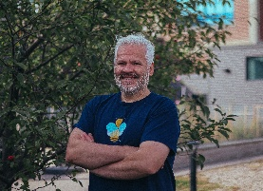
Keenan Wellar | Co-Leader and Director of Communications | LiveWorkPlay
keenan.wellar@liveworkplay.ca
Keenan Wellar has served as Co-Leader and Director of Communications for charitable organization LiveWorkPlay since 1997. LiveWorkPlay has earned numerous accolades, including Ottawa Board of Trade’s Best Non-Profit of 2019, Canadian Association for Supported Employment service provider of the year for 2021, and the Ontario Disability Employment Network's innovation award in 2024. Keenan has an MA in Applied Linguistics from Carleton University as well as degrees in History and Education with Ontario Teacher Certification from the University of Ottawa and is BoardSource Certified Governance Trainer. Keenan engages in a variety of advocacy initiatives related to community inclusion, housing, and employment, and has been recognized with a Community Builder award from the United Way. He serves as LiveWorkPlay’s media spokesperson, with more than 250 radio, TV, and print appearances to date, and enjoys serving as an MC and event host at multiple annual events. He enjoys kayaking and nature photography as well as the local music and sports scene.

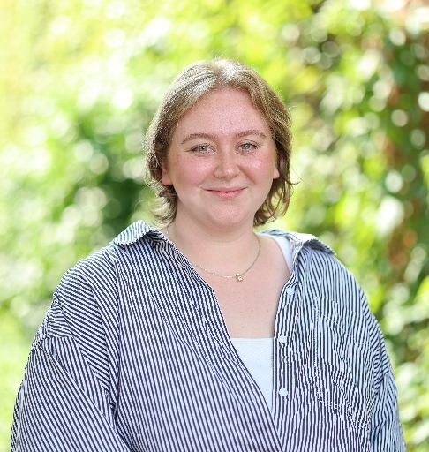
Delaney Wiens
Delaney Wiens is a Registered Social Worker who brings a student-centered and equity-driven approach to her work. As the Co-op Foundations Coordinator and COOP*1100 Instructor at the University of Guelph, she helps students navigate the transition into co-operative education and build confidence in their career journeys. Before joining the University, Delaney supported people and youth with disabilities through her work in Employment Ontario and the non-profit sector, and later as a Co-op Navigator and WorkAbility Employment Pathways Facilitator at U of G. She is passionate about creating supportive spaces where all students can see their potential and thrive.


Patrick Wray
Patrick Wray has over 15 years of experience in the development and management of social research and evaluation initiatives in both the public and private sectors. Patrick’s research at SRDC over the last six years has focused on skills, training, and employment, including Skills for Success approaches to workforce development; approaches to youth skills and employment; climate literacy knowledge and skills in the construction sector; and accessibility, employment, and skills related to people with disabilities. Patrick’s research associated with accessibility and people with disabilities has focused on standards development in the areas of ICT and digital payment methods, entrepreneurship and career mobility, the experiences of small and medium-sized enterprises hiring and retaining people with disabilities, and accessibility issues related to climate emergencies.
Patrick has a Master’s degree in International Development from Carleton University, a Graduate Certificate in Program Evaluation from the University of Ottawa, and a Bachelor’s degree in Sociology from the University of Victoria.

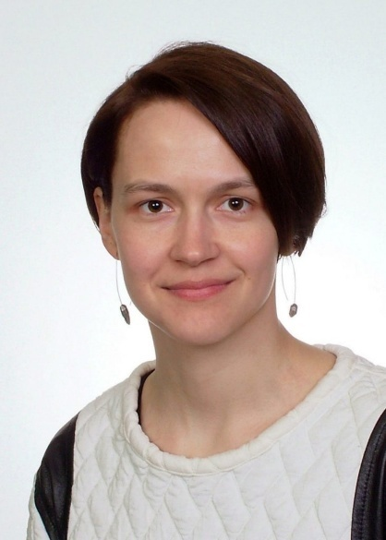
Anna Zhyn
As a communicator, artivist, and feminist, Anna Zhyn is passionate about disability justice and strongly believes that every worker deserves fair, safe, and accommodating working conditions. Before joining Prevention Link as communications and outreach coordinator, she used her skills to resource the human rights and women’s committees at Ontario Secondary School Teachers’ Federation. With an MA in Linguistics and Graphic Communications, Anna is dedicated to connecting workers across the province and providing easily digestible content for knowing your rights and navigating Ontario’s compensation system.

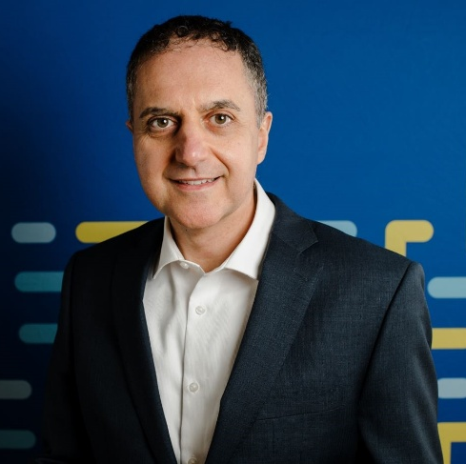
Dino Zuppa | Accessibility Standards Canada
Dino Zuppa, Accessibility Standards Canada’s CEO, oversees the development of equity-based accessibility standards supported by pioneering research funded by Accessibility Standards Canada’s grants and contributions program.
Dino’s career spans more than 25 years. He led a number of strategic initiatives at all orders of government in Canada, and at an American University. Dino holds a Ph.D. and lives in Ottawa with his wife and two kids.

